

BEHAVIOUR POLICY

Policy review: September 2022
Next Review: September 2023

BEHAVIOUR POLICY

The Fens Primary School prospectus contains the following aims which each relate in some way to the objective of fostering a high standard of behaviour:

- To promote high standards of behaviour by encouraging self-discipline and self-reliance.
- To encourage an ethos where tolerance and understanding, together with respect for the rights and views of others, is fostered.
- To promote a safe, secure and caring environment in which children can learn.
- To develop children as citizens with a caring attitude towards school, community and the wider world.

Schools which achieve these aims are those with the most effective discipline, and this begins with a clear, workable policy which is understood by children, staff and governors, and which is supported by parents/carers. It must be consistent and fair, and essentially positive in that it encourages positive working relationships.

Consultation with pupils produced the positive school rules (titled, ‘The Fens Five’ See Appendix 1: School Rules – The Fens Five), which incorporates the RESPECT character and positive behaviour curriculum framework. These are displayed in all classrooms and around the school. They are written in such a way that it promotes what should be done, rather than what should not.

In addition, there are a set of ground rules to which all in the school adhere:

- When a class moves from one part of the school to another, it must be done under adult supervision in a quiet, orderly manner e.g. playtimes, lunchtimes, Computing lessons etc.

- Children should walk on the left side of the stairs and corridors.

- Assemblies should be seen as a peaceful, reflective, quiet time of day for all participants.

- Children are not allowed in the stock cupboards, resource areas, Computer suite or any other similar areas unless accompanied by an adult.

- Children should enter and leave school via the designated door for their year group. The main entrance should only be used when children are late, are being collected for an appointment, or other exceptional circumstances.

Rewards

Good behaviour is encouraged in a variety of ways:

- Praise: this needs to be varied, imaginative, consistent, sincere, meaningful and appropriate to the child’s level of sophistication.

- Positive comments on children’s work.

- A variety of stickers, stars, stamps, merits and ‘Superstar Tokens’.

- Celebratory assemblies during which certificates are presented.

- Extrinsic Rewards: given out by the Headteacher and staff for good work and examples of good citizenship. Staff are able to give out sweets occasionally as a reward.

Sanctions

Sanctions (or punishments) are seen as ways of discouraging unacceptable or inappropriate behaviour. The following points are not graded and are used at the discretion of the class teacher depending on the severity of the incident. The School Council are actively involved in devising and reviewing this sanction system and posters within classrooms clearly communicate potential sanctions while prioritising and promoting positive behaviours first (See Appendix 1: School Rules – The Fens Five).

- Verbal reprimand. For the vast majority of children this will be sufficient.

- Child working under adult supervision, or in isolation within the classroom. Children should not be put outside the classroom, without adult supervision, as a punishment.

- Child may be sent to the Head, Deputy Head, Assistant Head or KS1/EYFS Leader, which should also be recorded by SLT. This will be left to the discretion of the class teacher to decide when this is appropriate. The severity of the incident and the persistence of the behaviours displayed will be considered.

- Children may occasionally have part (or all) of their playtimes removed, or at times walk around outside with an adult. Children will be isolated from their peers in a designated, supervised area of the school. The Head, Deputy Head or Assistant Head may also decide that a child’s behaviour warrants them being kept in at lunchtime.

- If children are misbehaving on a regular basis, class teachers should contact parents/carers by telephone to discuss the problem and suggest how they might assist in finding a solution.

- It may be that a child has specific needs and difficulties which lead to extremes of poor behaviour or persistent bad behaviour. In this situation, the child may require a carefully tailored, personalised plan to help to deal with the range of difficult behaviours that are being exhibited. The class teacher should meet with the SENDCO and/or Designated Safeguarding to discuss the most appropriate actions.

- A child may be stopped from playing in a school sports team or representing the school in any way. This should only occur after consultation with the teacher in charge of the team and the Head. Parents/carers must be informed.

- Educational visits may be stopped if a teacher feels that a child is a danger to him or herself or other members of the class. Again, this must only occur after consultation with the Head. Parents/carers must be informed in the build up to this decision and the child must be given the opportunity to improve their behaviour.

- It may be necessary to seek the support of outside agencies, which will involve the school FSO (Family Support Officer) in meeting with the child’s parent(s) or carer(s) in order to determine the most relevant services to meet the child’s needs. Where possible, the school should make contact with those agencies and set the support in motion.

- Fixed term or permanent exclusions are administered by the Head in consultation with the school Governing Body. This will be used in only the most extreme of cases.

Monitoring and Recording

Behaviour is the responsibility of all school stakeholders. Positive behaviours at playtime will be noted on the RESPECT sheets, linked to the school’s character values. Any persistent negative behaviour issues must be logged with the SLT. Parents/carers will be informed of issues surrounding their child’s behaviour. At lunchtime, behaviour logs will be kept by lunchtime staff where behaviour is recorded using a 1/2/3 coded system (1= low level repeated reminders, 2 = verbal insults intentionally directed, 3 = physical non-accidental incident). Issues that are logged must be communicated with the class teachers /covering adult as soon as possible after lunchtime to ensure issues are fully resolved in a timely and effective manner. The Headteacher will monitor the lunchtime behaviour logs and SLT will review behaviour systems regularly.

Support Systems and Agencies

Mentoring:
Fens School has a mentoring system, which provides adult support for vulnerable children, some of whom have a behavioural problem or problems. Each mentee knows his/her mentor (a member of the teaching or TA staff) and has regular contact; the exact frequency of the sessions varies from case to case, and depends to an extent on what the child requests. The purpose is to give these children the opportunity to talk through their issues and perhaps solve some of their problems, or at least alleviate them. Ultimately, the goal is to increase the child’s sense of well-being and self-worth, and reduce the incidence and severity of episodes of poor behaviour.

Safeguarding:
Contact with the Duty Officer (Social Services) must be via the designated members of the safeguarding team: Mr C. Keen (Designated safeguarding lead) Mrs S. Pugh (Deputy safeguarding deputy) Mr P. Bryson (Deputy safeguarding deputy). Victims of abuse often display uncharacteristic, unexplained behaviour. Any such unusual behaviour patterns must be reported (for additional information please refer to the Safeguarding and Child Protection Policy).

Attendance Officer:
The attendance officer pays regular visits to the school, and can help families to address problems with lateness and absence on the rare occasions that it is necessary.

Educational Psychologist:
The Educational Psychologist can be accessed for consultation and assessment with the aim of modifying children’s behaviour and thus improving their learning.

Family Support Officer:
The Family Support Officer (FSO) works directly with parents/carers supporting them with behaviour issues that their children display either within or outside the school environment. The FSO is an additional school based link regarding referrals to outside agencies. These agencies include local and regional Child and Adolescent Mental Health Services (CAMHS), Trailblazer, Harbour and parenting programmes.

Parents/Carers
The formation of a strong working partnership between parents/carers, teachers and pupils is central to a child’s success and well being in school. Home/school liaison is an important part of the school’s communication systems, which incorporate a variety of issues, from special achievements to examples of unacceptable behaviour. Parents/carers want and expect their children to work hard and behave well in school. To ensure this happens, parents need to be fully involved at the early stages rather than as a last resort if any child is failing to reach his or her potential, particularly because of poor behaviour.

School Council
The School Council provides a forum for pupils to discuss and reflect upon behaviour in the school. Children from Y1 to Y6 can raise matters in their classes which are concerning them. The School Council helps to promote ownership of the Behaviour Policy amongst all pupils.

Theft
Whilst theft is an extremely rare occurrence in school, it is treated very seriously if it does happen. If a case cannot quickly and easily be resolved, the Headteacher must be involved. The Head should be informed of every case of theft.

Damage
Any child that causes damage to school resources, or to the school building, will have to pay to replace broken items, or to make good any damage.

PROCEDURES

(i) Playtimes:

Staff who are on duty need to be on their respective playgrounds promptly.

- Class teachers are responsible for dismissing and supervising their own children in corridors and cloakroom areas. Teaching Assistants will provide added supervision.
- Any child in school must be supervised by members of staff or suitable adults.
- No child is allowed back into school during playtimes, except to use the toilet or receive additional medical attention (or with the permission of an adult outside (e.g. to collect a coat).
- Children must stay on the school yard until a teacher on duty gives them permission to go on the school field.
- The grassed area bordering Mowbray Road, the Site Supervisor’s house and the Office area are out of bounds. Children must remain within the boundary fences.
- Children who misbehave during playtime are to be dealt with by the teacher(s) on duty. The child must be reported to the class teacher, Key Stage Coordinator, AHT, DHT or HT depending on the severity of the incident.
- At the end of playtime, a bell will ring to signal the children to stand still and then a further bell will ring to signal the children to line up. Staff will then lead their children into the school building.

(ii) Wet Playtimes:

Children are supervised in their classrooms by the teachers and teaching assistants on duty. Staff must ensure that their class is settled before they are left. Children are allowed games, books, scrap paper etc. at the teacher’s discretion. Children are not allowed to use scissors or any electronic equipment such as iPads or laptops.

(iii) Lunchtimes:
See Appendix 2

(iv) Before School:
Children are to enter school from 8.45am when the school gates are unlocked. KS1 children will file straight into the classrooms where they will be supervised by additional members of staff. KS2 children will enter the school via the two KS2 entrances; teachers from across KS2 will supervise both the doorways and the cloakroom areas, greeting the children as they come into school. Members of SLT will also provide additional support in supervising these areas. Parents who work are able to access the Breakfast Club from 7.55am for their children.

(v) After School:
All children must be supervised off the site after school. KS1 children will be taken to designated areas on the playground, before the gates are open to parents/carers. Once all children are lined up safely, the parents/carers will enter the yard and collect them from the class teacher/ supervising adult. KS2 children will be taken to their designated areas of the KS2 playground. Once all children are lined up in classes safely, the parents/carers will enter the playground and collect them from their class teacher/ supervising adult. Any Year 5 and Year 6 children with permission to walk home, will wait until all other children are collected and be walked out of the gates by a supervising adult. They will be reminded of road safety and allowed to walk home. Children are reminded to come back into the school if they experience any issues beyond the school gates, and inform a member of school staff.
Children waiting to be collected by external After School Clubs or taxis assemble at the school reception.

(vi) Searching and Searching of Pupils, and Confiscation:
In July 2022 the DfE updated guidance on searching, screening and confiscation. The Headteacher, Deputy Head or Assistant Head are the people designated to deal with any incidents where the searching of pupils and possible confiscation is required. If it is deemed necessary, a female member of staff may need to be involved if the child to be searched is female. Suitable PPE equipment will be worn by the staff member.

The list of items which are banned in school and which may be searched for can be found via the following link:

Searching, Screening and Confiscation (publishing.service.gov.uk)

Related Policies:
Other school procedures related to behaviour can be found in other school policies. E.g.:

- Anti-Bullying & Child-on-Child Abuse Policy
- Safeguarding and Child Protection Policy
- Control and Restraint Policy
- Computing (related policies (references to cyber-bullying))

Control and Restraint information can be found in the DfE document ‘Use of Reasonable Force – advice for head teachers, staff and governing bodies’:

https://www.gov.uk/government/uploads/system/uploads/attachment_data/file/444051/Use_of_reasonable_force_advice_Reviewed_July_2015.pdf

Conclusion:
This policy has been developed through a considerable degree of professional discussion and agreement, and needs to be explicit to all involved with the school. It provides the guidelines within which our school community operates.

As a staff, we agree to apply the rewards and sanctions fairly and consistently, expecting high standards and being prepared to work hard to achieve them. The aim is to emphasise the positives and the rewards, and recognise that, when sanctions are applied, they are done so with flexibility. As a staff, we aim to support each other in achieving these goals.

Monitoring and Reviewing
The policy will be reviewed annually by the SLT Designated Safeguarding Leader in consultation with the Headteacher, the Governors and the Chair of Governors.
It will be updated, modified or amended as necessary.

Signed:………………………………………………………..

Date:…………………
(Designated Safeguarding Lead)

Signed:………………………………………………………..

Date:…………………..
(Headteacher)

Signed:………………………………………………………..

Date:…………………..(Chair of Governors)

Appendix 1: School Rules – The Fens Five

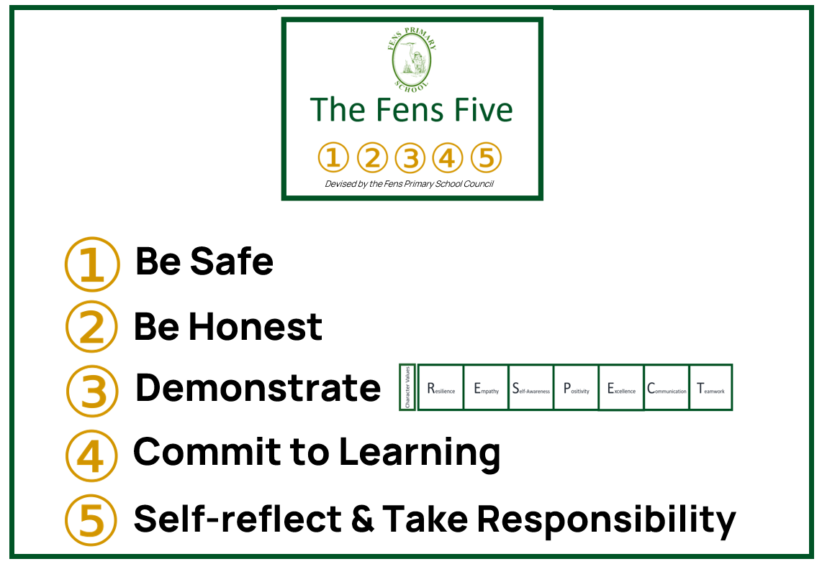

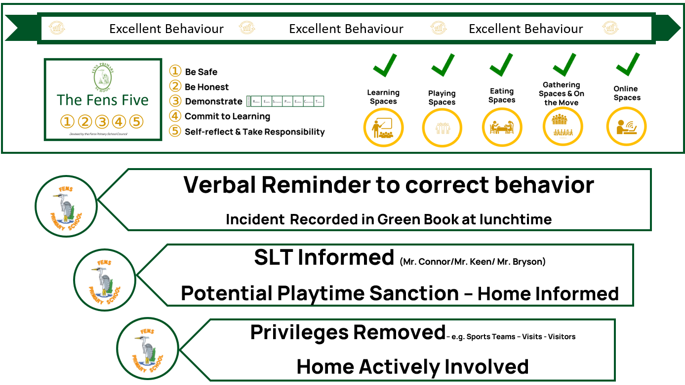

Appendix 2: Lunchtime Arrangements

SLT:

Members of the senior leadership team are on site at lunchtime and plays an active part in supervising and monitoring children in school.

Absence:

If a Supervisory Assistant is unable to attend for work, the school must be contacted as early as possible on the day of the absence so that alternative arrangements can be made.

Dress:

Tabards and ID badges are provided and must be worn whilst on duty, as they distinguish Supervisory Assistants from other adults on site.

Dining Room:

Children are to be encouraged to cut their own food and try everything on their plate, but will not be made to eat anything. If there are concerns about a child’s eating habits, a member of the SLT must be informed.

Food must be finished at the table and children should not eat any remaining fruit, cakes or biscuits outside. Young pupils may need help cutting fruit and opening yoghurts and should thus be assisted where necessary. Some children display poor table manners and should be shown the correct way to hold and use cutlery and conduct themselves at the table.

Children Leaving School at Lunchtime:

Any children going home at lunchtime must leave and re-enter school via the main entrance, and be formally signed out by a member of office staff. Parents/carers should not be on site over lunchtime.

Lunchtime Lessons/Clubs and Sports Teams:

Some children attend a range of activities at lunchtime. This may result in them having to take their lunch at 12.10pm. Some monitors also have their lunch at 12.10pm depending on their duties that day.

Dry Lunchtimes:

Unless children are eating or attending supervised lunchtime activities they should be outside. No child is allowed to be in a classroom unsupervised.

As soon as there are any children playing outside, there must be an adult supervising them. Children must not be left unattended on the yard under any circumstances.

Children are not allowed to wrestle, play-fight, or play games, which could result in physical injuries.

Where there are any doubts as to the suitability of the weather conditions, a member of the SLT should be consulted.

Young children should be encouraged to fasten their coats in colder weather and to wear sunhats or caps in hot weather. No members of staff are permitted to put sun cream on a pupil.

Pupils should always be encouraged to play games and occupy themselves positively and appropriately.

Accidents:

If a child has a minor accident, duty staff are expected to deal with it. Several duty staff members have received first aid training, and first aid boxes are placed around the school. Head injuries or anything of a serious nature must be reported to a designate first aider or a member of the SLT. These occurrences must be recorded on an accident form. Depending on the seriousness of the head injury, parents/carers are informed or a head bump note is sent home with the child.

Wet Lunchtimes:

Children remain in their classrooms during wet playtimes, occupied by a variety of activities.

Lunchtime Behaviour:

It is of enormous, indeed, crucial importance to maintain a happy atmosphere within the school. Areas of concern, or repeated unwanted behaviour class teacher and parents are informed.

