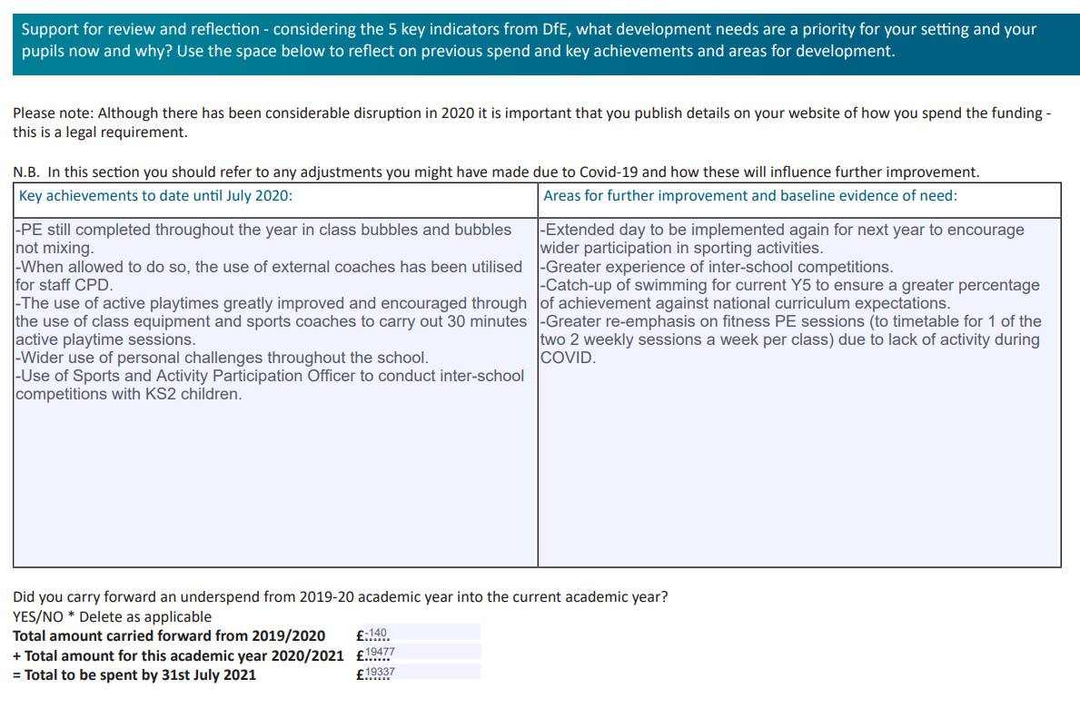
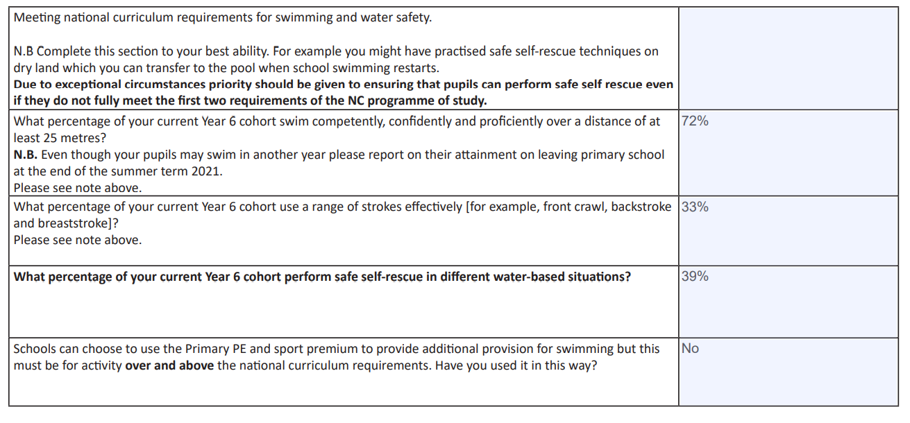

Academic Year: 2020/21 | Total fund allocated £19,477 | Date updated: July 2021
Key indicator 1: The engagement of all pupils in regular physical activity – Chief Medical Officers guidelines recommend that primary school pupils undertake at least 30 minutes of physical activity a day in school |  |  |  | Percentage of total allocation:  21.73%
Intent: | Implementation |  | Impact:
Your school focus should be clear on what you want the pupils to know and be able to do and about what they need to learn and to consolidate through practice: | Make sure your actions to achieve are linked to your intentions: | Funding allocated: | Evidence of impact: what do pupils now know and what can they now do? What has changed?: | Sustainability and suggested next steps:
- Ensure pupils have an extensive selection of sporting equipment to increase engagement and physical activity. | -Skipping ropes, bean bags and tennis ball purchased for every child in the school.  - New equipment purchased to provide each class with a class set of playground equipment to encourage active playtime. | £3617.73 on playground equipment | - All children active for at least 30 minutes a day, using equipment provided.  -Children have a greater awareness of the benefits of healthy, active lifestyles. | -Improved levels of activity and fitness from exposure to active playtime sessions and the of use playground equipment.  Next steps:  Increase amount of equipment, replacing old and damaged equipment with new.
- Use of sports coaches for specific sports/activities. | -External sports coaches used to widen the range of sports/activities on offer, including both PE lessons and active playtime sessions. | £615 on external coaches. | School timetables show amount of the sports covered by external coaches, and with which classes.  -All KS2 classes have participated in an active playtime session to encourage greater movement and an improvement of fitness.  -As a result of coaching/PE sessions, children can more confidently use a range of skills, such as ball handling and evading techniques. | -Exposure to a wide range of PE lessons and active sessions leads to a greater improvement in skill and confidence thus encouraging the desire the continue with the sport.  Next steps:  -Monitor sports coaches to ensure they continue to add value to existing sports provision.  -Ensure children continue to build upon skills and techniques for a wide range of physical activities in 2x weekly timetabled sessions

Key indicator 2: The profile of PESSPA being raised across the school as a tool for whole school improvement |  |  |  | Percentage of total allocation:  0.88%
Intent: | Implementation |  | Impact:
Your school focus should be clear on what you want the pupils to know and be able to do and about what they need to learn and to consolidate through practice: | Make sure your actions to achieve are linked to your intentions: | Funding allocated: | Evidence of impact: what do pupils now know and what can they now do? What has changed?: | Sustainability and suggested next steps:
- Improve levels of equipment for teaching of PE | A new set of netballs purchased to ensure replace old to ensure high quality equipment is available for PE sessions. | £99.95 | Children are enthusiastic to use new equipment and can further develop skills due to high quality resources. | Children benefit from greater development of skills due to high quality equipment.  Next steps:  Continuous discussions with teachers to monitor quality and quantity of equipment.
- End of year Sports Awards | Sporting awards provided to leaving Y6 children who have excelled in PE/competitions during their time in the school | £72.96 for trophies for Sports Achievement Awards | -Pupil achievements celebrated to encourage and motivate wider participation. | Continue to review the achievement awards process and ceremony.  Next steps:  To use playground leaders to set personal challenges for children in other year groups as part of a ‘personal challenge leaderboard’.
- School website and social media updates. | Regular sports news is shared via school website/social media pages. This keeps families updated on sporting events/results. | N/A | Parents/carers celebrate sporting success of the children, creating greater community links. | Ensure regular communication occurs between school and parents/carers so sporting news is up to date and relevant.

Key indicator 3: Increased confidence, knowledge and skills of all staff in teaching PE and sport |  |  |  | Percentage of total allocation:  0%
Intent: | Implementation |  | Impact:
Your school focus should be clear on what you want the pupils to know and be able to do and about what they need to learn and to consolidate through practice: | Make sure your actions to achieve are linked to your intentions: | Funding allocated: | Evidence of impact: what do pupils now know and what can they now do? What has changed?: | Sustainability and suggested next steps:
Use of sports coaches to work alongside teachers to improve skills/confidence in teaching PE and sport. | -External PE coaches employed to deliver PE throughout the school. | £615 (As identified from bullet point 2 in Key Indicator 1). | -Pupils have opportunities to experience a wider range of sporting activities.  -New ideas, taken from coaches, introduced and implemented in planning.  -Teachers use games/activities from coaching sessions within their own PE lessons.  -Greater teacher confidence when delivering PE lessons. | -Exposure to expertise tuition leads to a greater improvement in skill and confidence thus encouraging the desire to continue with the sport.  -Enhanced teacher skills and confidence are embedded in practice ensuring that the heightened curriculum is sustained.  Next steps:  -Ensure funding is available to be allocated for external coaches to deliver PE and provide CPD for staff.  - Seek out CPD courses for PE co-ordinators.  - Co-coordinators to look at the possibility of using CPD courses to upskill staff to lead after school clubs, particularly fitness based.

Key indicator 4: Broader experience of a range of sports and activities offered to all pupils |  |  |  | Percentage of total allocation:  2.99%
Intent: | Implementation |  | Impact:
Your school focus should be clear on what you want the pupils to know and be able to do and about what they need to learn and to consolidate through practice: | Make sure your actions to achieve are linked to your intentions: | Funding allocated: | Evidence of impact: what do pupils now know and what can they now do? What has changed?: | Sustainability and suggested next steps:
- Opportunities to experience different sporting activities | Class set of table tennis equipment purchased for each KS2 class to use on outdoor table tennis tables during playtimes and dinnertimes. | £539.60 for table tennis equipment  £43.05 (coach for C4L club from before COVID). | Children were more active during playtimes/dinnertimes, experience a range of sporting activities not currently delivered in school. | Improved pupil skills and confidence encourages greater participation in sport both inside and outside of school.  Next steps:  Due to COVID and class bubbles not being allowed to mix, after-school clubs have not been taking place so to re-introduce extra-curricular clubs for a wider range of sporting activities – for example, table tennis and yoga.  To incorporate purchased equipment into after school clubs.  Continue to analyse class club sheets and registers used to encourage less active to participate in after school clubs.

Key indicator 5: Increased participation in competitive sport |  |  |  | Percentage of total allocation:  6.46%
Intent: | Implementation |  | Impact:
Your school focus should be clear what you want the pupils to know and be able to do and about what they need to learn and to consolidate through practice: | Make sure your actions to achieve are linked to your intentions: | Funding allocated: | Evidence of impact: what do pupils now know and what can they now do? What has changed?: | Sustainability and suggested next steps:
- The Collective Cluster Sports Partnership and Youth Sport Trust Membership. | Fens Primary enter the cluster competition calendar to provide pupils from KS2 with the opportunity to take part in competitive and non-competitive tournaments. | £1050 on Cluster Events | Due to COVID the competition calendar has not been able to be completed | Pupils involved in competitive activity build confidence and desire to continue and further pursue sporting participation.  Next steps:  Every effort will be taken to ensure a wide range of children are able to compete in cluster competitions, including B and C team competitions.
- Youth Sport Trust Membership | Fens Primary School bought into YST membership. Resources were shared with the staff to use during PE lessons.  During lockdown, a wide range of resources from YST set as part of online learning for children to stay active at home. | £210 Youth Sport Trust membership. | Termly personal challenges promoted and children now regularly set themselves a personal target to beat during PE sessions. | Personal challenges have become a regular feature of PE lessons, providing children with opportunities to improve their attainment.  Next steps:  To provide staff with resources and possible CPD opportunities.

Signed off by:
Head Teacher:

Date:

Subject Leader: | R. Johnson/ L.Todd
Date: | 20.07.21
Governor:

Date:

