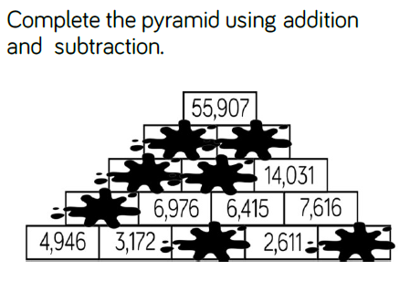

See if you can use your ‘inverse’ skills to complete this.
- If you add two blocks next to each other, they will equal the block above
- Sometimes you will need to use the inverse though – use the larger number on top and subtract the smaller number below to find the missing block

