[](http://www.nhsdirect.nhs.uk/index.aspx)

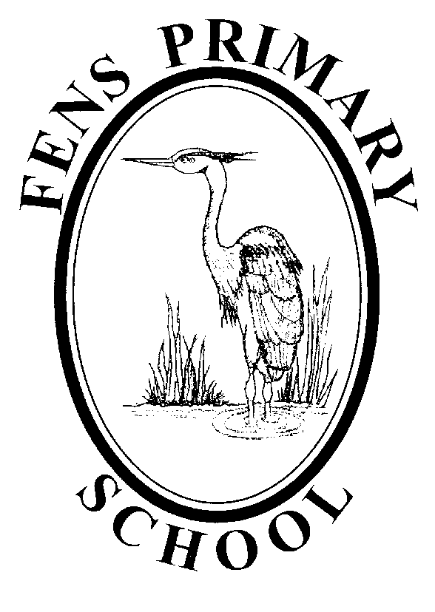

**Oral Health Policy/Agreement**

**Review date: November 2022**

**Oral Health Policy**

**Introduction**

Poor oral health can affect a child’s ability to sleep, eat, speak, play and socialise with other children. We see oral health as an integral part of overall health and how it can contribute to school readiness.

Fens Primary School oral health policy sets out the settings formal commitment to providing a high standard of oral health promotion, linking this to education and life skills to promote optimum health in all of our children.

The staff aim to ensure that all aspects of oral health promotion at Fens primary School promotes the health and wellbeing of children, staff and visitors to our setting, supporting individual needs (cultural, ethical and medical) as appropriate.

The Staff will ensure the creation of partnerships between the children, parents and other relevant groups so that all those involved in oral health at Fens primary School have the opportunity to plan, implement deliver and evaluate oral health effectively.

Fens primary School is committed to

* Supporting partnerships with agencies which support Oral Health and deliver effective oral health promotion involving staff, parents and children.
* Planning and delivering effective oral health promotion through participating in local initiatives as determined by Public Health England (PHE).
* Raising concerns relating to oral health of children in line with our safeguarding policy.

By implementing our oral health policy there will be a formal structure in place to allow feedback from staff and parents and we are committed to responding appropriately to such feedback. This will ensure that we continue to rate oral health very highly as demonstrated by the high standard set by our local Oral Health Promotion service. We will link oral health to what is taught in the EYFS Standards and the National Curriculum, to ensure children receive consistent and up to date messages around oral hygiene and healthy eating. The settings oral health policy will be linked to the nutrition and food policy which relates to the Eat better start better food guidance and to Every Child Matters and The National Healthy Schools Programme.

Fens primary School named Oral health lead is Jenny Connor (Early Years Lead)

**Tooth Brushing**

A daily supervised tooth brushing programme is a local initiative to help improve the oral health of children in Teesside. Fens primary School has been identified to deliver tooth brushing in Nursery and Reception classes. Tooth brushing resources are provided by the Tees Community Dental Service Oral Health Promotion Department subject to funding and consists of storage racks, toothbrushes and toothpaste. We support children to brush their teeth at home and in the pre-school setting. We do this with the support of the staff reinforcing messages to parents to implement at home.

**Fens primary School is committed to**

* Delivering the tooth brushing scheme in line with guidance provided by the Tees Community Dental Service Oral Health Promotion Department.
* Implementing a high stand of infection control in line with guidance provided by the Tees Community Dental Service Oral Health Promotion Department.
* Encouraging all children to participate in the scheme in the setting and continue with support at home.
* Maintaining a high standard of staff knowledge in Oral Health Promotion.

**Guidance on Tooth Brushing in Setting**

* The setting will have a nominated oral health lead person responsible for liaising with the Oral Health Promotion Department, and ensuring the effective delivery of the scheme.
* All staff involved in the tooth brushing scheme will be suitably trained, training will take place on an annual basis. This will be recorded and monitored.
* All parents will be made aware of the scheme in order to give consent (opt out is sufficient)
* Tooth brushing will take place in a suitable environment in line with infection control guidelines.
* All children are supervised whilst brushing.
* Toothbrushes will be rinsed individually after each session by the child/member of staff. If by the child this should be supervised.
* Storage racks will be maintained, and cleaned on a regular basis inline with cross infection control.
* Every child with have their own identifiable toothbrush. (appendix C)
* A fluoride toothpaste will be used which contains the current recommended level of Fluoride.
* Every child will use toothpaste which has been dispensed inline with infection control guidance. (appendix D, E & F)
* A pea sized amount of fluoride toothpaste will be dispensed for over 3 years and smear for under 3 years by the supporting staff.
* Children will be encouraged to spit out excess paste and NOT swallow paste.
* Toothbrushes will be replaced every three months or sooner if required, when bristles become splayed, are dropped on the floor or used by a child with a contagious infection. (appendix F)
* Staff will wash hands before and after each brushing session.
* Toothbrushes will be stored in an upright position, out of reach of children, away from toileting facilities and left to air dry when not in use.
* Storage equipment will be washed weekly, and replaced if cracked, scratched or rough surfaces appear.
* A representative from OHPD will observe the setting quarterly to ensure compliance to standards.
* The dental health link for the setting will self-assess against standards. (see appendix G)

Appendix A sets out specific tooth brushing routines in Fens primary School

**Healthy Eating**

**Food and drink**

Meals, snacks and drinks must be healthy, balanced and nutritious in line with our food and drink policy. All staff responsible for preparing and handling food is competent and trained. Special dietary requirements are obtained before a child is admitted to the setting.

Food served in schools and academies in England must meet the school food standards so that children have healthy, balanced diets. These standards are intended to help children develop healthy eating habits and ensure they get the energy and nutrition they need across the school day.

A child’s healthy, balanced diet should consist of

* Plenty of fruit and vegetables.
* Plenty of unrefined starchy foods.
* Some meat, fish, eggs beans and other non-dairy sources of protein.
* Some milk and dairy foods.
* A small amount of food and drink high in fat, sugar and / or salt.

Oral health is affected by the frequent consumption of food or drinks that contain extrinsic sugars. Fens Primary School recognises the importance of reducing the frequency of sugary food / drinks that are available to prevent tooth decay.

**Pre school**

Nurseryy is committed to

* Providing free, fresh drinking water which is available at all times.
* Using free flow beakers / cups for children over 1 year.
* Providing milk.
* Providing other low fat/low sugar drinks as part of a meal only.
* Providing fresh whole fruit as a snack in between meals.
* Dried fruits will only be served as part of a meal.
* Not giving sweets as rewards.
* Allowing cakes to be consumed as part of a meal (this applies to parties, celebrations to mark religious or cultural occasions, or at fund raising events)
* Sending home any confectionary that is brought into pre-school.

**School**

Reception is committed to

* Providing free, fresh drinking water which is available at all times.
* Providing lower fat milk which will be available at least once a day.
* Providing other low fat/low sugar drinks as part of a meal only.
* Providing fresh whole fruit as a snack in between meals (on occasion dried fruit may be provided by the free fruit scheme after school holiday periods).
* Not giving sweets as rewards.
* Not allowing cakes to be consumed in school (this does not apply at parties, celebrations to mark religious or cultural occasions, or at fund raising events)
* Sending home any confectionary that is brought into school.

Oral Health snack guidance Appendix B

**Teething and Dummies**

It is Fens Primary School policy to discourage the use of dummies in the setting; They are only used when provided by parents/guardians as a comforter for sleep and/ or if the child is upset. Once children are settled the dummy is stored hygienically away in…………………………… in line with infection control procedures.

If a dummy needs sterilising it is done in accordance with infection control procedures as set out in Fens Primary School.

**Dental Emergencies**

**Knocked – out tooth**

This is for adult teeth only; **children’s baby teeth should not be re-implanted**.

On occasions children may injure themselves affecting the mouth. If a tooth is knocked out the sooner it is re-implanted, the more likely it is to embed itself back into the gum.

A knocked-out adult tooth can usually be saved by putting it back in place or in milk as soon as possible, before seeing a dentist

If a child has sustained a facial injury this will be assessed by the first aider in the setting who will follow the advice given by NHS choices as below:

**If it's an adult (permanent) tooth:**

* Hold it by the white bit that sticks out of the gum (the crown). Do not touch the root.
* Lick it clean if it's dirty, or quickly rinse it in cold running water for no more than 10 seconds.
* Try to put it back into the hole in the gum. **If it does not go in easily:**
* put it in milk
* put it in saliva – by spitting into a container (if it's your tooth) or having your child spit into a container (if it's their tooth)
* hold it in your cheek until you see the dentist – but do not have younger children do this in case they swallow it
* If it goes back in, bite down gently on a clean cloth to hold the tooth in place.

**If it's a baby tooth:**

* do not put it back in – it could damage the tooth growing underneath.

Chipped or broken teeth should be reported to parents / guardians in line with the school accident policy where non emergency appointments can be made.

Parent / guardians should be informed immediately so that a dental appointment can be made.

For help finding an NHS dentist and dental emergencies – Tel: 111 or visit NHS 111 online.

NHS England Customer Contact Centre on 0300 3112233

NHS Choices - www.nhs.uk

**Oral Health Education**

Providing the children with a sound knowledge in oral health is a priority at Fens Primary School we strive to provide a holistic approach to health whereby dental health is given equal priority to general health messages.

Fens Primary School is committed to

* Providing parents with relevant information/ literature relating to oral health.
* Working in partnership with dental professionals.
* Providing dental health education to all children.
* Incorporating dental health education into the setting by loaning resources which support the education of the children.

Further guidance on oral health and resources can be obtained from-

Tees Community Dental Service

Oral Health Promotion Department

01642 383833

nth-tr.cdsohp@nhs.net

**Appendix A**

*Fens Primary School*  follows the following procedure when tooth brushing with children in preschool.

Tooth brushing is supervised by (Name) Nursery- Claire Martin, Reception- Jenny Connor & Faye McCarroll

|  |  |  |  |  |  |
| --- | --- | --- | --- | --- | --- |
| **Tooth brushing procedures at Fens Primary School** | | | | | |
| **Age of children/rooms taking part.** | **Storage Holder**  **(Toy rack/brush bus)** | **Symbol (toy/snack)** | **Storage area** | **Tooth brushing area- groups at table /dry brush** | **Paste – shared or individual** |
| **3-4** |  |  |  |  |  |
| **4-5** |  |  |  |  |  |
|  |  |  |  |  |  |
|  |  |  |  |  |  |
|  |  |  |  |  |  |
|  |  |  |  |  |  |

**Appendix AA**

|  |  |  |  |  |  |
| --- | --- | --- | --- | --- | --- |
| **Class** | **Type of Rack**  (Toy Rack/BrushBus)  Type of Toothbrush  (Toy/Healthy Snacks/Sports) | **Storage Area**  (Up high) | **Tooth Brushing Area**  (Where?) | **Cleaning Procedure:**  Of area (product used)  Of Rack:  Of Tooth brushes: | **Method of brushing:**  One tube of toothpaste dispensed onto?  Each child every day? |
| **2yrs** |  |  |  |  |  |
| **Nursery** |  |  |  |  |  |
| **Reception** |  |  |  |  |  |
| **Year 1** |  |  |  |  |  |
| **Year 2** |  |  |  |  |  |
| **Year 3** |  |  |  |  |  |
| **Year 4** |  |  |  |  |  |
| **Year 5** |  |  |  |  |  |
| **Year 6** |  |  |  |  |  |



**Appendix C**

**Appendix B**

***Oral Health Snack Guidance***

***Between Meals - healthy snacks between meals should be encouraged to cut down on the frequency of sugars***

Foods

* Fresh fruit and vegetables
* Salads including pasta, wholegrain rice and couscous

(Occasionally)

* Hard boiled egg
* Small portions of Cheese *(not exceeding 30g in 1 day),*
* Cream cheese or cottage cheese
* Hummus
* Bread or toast - including white, wholemeal, granary, brown, wheatgerm, multigrain, potato bread, chapattis, plain baked naan, rotis, rolls, bagels, pitta and wraps.
* Sandwiches with savoury fillings e.g. lean meat or fish, cheese, egg, salad
* Savoury scones (try making wholemeal)
* Plain popcorn
* Plain yoghurt
* Nuts and seeds

Drinks

• Plain milk

• Plain water

• Tea/coffee (without sugar)

***Meal Times Only - these snacks should only be eaten occasionally and as part of a meal***

Foods

* Sweets and chocolate
* Dried fruit e.g. Raisins, apricots
* Tinned fruit - in natural juice or syrup
* Biscuits, cakes
* Fruit scones, teacakes
* Crisps
* Ice Cream
* Fruit yoghurts
* Sandwiches with sweet fillings e.g. jam
* Fruit yoghurt
* Sweet popcorn e.g. Toffee or caramel

Drinks

* Fresh fruit juice
* Diluted cordial juices
* Fizzy drinks
* Milkshakes
* Flavoured or carbonated water
* Fruit smoothies
* Hot chocolate

**Appendix D**

|  |  |  |  |  |
| --- | --- | --- | --- | --- |
|  | **Rack Colour** | |  |  |
|  | **Toys** |  | **Name** | **Date** |
|  |  | **House** |  |  |
|  |  | **Apple** |  |  |
|  |  | **Bike** |  |  |
|  |  | **Bus** |  |  |
|  |  | **Chair** |  |  |
|  |  | **Tree** |  |  |
|  |  | **Coat** |  |  |
|  |  | **Hat** |  |  |
|  |  | **Pram** |  |  |
|  |  | **Shoe** |  |  |
|  |  | **Flower** |  |  |
|  |  | **Bed** |  |  |
|  |  | **Teddy** |  |  |
|  |  | **Bricks** |  |  |
|  |  | **Cup** |  |  |
|  |  | **Spoon** |  |  |
|  |  | **Ball** |  |  |
|  |  | **Car** |  |  |
|  |  | **Book** |  |  |
|  |  | **Pencil** |  |  |

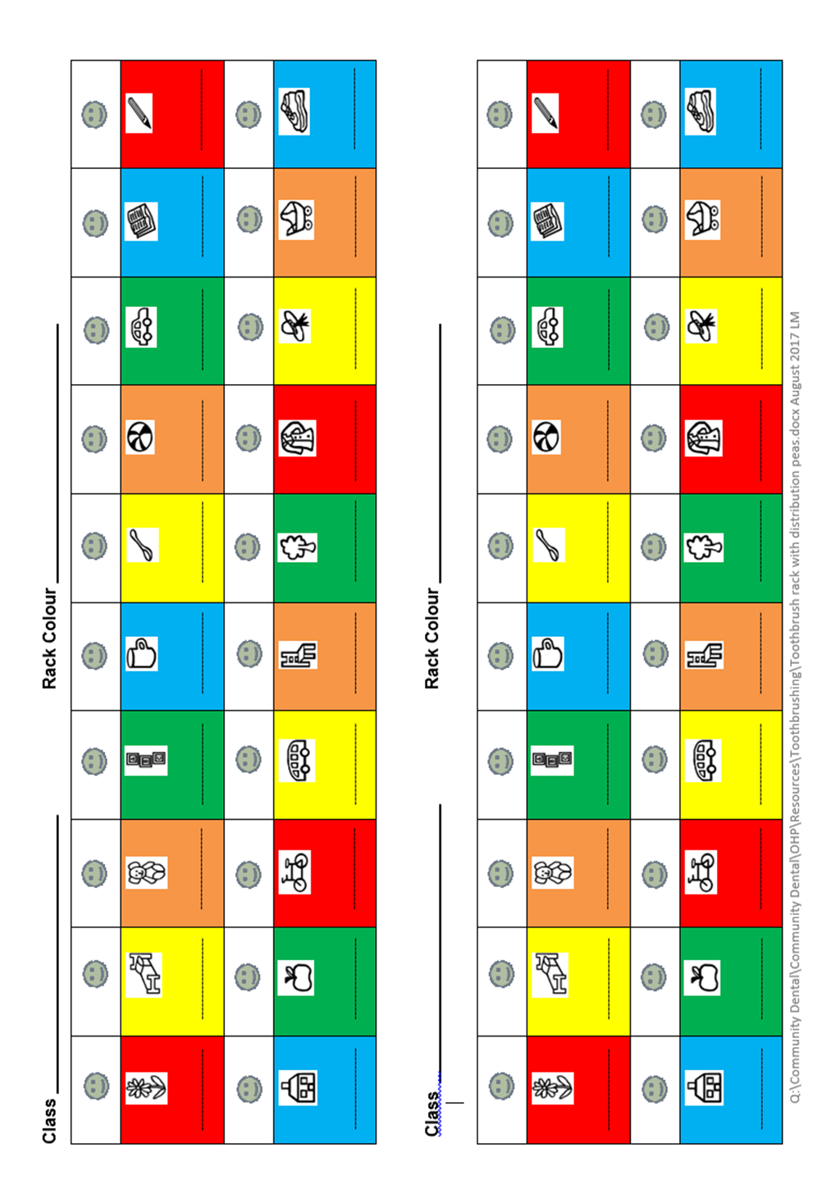

**Appendix D**

**Appendix E**

|  |  |
| --- | --- |
| **Year groups taking part in scheme** | |
| **Year group** | **Brushing** |
| Nursery | **✓** |
| Rec | **✓** |
| Y1 | **x** |
| **If whole school** | |
| Y2 | **x** |
| Y3 | **x** |
| Y4 | **x** |
| Y5 | **x** |
| Y6 | **x** |

**Appendix F**

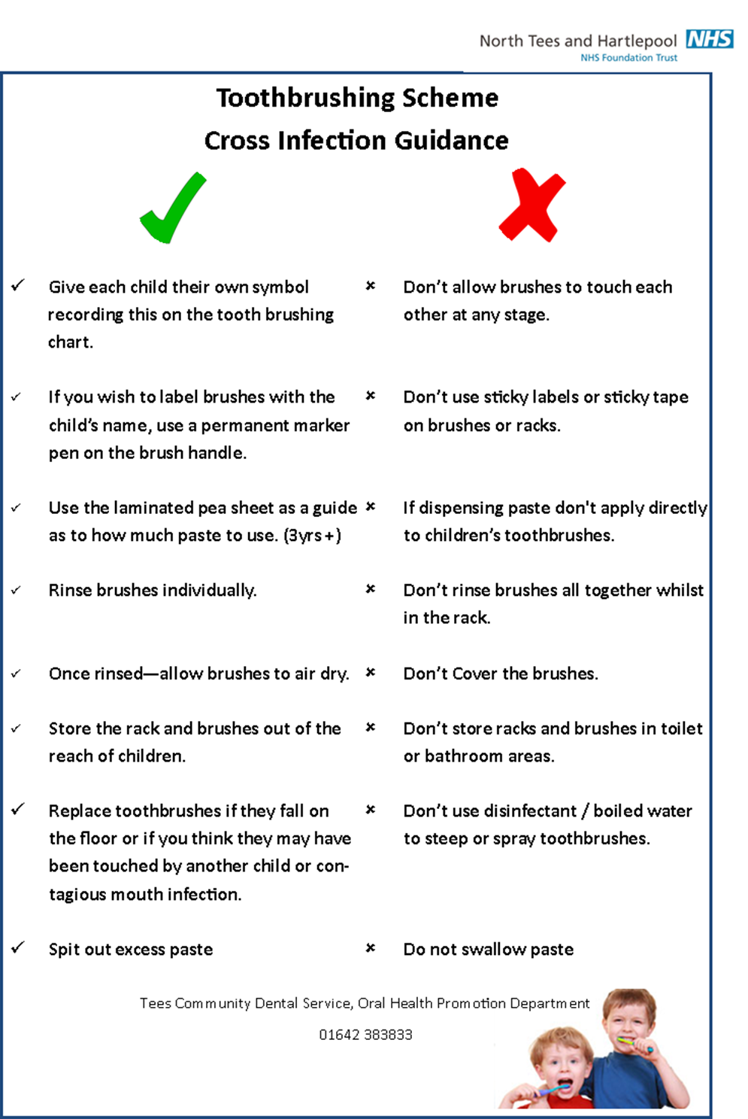

**Appendix G**

**EXAMPLE Form**

**Not to be com**

**Setting Quality Assurance Checklist**

**Setting Name:**

This is a self assessment tool to be completed by the designated oral health lead within the setting to assess compliance to the quality standards of the supervised tooth brushing scheme. The document should be completed at least annually and results discussed at the settings annual needs assessment meeting with the representative from the Tees Community Dental Service Oral Health Promotion Department (OHPD).

|  |  |
| --- | --- |
| **Organisation Standards** | Implementation  Yes/No |
| A designated oral health lead within the preschool/school has been identified to work with the (OHPD) to set up and maintain the delivery of the programme. |  |
| All staff involved in delivering tooth brushing programme have received appropriate training in tooth brushing which includes the consideration of cross-infection procedures. This training has been recorded. |  |
| Systems are in place to inform parents about the programme and seek their permission for their child’s participation. |  |
| Performance against the standards in this document is monitored at least annually. |  |
| **Effective Preventive Practice Standards** |  |
| Fluoride toothpaste containing 1450ppm fluoride is used:   * Children under 3 years of age have a smear of paste applied to their brush. * Children over 3 have a pea sized amount of paste applied to their brush. |  |
| Where toothpaste is shared, a supervisor dispenses it onto a clean surface such as a plate or paper towel, and applies this to the child’s brush |  |
| Toothpaste is only dispensed at the time the child is ready to brush. |  |
| Supervisors cover any cuts, abrasions or breaks in their skin with a waterproof dressing. |  |
| Children are closely supervised during brushing and encouraged to spit out excess toothpaste during or after brushing their teeth. |  |
| Toothbrushes are individually identifiable for each child. |  |
| Tooth brushes are stored out of reach, rinsed thoroughly and allowed to air dry after use. |  |
| Toothbrushes are replaced at least once per term (every 12 weeks) or once the bristles become splayed. |  |
| **Prevention and control of infection standards** |  |
| Toothbrushes are stored in appropriate storage systems as provided. There should be no contact between tooth brushes. |  |
| Storage systems should not be stored in toilet area or within reach of children. |  |
| Storage systems display symbols corresponding with those on the toothbrushes to allow individual identification. |  |
| Storage systems are replaced if cracks, scratches or rough surfaces develop. |  |
| Storage systems and storage areas are cleaned at least once a week. |  |
| Tooth brushes that fall on the floor are discarded. |  |
| Toothbrushes are not soaked in bleach or other cleaner/disinfectant. Tubes of toothpaste are cleaned with a damp tissue. |  |
| **Tooth brushing in dry areas** |  |
| After tooth brushing is completed, children who have excess toothpaste spit into a disposable tissue, disposable paper towel or a disposable cardboard cup. |  |
| Tissues/paper towels are disposed of immediately after use in a refuse bag. |  |
| **Tooth brushing in a sink** |  |
| Tooth brushing takes place at the identified sink area. |  |
| The supervisors wash their hands before and after the tooth brushing session to prevent cross-infection. |  |
| Sinks are cleaned following tooth brushing following the settings usual infection control guidelines. |  |

**EXAMPLE Form**

**Not to be com**

**Quality assurance checklist for the Oral Health Promotion Department (OHPD)**

|  |  |
| --- | --- |
| The Oral Health Promotion Department (OHPD) provide annual training to all staff directly involved in the supervising of the tooth brushing scheme which includes setting up and maintaining a tooth brushing scheme, relevant oral health messages and discussions around infection control considerations. |  |
| The OHPD work with the oral health promotion lead within the preschool/school to quality assure the tooth brushing programme. |  |
| The OHPD provide the preschool/school with resources to enable each child to have their own designated tooth brush and paste. Where schools prefer to use a single tube of toothpaste, this is dispensed and applied to children’s toothbrushes by a supervising adult. |  |
| The OHPD provide dental health training to preschool/school staff to support learning around oral health to tie in with the curriculum. |  |
| The OHPD provide the preschool/school oral health resources (on loan) to assist learning relating to healthy eating and other oral health messages. |  |

**Designated Preschool/School Oral Health Lead Oral Health Promotion Department**

**(date observed) (to be signed at annual review)**

Signature _________________ Signature ___________________

Date Observed ______________ Date Discussed _____________

**Monitoring and Reviewing the Science Policy**

The policy will be reviewed annually by the Early Years Leader in consultation with the Staff, Headteacher and the Governors to ensure it meets the needs of every child at Fens Primary School.

It will be updated, modified or amended as necessary.

**Signed: ……………………………………………………….. Date: …………………..**

**(Early Years Leader)**

**……………………………………………………….. Date: …………………..**

**(OHPD)**

**……………………………………………………….. Date: …………………..**

**(Headteacher)**

**……………………………………………………….. Date: …………………..**

**(EYFS Link Governor)**