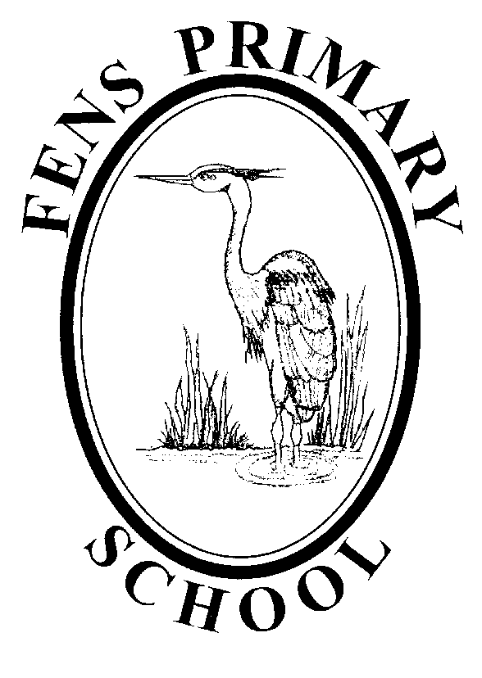

ENGLISH POLICY

Policy review: July 2022
Next Review: September 2023

Our English Curriculum

Intent
A high quality English education provides a foundation for pupils to:
- access the wider whole curriculum;
- communicate their ideas and emotions to others;
- develop culturally, emotionally, spiritually and socially; literature plays a key role in this development.
The overarching aim for English in the national curriculum is to promote high standards of language and literacy by equipping pupils with a strong command of the spoken and written word, and to develop their love of literature through widespread reading for enjoyment.
We aim to ensure that all pupils:
- read easily, fluently and with good understanding
- develop the habit of reading widely and often, for both pleasure and information
- acquire a wide vocabulary, an understanding of grammar and knowledge of linguistic conventions for reading, writing and spoken language
- appreciate our rich and varied literary heritage
- write clearly, accurately and coherently, adapting their language and style to a range of contexts, purposes and audiences
- use discussion in order to learn; they should be able to elaborate and explain clearly their understanding and ideas
- are competent in the arts of speaking and listening, making formal presentations, demonstrating to others and participating in debate.
(National Curriculum in England)
- To strive to be an ‘Evidence Informed’ school, taking into account the important role different forms of evidence can play in improving our school English curriculum through informing decision making and implementation practices that continually work to improve the outcomes of teaching and learning.

Implementation
In order to achieve this goal, we will:
  - Engage with a wide range of research, related to both English and wider teaching and learning
  - Explore areas of school practice that can be improved and clearly define them for all school stakeholders
  - Prepare clear school development plans that outline how implementation activities and resources will be deployed to meet the intended outcomes
  - Deliver and Adapt implementation strategies, monitoring their effectiveness through developed school systems and a flexible and collaborative peer-to-peer approach to school improvement
  - Sustain and scale successful implementation practices to ensure they are embedded.
- Develop children’s awareness of their ability to self-regulate and think about their learning by sustaining and promoting the school’s metacognition agenda, in order to develop metacognitive strategies in conjunction with building a progressive understanding of English concepts.

English is taught through daily lessons and the skills and understanding are practised and applied across the whole curriculum.
Speaking and listening
Spoken language is given high priority in Fens because of its role in children’s cognitive, social and linguistic development. We aim to ensure that pupils
• develop confidence and competence in spoken language
• hear and speak quality and varied language to develop their understanding for reading and writing, grammar and vocabulary
• develop a capacity to explain their understanding of books and poems and to prepare their ideas prior to writing
• are assisted to make their thinking clear to themselves as well as to others
• are probed by discussion with teachers to remedy their misconceptions
• are taught to understand and use the conventions for discussion and debate.
We achieve this by direct teaching in English and across the whole curriculum, modelling by all staff and adults in school and use of high quality texts and audio-visual materials, through scaffolding talk where necessary, through the use of discussion and questioning and through the provision of a wide range of high quality opportunities for both formal and informal talk. Children are given constructive feedback on their talk, providing both praise and challenge.
We have experienced Teaching Assistants trained in Speech and Language and children requiring extra support are identified as early as possible, their progress monitored and external agencies involved where necessary.
Reading
Throughout school both dimensions of reading are taught: word reading and comprehension.

Phonics
At Fens, phonics is taught using the Twinkl Phonics programme. This ensures that our phonics teaching is systematic and synthetic. Children learn to associate a written letter or group of letters, known ‘graphemes’, with each phoneme. Sounds are then built up or ‘blended’ together into words for reading or, conversely, whole words are broken down or ‘segmented’ into their constituent sounds for writing.
Reception and Key Stage 1 teachers plan discrete daily phonics lessons using the teaching sequence below. Planning is completed for each relevant phase by the year group teachers. Teachers and teaching assistants liaise daily about progress and outcomes, and planning is adapted as necessary to meet the needs of learners. Assessment is an integral part of the teaching and learning, and outcomes are noted using the school format by each group leader.
Sequence of teaching in a discrete phonics session
- Introduction - Objectives and criteria for success
- Revisit and review
- Teach
- Practice
- Apply
- Assess

Phonics Intervention
Throughout EYFS and KS1 children are taught in groups, closely matched to their phonics attainment. Some children will require further support. The first level of support would be 1:1 Same Day intervention. If further support is needed, KS1 intervention packs and KS2 Twinkl Codebreakers can be used. Such interventions are specifically tailored to the needs of each key stage and designed to move children on to the next stage in their learning.

Reciprocal Reading
Reciprocal Reading is used throughout KS1 and KS2 to ensure children develop “deep comprehension” of texts and to build vocabulary. By modelling expert reading behaviours it allows us to ensure that children develop a language for talking about and investigating texts, and sorting out difficulties. We use it in shared and guided reading and also as an intervention. It also provides a consistent approach to support children's reading in different curriculum areas.
The sequence for Reciprocal Reading is:
Activate Prior Knowledge: What do we know about this already?
Predict what the book/page will be about.
Clarify any words your child does not understand.
Ask questions about the reading.
Summarise what has been learned so far.
Training in Reciprocal Reading is provided for all new staff.

Reading books in EYFS and KS1
Within early reading, children are introduced to a range of books: both stories and non-fiction. Introducing and exploring new texts and sharing familiar stories with children will enable them to develop a love of reading and sharing books.
Reading books in KS2
Children in KS2 have access to a banded reading book which they are able to enjoy at home. The reading bands are broad, therefore choice and independence are encouraged in both selection and reading. This may mean that sometimes a child chooses a book outside of these accuracy ranges. Staff monitor choices to ensure that children are reading a range of texts at appropriate levels and to engage in dialogue with children about their reading for pleasure.
Home Reading Records
EYFS and KS1: Home reading records should record all reading books and lending library books that are sent home. Whenever a comment by a member of staff is made in the books, the comment should be dated and initialled.
Y3 and Y4: Home reading records should have all reading books recorded either by the child or an adult. When an adult in school reads with a child, a comment should be made in the reading record and dated and initialled.
Y5 and Y6: Home reading records should have all independent reading books recorded by the child. Children in these years who are regularly heard reading by an adult may have IEPs and will probably be using a specialist resource in school. A record of their reading achievement will be kept in the TA file and will be monitored by the class teacher and SENCO.
Promoting a Love of Reading
It is widely recognised that supporting children to become capable and engaged readers plays an important role in their future success. Reading empowers; it facilitates education and employment, and it enriches one’s personal life and growth. Learning to read is therefore a key goal at Fens. We ensure we have an effective literacy curriculum that not only teaches children how to read, it also inspires them to want to read. We work on a daily basis to promote reading to our children that will in turn create children who do love reading.

Writing
Writing is taught explicitly in English lessons and practised and applied across the curriculum. Links between speaking and listening, reading and writing are crucial to children’s progression in writing and our teaching sequence reflects this.
Teaching Sequence

Cold Sample

Teachers plan for a cold sample which helps teachers and children establish focuses and targets for the unit. This is marked with praise and targets but is not close marked.

Creative Introduction

The purpose of this is to engage, excite and inspire children. The Bousfield Learning Suite can be very useful in providing a range of experiences to stimulate writing, model vocabulary and sentence structures orally and set high expectations.

Imitation
Shared writing using reading is an extremely powerful teaching and learning tool and teachers should plan to include this in every unit. Shared writing should be a dialogue between teacher and class, in which the teacher as writer makes explicit the writing process: discussing choices, modelling the re-reading and re-drafting process, improving vocabulary and gradually introducing the children’s own suggestions and contributions. The writing should be aimed at the “aspirational level for the class” and the grammar or punctuation focus for the unit should be included and made explicit in the writing process. The progression documents for both fiction and non-fiction should be referred to as setting minimum expectations for the large majority of the children.
Innovation
In the Innovation part of the teaching sequence, children use their learning from the Reading as a Reader and Imitation to write their own text. Initially children will stick closely to the shared text, perhaps changing a character or a setting, moving to wider innovation as they progress through the school. “Boxing up” text can assist children in moving to greater independence as it makes explicit the structure of a text.
Expectations that children apply their learning about the grammar or punctuation focus of the unit should be clear and marking should reflect this. Similarly, for all but a few children for whom spelling is part of a Specific Learning Difficulty, spelling expectations should be high and taught words and patterns should be expected to be used correctly and corrected by the child when not.
Independent Application
In the Invention part of the teaching sequence, learning is applied and children are expected to take full ownership of their writing. Talk for Writing can help set expectations, inspire and engage but children are expected to write more independently.
Invention can also be practised in Foundation Subjects, where children should be given a wide range of opportunities to practise and apply their skills.
It is this writing which is used to assess children’s writing progress
Publishing
Some pieces of writing should be published to be shared as displays, sent home or made into class books for sharing. Where time is allocated to this, the expectation should be that children respond to marking and targets for improvement as part of the publishing process. Some pieces should be published as handwritten to give children the opportunity to practise handwriting for “best presentation”.
Evaluation
Evaluation at the end of the unit should focus on progress: referring children back to their cold piece and celebrating success, as well as setting new targets. Individual writing conferences with a child discussing their writing should be included as often as practicable.
Marking
Marking writing is central to children’s progress and a key professional skill. At Fens we take every opportunity to engage in professional dialogue with year group partners, in phase teams and across phase teams to hone our skills and share good practice. We use a marking code which is stuck into every child’s English book and mark every piece of writing with praise to reinforce achievements and progress and a target to signpost the next steps for that child.
Occasionally, a piece of work represents a major (and sometimes hard-won) step forward for an individual and teachers may choose to celebrate success without further targets in this particular instance. We expect to see children writing at length (for the child) at least once a week on average as we recognise that the best way to improve writing is to write.

Reading as a Reader

We use high quality texts should always be used to model the structure and features of the chosen genre. On occasion it may be necessary for these to be written by staff, although normally the work of established writers should be used. Discussion, text marking (which needs to be taught as a skill through teacher modelling) and other directed activities around a text can all extend and deepen understanding of both the text chosen and the genre being studied. Each year group studies at least one whole novel or 6 picture books in depth each term along with a poetry unit. Explicit teaching of the grammar focus for the week/unit should be embedded in this part of the teaching sequence.

Spelling
We use the Twinkl scheme for Years 1-6. This provides for the teaching of all the statutory requirements of National Curriculum. Spelling is explicitly taught at least three times each week and ideas for activities and investigations in the spelling scheme. Teachers note their teaching strategies and assessment outcomes on the given planning.
EYFS teach spelling as a fully integrated part of phonics whilst Year 1 teach spelling discretely in addition to that integrated in phonics.

Adapting our English curriculum for ALL learners
Special Educational Needs and Disability, Pupil Premium and More-Able
At Fens School all pupils have equal access to all areas of the English curriculum. A broad and balanced English curriculum is the entitlement of all our pupils regardless of background, ethnic origin, gender, class, attitude or disability. Our aim is to support the less able and challenge the more-able pupils so that they may all reach their potential.
Differentiation is planned into lessons to develop pupils’ ability whatever their level. This may be in the form of additional differentiated resources, support from the class teacher or a teaching assistant, targeted questioning as well as the pupils working individually or in groups.
Those pupils who are on the SEN register and have IEP’s are supported and taught according to their individual needs.

Impact
Assessment and Monitoring (Including Assessment for Learning through verbal and written feedback)
- Assessment follows the guidelines in the Assessment Policy and is part of the school’s self evaluation process. It is based on the appropriate levels of attainment and is linked to learning objectives and learning outcomes. It is carried out to monitor pupils’ progress and achievements and ensure that individual pupil needs are being met.
- Ongoing assessments inform weekly planning and individual lesson delivery. Teachers regularly offer children timely feedback both verbally and through written marking.
  - Teacher Questioning and pupil-teacher classroom dialogue is used as an integral element of assessment. Teaching staff will adapt their curriculum to the needs of all children based on the ongoing feedback this process provides.
  - Marking is to be against clearly set lesson objectives that the children’s title will relate to.
  - Children of all ability groups should be challenged through marking.
  - Teachers should ensure children respond to their feedback when asked to do so.

- Year group/ phase teams should moderate their judgements to ensure consistency.
- Summative assessments include termly use of the Hartlepool Assessment Outcomes to benchmark progress in Reading and Writing.
- At the end of Year 1, children are screened for their phonic attainment and an individual plan for each child not meeting the standard is put in place.
- At the end of Key Stage 1 statutory teacher assessments of children’s progress in Reading and Writing are made.
- At the end of Key Stage 2 statutory teacher assessments of children’s progress in Speaking and Listening, Reading and Writing are made. In addition children complete statutory tests in Reading and in Spelling, Punctuation and Grammar.
The English Subject Leader monitors the planning and assessments. School needs for staff development, resources and assessment monitoring are linked in to the School Self-Evaluation timetable as part of the whole School Development Plan.

Class teachers report on pupils’ progress and attainment at parental consultations each term, as well as in their annual report to parents.

Targets

Individual targets are set throughout each unit of work through teachers’ use of verbal and written feedback. These should be clearly evidence in children’s workbooks. Through assessment and monitoring of pupils’ progress, teachers acquire information which they use to inform future planning.

Monitoring and Reviewing the English Policy

The policy will be reviewed annually by the English Subject Leader in consultation with the Staff, Headteacher and the Governors to ensure it meets the needs of every child at Fens Primary School.
It will be updated, modified or amended as necessary.

Signed: ……………………………………………………….. Date: …………………..
(English Subject Leader)

……………………………………………………….. Date: …………………..
(Headteacher)

……………………………………………………….. Date: …………………..
(English Link Governor)

