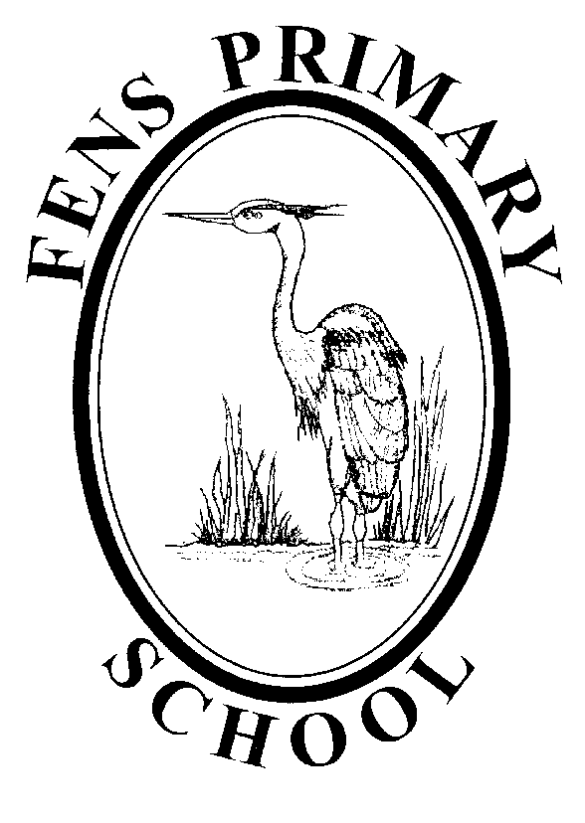

EARLY YEARS FOUNDATION STAGE POLICY
Policy review: October 2021
Next Review: October 2022

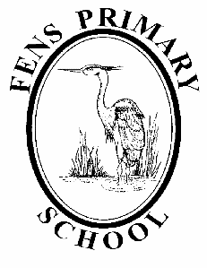
Fens Primary School EYFS Policy

Intent

Intent

At Fens Primary School we are passionate that all of our children have the very best start to their education, where perseverance, resilience and successes are celebrated and every child feels valued and respected. We endeavour to embed a language of learning and use metacognition to develop all children to be resilient lifelong learners.

The Early Years Foundation Stage (EYFS) applies to all of our pupils in Nursery and Reception. The curriculum for the Early Years Foundation Stage underpins all future learning by supporting, fostering, promoting and developing:

• positive attitudes and dispositions towards learning
• self-confidence and self-esteem
• respect for others as well as oneself
• social skills and emotional well-being
• a sense of community
• language for communication and thinking
• reading and writing skills
• problem solving, reasoning and numeracy skills
• knowledge and understanding of the world
• physical skills
• creative skills

We aim to build on the wealth of knowledge and skills children already have when they arrive in our early years, at different points in time and from a range of previous experiences e.g. day care providers, childminders and home. We actively develop relationships between home and school; recognising that parents/carers are a child’s first educator and support throughout their education.
We recognise that all children are unique, celebrating and welcoming differences within our school community. We strive to promote a love of stories and reading by planning teaching and learning based on themes around a range of traditional and popular children’s stories.

We strive to:

- Provide a curriculum that offers children a wide range of opportunities that broaden their experiences providing opportunities to try new things and encouraging them to relish a new challenge
- Provide high expectations of behaviour and engagement, encouraging children to develop perseverance and self-belief so that they can problem solve and be proud to achieve far more than they expected
- Provide a learning environment that promotes safety and independence, and allows all children to achieve their potential, with support for children who need additional help in order to maximise their chances of achieving the Early Learning Goals and therefore preparing them for the National Curriculum
- Support children’s speaking and listening development and model correct use of language and grammar
- Provide children opportunities to develop their sense of wellbeing and ability to regulate their feelings so that they feel confident in our community and are equipped with all the tools they need to transition to Year 1 effectively
- Ensure our staff are equipped with the skills and expertise to carry out their roles to the very best of their ability, always aiming higher
- Give our children at Fens the very best start with strong relationships between children, parents/carers, Key Stage 1 staff, other professionals and the local community

Implementation

Our curriculum in Nursery and Reception follows the revised ‘Early Years Statutory Framework for the Early Years Foundation Stage’, September 2021. This document specifies the requirements for learning and development in the EYFS and provides the Prime and Specific Areas of Learning we must cover in our curriculum.
Curriculum planning focuses on Development Matters and the Early Learning Goals, which includes seven prime and specific areas of learning and development:

Prime Areas
Communication and language development involves giving children opportunities to experience a rich language environment; to develop their confidence and skills in expressing themselves; and to speak and listen in a range of situations.
Physical development involves providing opportunities for young children to be active and interactive; and to develop their co-ordination, control and movement. Children must also be helped to understand the importance of healthy activity, and to make healthy choices in relation to food
Personal, social and emotional development involves helping children to develop a positive sense of themselves and others; to form positive relationships and develop respect for others; to develop social skills and learn how to manage their feelings; to understand appropriate behaviour in groups; and to have confidence in their own abilities

Specific Areas
Literacy development involves encouraging children to link sounds and letters and to begin to read and write. Children must be given access to a wide range of reading materials (books, poems and other written materials) to ignite their interest.
Mathematics involves providing children with opportunities to develop and improve their skills in counting, understanding and using numbers, calculating simple addition and subtraction problems; and to describe shapes, spaces and measures.
Understanding the world involves guiding children to make sense of their physical world and their community through opportunities to explore, observe and find out about people, places, technology and the environment.
Expressive arts and design involves enabling children to explore and play with a range of media and materials, as well as providing opportunities and encouragement for sharing their thoughts, ideas and feelings through a variety of activities in art, music, movement, dance, role-play and design and technology.

Through our knowledge of each child and observational assessments, the EYFS team plan exciting and engaging activities that develop children’s learning. Teaching and learning is carefully planned ensuring it is sequential and that new learning always builds upon prior learning. Our long term planning ensures the progression of learning from entry to Nursery and Reception to the Early Learning Goals (ELGs) at the end of the Reception year.

Weekly planning follows themes to take advantage of cross curricular links and to provide excitement and purpose to learning activities. This approach also allows for the development of transferable skills and a wide-ranging vocabulary; which underpins the children’s learning. Planning is adapted to meet children’s interests, making the most of those focused moments where the teaching and learning can be maximised in a one to one way with teacher and child. We also plan opportunities to learn about and promote British Values and differences of opinions.
As a school, we are aware of the predominant white British nature in our locality. To ensure our children have experience and understanding of diversity we actively promote the use of stories and events e.g. Black History Month. We also ensure that when covering topics such as ‘families’, we celebrate diversity by representing all kinds of families, and that our approach is non-stereotypical and models a range of gender roles. British Values are embedded in our curriculum by learning about different opinions, faiths and beliefs, being fair, respecting each other’s differences and celebrating strengths. We further support British values by celebrating a range of events such as The Queen’s Birthday.
To supplement our curriculum and provide enrichment activities we provide opportunities for our children to learn yoga and balance bikes with specialist instructors. We also plan enrichment celebration events at the end of each half term such as an Easter egg hunt, visit to the farm and a Mini-beast ball.

Children in EYFS learn by purposeful play and exploring, being active and thinking critically and creatively and this takes place both indoors and in our outdoor area. Leaning outdoors provides children with the opportunity to take measured risks and develop gross motor skills. Our outdoor area is open all year round and in all but the most challenging weather conditions.

As a school, we follow the ‘Letter and Sounds’ Systematic Synthetic Phonics Programme. This is supplemented with a wide range of physical and online resources to support the teaching of reading and writing. Daily Phonics sessions are adapted to meet the needs of all abilities. Children not on track to meet the end of term expected progress have carefully planned interventions to enable them to ‘catch up’. We also use ‘Letter Join’ to develop children’s letter formation and handwriting.

Our curriculum is adapted to meet the needs of all learners. We provide focused interventions for those children who are finding learning challenging and are not on track to meet expectations at the end of the year. Parents/carers are made aware of any concerns about progress at an early stage, to ensure that the children have every chance to achieve the Early Learning Goals. Parents/carers are kept up to date with information on interventions and are supported to help their child with learning targets at home.

Parental involvement is vital for children to reach their true potential. We engage with parents/carers regularly through initial information sharing, starting Nursery/School meetings, ‘Stay and Play/Learn/Sing with Me’, parent workshops, newsletters, ‘eSchools’ learning platform, email messaging service, termly parent consultations and operating an ‘open door’ policy.

In EYFS, we collect evidence of children’s learning through a variety of purposeful ways including observations, children’s individual workbooks, class shared journals, photographs, ‘Evidence Me’ app by ‘2Simple’, shared professional dialogue and moderating children’s recorded work with Year 1 teachers. As a team we have produced an ‘Expected Progress’ document to use as an assessment tool to carefully monitor children working at and towards the expected level each term, ensuring children are working towards the ELGs. This tool is not a checklist, it is to be used in addition to professional judgement and moderation between practitioners to attain which children are ‘on track’ to meet the ELGs by the end of the Reception year.

By the end of the Reception year, we provide opportunities for children to increase their independence in recording their work as appropriate to ensure they are well prepared for the transition to Year 1. We have transition meetings with Year 1 staff and the children spend time visiting their new classroom and meeting their next teacher.
All staff work relentlessly to ensure that children are surrounded by caring, supportive, and positive staff who love their role in providing a warm and nurturing environment for our youngest children in school. All EYFS staff have regular CPD and relevant up to date safeguarding, food preparation and paediatric first aid training.

Impact

The impact of the EYFS curriculum is reflected in the positive ethos shared between children, parents/carers and staff. Our children in Early Years demonstrate caring behaviour towards each other, an excitement and love of learning, confidence to share their ideas and views, understanding of the needs of others and are great ambassadors of our school.

Our attainment regularly exceeds the Local Authority and National average for Good Level of development year on year. Almost all our children make more than the expected steps of progress from their starting points. By the end of EYFS our children make a smooth transition into Year 1.
The Early Years provision features in all areas of the School Development Plan and has a rigorous plan for development each year. This is monitored and evaluated by the EYFS Lead, the Head teacher and designated link-governor Carol Menabawey.
Monitoring and Reviewing the Mathematics Policy
The policy will be reviewed annually by the EYFS Leader in consultation with the Staff, Headteacher, the Governors and the Chair of Governors to ensure that it meets the needs of every EYFS child at Fens Primary School.
It will be updated, modified or amended as necessary.
Signed:……………………………………………………….. Date:…………………
(EYFS Leader)
Signed:……………………………………………………….. Date:…………………..
(Headteacher)
Signed:……………………………………………………….. Date:…………………..
(Chair of Governors)

