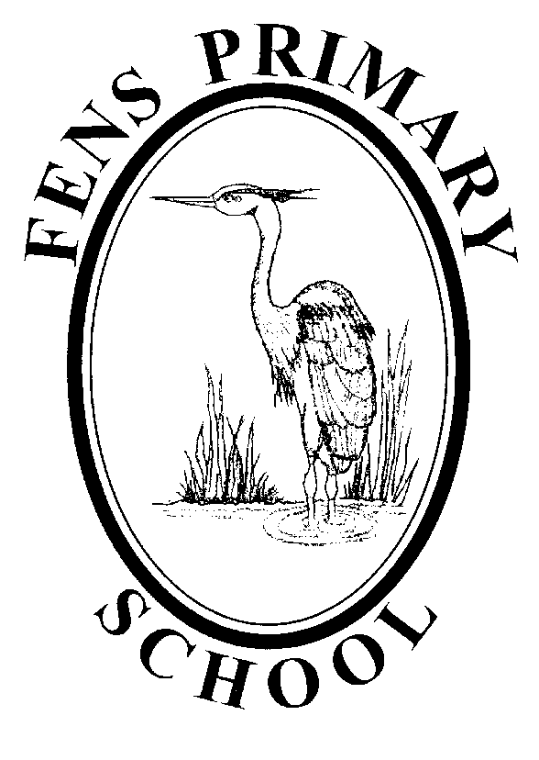

Art & Design Policy

Policy review: 2021
Next Review: 2022

Fens Primary School
Art and Design Policy

Our Art and Design Curriculum Intent
- To strive to be an ‘Evidence Informed’ school, taking into account the important role different forms of evidence can play in improving our school Art & Design curriculum through informing decision making and implementation practices that continually work to improve the outcomes of teaching and learning.
In order to achieve this goal, we will:
  - Engage with a wide range of research, related to both Art & Design and wider teaching and learning
  - Explore areas of school practice that can be improved and clearly define them for all school stakeholders
  - Prepare clear school development plans that outline how implementation activities and resources will be deployed to meet the intended outcomes
  - Deliver and Adapt implementation strategies, monitoring their effectiveness through developed school systems and a flexible and collaborative peer-to-peer approach to school improvement
  - Sustain and scale successful implementation practices to ensure they are embedded.

- Develop children’s awareness of their ability to self-regulate and think about their learning by sustaining and promoting the school’s metacognition agenda, in order to develop metacognitive strategies in conjunction with building a progressive understanding of Art & Design concepts.

In Fens School, we offer a structure and sequence of lessons that help teachers ensure they have covered the skills required to meet the aims of the national curriculum. Our intent is to ensure that all pupils produce creative, imaginative work that is individual to them, allowing each child to have ownership of their learning. We intend to give children the opportunity to explore their ideas and record their experiences, as well as exploring the work of others and evaluate different creative ideas.

Children will become confident and proficient in a variety of techniques including drawing, painting, printing, collage, textiles and 3d form. They will have a good knowledge and experience of different applications, allowing them to use metacognitive skills to produce their own, unique final piece.

Children will also develop their knowledge of famous artists, designers and craft makers. They will develop their interest and curiosity about art and design through a series of lessons that offer skills progression, knowledge progression and be given an opportunity to ask questions and demonstrate their skills in a variety of ways. The lessons will offer the chance for children to develop their emotional expression through art to further enhance their personal, social and emotional development.

How we implement our Art & Design Curriculum
Our lessons are delivered through innovative and inspiring units. Each unit comes with an overview of the skills and techniques required to successfully meet National Curriculum objectives, key vocabulary and additional resources to give our teachers and adults delivering art confidence in the progression of skills and knowledge.
Children in KS1 and KS2 have their own sketchbooks and portfolios that allow them to explore and experiment freely, using a variety of new skills and techniques. Sketchbooks are used as working documents and provide an opportunity for children to document the learning process and evaluate their own work. Sketchbooks and portfolios progress through school with the children allowing them to see their own unique learning journey in art.
Each year group focuses on different themes (linking to other areas of the curriculum where possible) to ensure continued interest in the subject as well as acquiring new knowledge. The lessons we plan for develop children’s techniques, including their control and their use of materials, with creativity, experimentation and an increasing awareness of different kinds of art, craft and design.

How we measure the impact on our Art & Design Curriculum
- Art and design learning is loved by teachers and pupils across our school.
- Teachers have high expectations of children and quality evidence can be presented in a variety of ways (sketchbook, displays, portfolios).
- All children use technical vocabulary accurately and pupils are expected to know, apply and understand the matters, skills and processes specified.
- Children improve their enquiry skills and inquisitiveness about the world around them, and their impact through art and design on the world.
- Children will become more confident in analysing, critiquing and evaluating their own work and giving their opinion on the work of others.
- Children show capabilities in improving their resilience and perseverance by continually evaluating and improving their work.
- All children in school can speak confidently about their art and design work and their skills.

Adapting our Art & Design Curriculum for ALL learners
-Special Educational Needs and Disability, Pupil Premium and More-Able

At Fens School all pupils have equal access to all areas of the Art & Design curriculum. A broad and balanced Art & Design curriculum is the entitlement of all our pupils regardless of background, ethnic origin, gender, class, attitude or disability. Our aim is to support the less able and challenge the more-able pupils so that they may all reach their potential.

Differentiation is planned into lessons to develop pupils’ ability whatever their level. This may be in the form of additional differentiated resources, support from the class teacher or a teaching assistant, targeted questioning as well as the pupils working individually or in groups.
Those pupils who are on the SEN register and have IEP’s are supported and taught according to their individual needs.

-SMSCD & PSHE

Staff ensure they help their pupils develop into self-assured, confident, happy, positive young people. Pupils learn to articulate their feelings and justify them in both informal and formal settings and are given responsibility and trust to develop their confidence. Staff encourage pupils to have the confidence to undertake difficult tasks and have a wide range of experiences. Artistic and creative achievements are celebrated through regular merit star assemblies, annual Art Weeks and through the school’s website. It is important for adults and older pupils in the school to act as role models for younger pupils.

Progression of Skills
By the end of each key stage, pupils are expected to know, apply and understand the matters, skills and processes specified in the relevant programme of study. We deliver our units with a focus on teaching seven key skills:
- Exploring and Developing ideas
- Evaluating and Developing work
- Drawing
- Painting
- Printing
- Textiles/Collage
- 3d Form
These skills form the foundations of our Art & Design curriculum.

Early Years Foundation Stage
Art and Design is encompassed through the specific learning area of ‘Expressive Art and Design’. Children are continually provided with opportunities to experience and explore the progressive skills through discrete teaching and continuous provision.

Planning

- Long Term Planning is based on the National Curriculum at a whole school level- See appendix 1
- Medium Term Planning is set for each year group, with each unit having clear objectives which are then included in the short term planning.
- Short Term Planning is on a weekly basis set on the agreed planning format. These take into account the needs of the particular abilities within the class and work is differentiated to meet those needs. Short term planning clearly shows the learning objectives for that lesson, the main input of the lesson, including key questions, and the organisation of adapted activities in order for learning to take place for all pupils.
- Assessment opportunities are built in to each lesson, with an assessment outcomes grid for completion after each lesson. Planning sheets are annotated with information regarding pupils’ progress, and difficulties or misconceptions are noted which will be addressed in future lessons.
- Teaching assistants make an important contribution to class, group and individual work and their contributions are planned into the lessons accordingly.

Resources

- All resource cupboards are well organised and clearly labelled to ensure that staff can access all materials quickly and efficiently.
- All art materials and resources are located in the central store in the upper school hall.
- Sketchbooks and portfolios can be found in the resource cupboard located in the staff room.
- The library contains a range of books that are for use by children and staff.
Any additional requests for resources must be handed in to the Art & Design coordinator.

Role of the Art & Design coordinator
- To provide leadership and direction in Art & Design.
- To promote high standards of teaching and learning.
- To be a positive role model for the teaching of Art & Design.
- To produce long term and medium term planning to match the national curriculum requirements.
- To bring new developments and ideas to the attention of the staff.
- To have a pivotal role in motivating, supporting and guiding staff in the planning and delivery of Art & Design.
- To review, monitor and evaluate planning and to scrutinise standards of pupils’ work.
- To evaluate standards achieved in Art & Design.
- To monitor and evaluate pupil achievement in relation to targets across the school.
- To provide internal CPD for staff to ensure continuing professional development.
- To attend network meetings.
- To ensure relevant resources are available and used effectively.
- To write, review and evaluate the Art & Design Development Plan which contributes to the School Development Plan.
- Promote Art & Design within the wider community

Assessment and Monitoring
- Assessment follows the guidelines in the Assessment Policy and is part of the school’s self evaluation process. It is based on the appropriate levels of attainment and is linked to learning objectives and learning outcomes. It is carried out to monitor pupils’ progress and achievements and ensure that individual pupil needs are being met.
- At the beginning of each Art & Design unit, year group teams look at the key skills and vocabulary of the medium term planning objectives which needs to be incorporated into planning, adapting and differentiating activities for their own cohort.
- Ongoing assessments inform weekly planning.
- Teachers plan ‘critique’ time into their lessons in order to evaluate children’s work and offer feedback.
- End of unit assessments assess pupils’ learning against expectations on the school’s agreed format.
- At the end of each Art & Design unit teachers make an assessment judgment as to whether pupils are working towards the expected standard, working at the expected standard or working at greater depth within the expected standard for each key skill area.
- Year group/ phase teams should moderate their judgements to ensure consistency.

The Art & Design Subject Leader monitors the planning and assessments. School needs for staff development, resources and assessment monitoring are linked in to the School Self-Evaluation timetable as part of the whole School Development Plan.

Class teachers report on pupils’ progress and attainment at parental consultations each term, as well as in their annual report to parents.

Evidence of pupils’ work is kept in children’s sketchbooks, portfolios and displays around school. Children progress through school with the same portfolio each year.

Arts Week
Each year at Fens, we hold an annual ‘Arts Week’ celebration. The objective for the annual event is to enhance the Art & Design curriculum at Fens by providing opportunities for children to apply their Art & Design knowledge and skills in a cross-curricular way.

Homework
Homework may be given to support activities within the classroom and will be set in accordance with the school’s homework policy.

Special Educational Needs and Disability

At Fens School all pupils have equal access to all areas of the Art & Design curriculum. A broad and balanced curriculum is the entitlement of all our pupils regardless of ethnic origin, gender, class, attitude or disability. Our aim is to support the less able and challenge the more able pupils so that they may all reach their full potential.

Differentiation is planned into lessons to develop pupils’ ability whatever their level. This may be in the form of additional differentiated resources, support from the class teacher or a teaching assistant, targeted questioning as well as the pupils working individually or in groups.
Those pupils who are on the SEN register and have IEP’s are supported and taught according to their individual needs.

Health and Safety
It is the responsibility of each teacher to make themselves aware of Health and Safety guidelines as detailed in the National Curriculum.
Children will be taught the safe handling of tools and materials and will be encouraged to develop a sense of safety for themselves and others.

Displays
Displays should be used to create a rich, challenging and lively environment for pupils to learn. Children’s work should be well displayed and displays should be titled and labelled with a context of work. They should be changed regularly and used to celebrate and value children’s achievements. Work across all ages and abilities should be included and reflect the curriculum we offer.
Display boards within communal areas, throughout the school, are allocated to each member of staff and should be changed on a regular basis.
The display in the entrance is a school council/merit winner board to be updated by School Council lead and British Values Coordinator.

Monitoring and Reviewing
The policy will be reviewed annually by the Art & Design Subject Leader in consultation with the Staff, Headteacher and the Governors to ensure it meets the needs of every child at Fens Primary School.

It will be updated, modified or amended as necessary.

Signed:……………………………………………………….. Date:…………………
(Art & Design subject leader)
Signed:……………………………………………………….. Date:…………………..
(Headteacher)
Signed:……………………………………………………….. Date:…………………..
(Chair of Governors)

