Dear Parent/Carer

We are delighted to introduce you to eSchools!

eSchools is our new online learning platform. We will be using it to set your child’s weekly homework and it is how we will conduct our home learning should the need arise.

Please see below the information you’ll need to login to your eSchools account:

Using the Platform
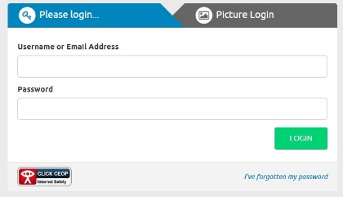
- Go to our eSchools page: https://fens-primary.eschools.co.uk/login and click on the login button.

- Enter your details:
Which your child has been given on a separate slip.
(please keep these safe and secure for future use)

- Support with using eSchools can be found on their website. If you click on the support tab on their website, this will take you to a section where you can access support material.

For further information and a quick video introduction to the eSchools platform please visit.

First Steps (eschools.co.uk)

You will be able to click on this link on the website and Facebook to take you straight to the relevant pages.
Your child will be given a homework book which, once taken home, can be kept at home permanently. This book can be used however you wish: you can print the homework directly from eSchools and stick it in the so you have a personal record of their work. Additionally, if you do not have a printer, you can record your work in the book after reading the questions from whatever device you are using.

Once this has been done, you can either scan the homework or take a photograph and upload it to eSchools. There is also a feature that enables you to type directly into eSchools to submit your homework. Having used it myself as a parent, it is very straightforward to use and uploading homework takes a matter of seconds.

This letter can also be found on our school website in the Pupil Section and on Facebook.

Downloading the eSchools App

Using the app

- Search ‘eSchools’ to find the free app in either the Apple App Store (iPhone) or Google Play (Android) or click on the link from your eSchools dashboard to download the app.

- Enter your details:
School Name (for app): [Fens Primary School]
Login details: As provided on the slip

- Within the app you’ll be able to view relevant information as well as receive notifications on the go.

- Ensure notifications are turned on within your phone settings, so you do not miss any important updates.

Thank you,

Mr C. Keen

