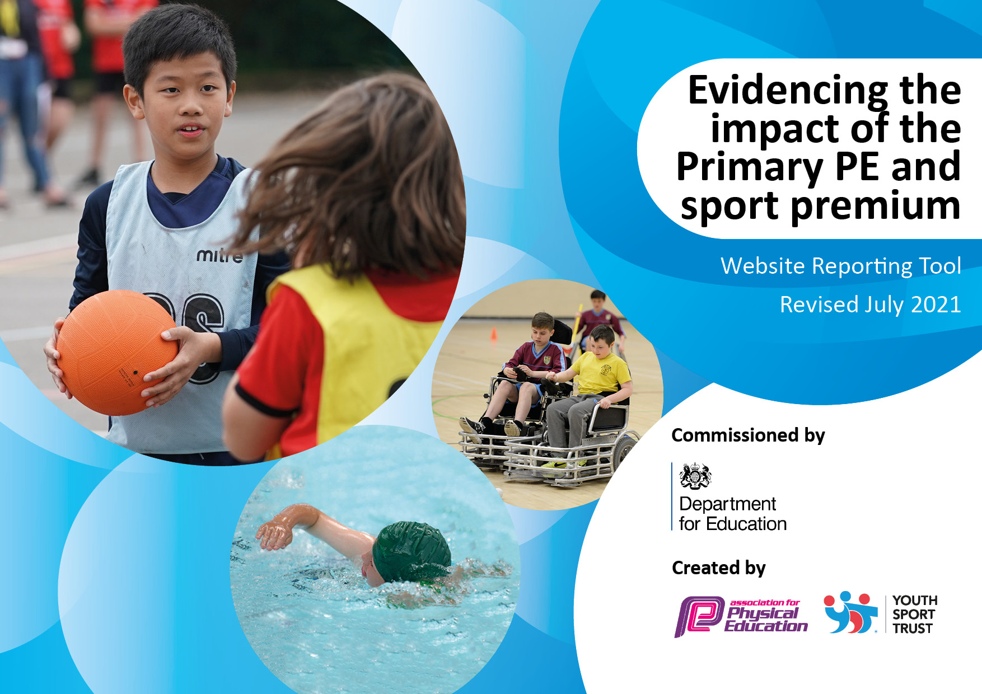
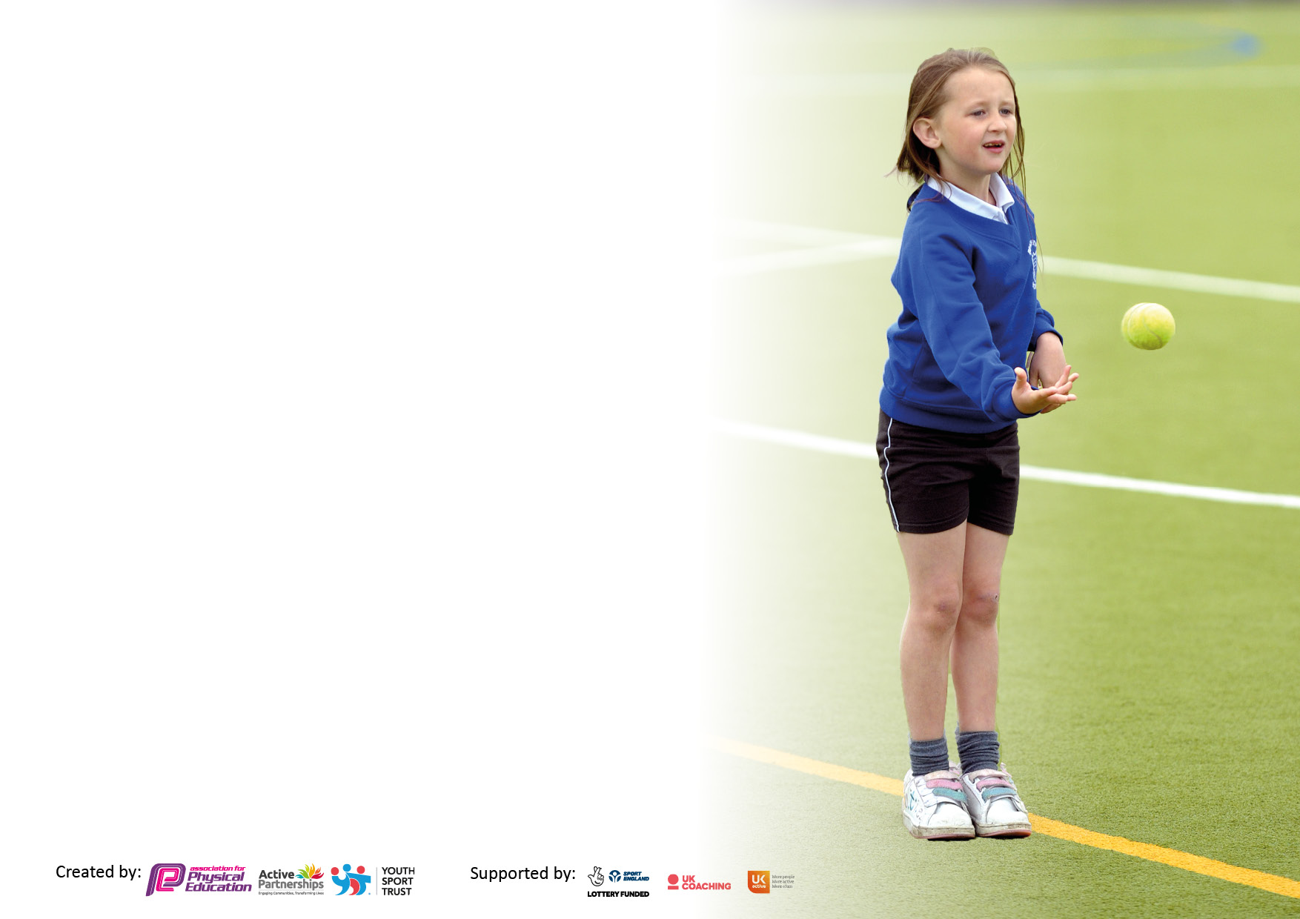

It is important that your grant is used effectively and based on school need. The Education Inspection Framework makes clear there will be a focus on ‘whether leaders and those responsible for governors all understand their respective roles and perform these in a way that enhances the effectiveness of the school’.

Under the Quality of Education Ofsted inspectors consider:
Intent - Curriculum design, coverage and appropriateness
Implementation - Curriculum delivery, Teaching (pedagogy) and Assessment
Impact - Attainment and progress

To assist schools with common transferable language this template has been developed to utilise the same three headings which should make your plans easily transferable between working documents.

Schools must use the funding to make additional and sustainable improvements to the quality of Physical Education, School Sport and Physical Activity (PESSPA) they offer. This means that you should use the Primary PE and sport premium to:

- Develop or add to the PESSPA activities that your school already offer
- Build capacity and capability within the school to ensure that improvements made now will benefit pupils joining the school in future years
- The Primary PE and sport premium should not be used to fund capital spend projects; the school’s budget should fund these.

Pleasevisitgov.ukfortherevisedDfEguidanceincludingthe5keyindicatorsacrosswhichschoolsshoulddemonstrate animprovement.Thisdocumentwillhelpyoutoreviewyourprovisionandtoreportyourspend.DfEencouragesschools to use this template as an effective way of meeting the reporting requirements of the Primary PE and sport premium.

We recommend you start by reflecting on the impact of current provision and reviewing the previous spend.

Schools are required to publish details of how they spend this funding, including any under-spend from 2019/2020, as well as on the impact it has on pupils’ PE and sport participation and attainment. All funding must be spent by 31st July 2022.

We recommend regularly updating the table and publishing it on your website throughout the year. This evidences your ongoing self-evaluation of how you are using the funding to secure maximum, sustainable impact. Final copy must be posted on your website by the end of the academic year and no later than the 31st July 2021. To see an example of how to complete the table please click HERE.
Created by: Supported by:

Details with regard to funding
Please complete the table below.

Total amount carried over from 2019/20 | £-140.00
Total amount allocated for 2020/21 | £19,477
How much (if any) do you intend to carry over from this total fund into 2021/22? | £17,285
Total amount allocated for 2021/22 | £19,430
Total amount of funding for 2021/22. To be spent and reported on by 31st July 2022. | £36,715
Swimming Data
Please report on your Swimming Data below.

Meeting national curriculum requirements for swimming and water safety.

N.B. Complete this section to your best ability. For example you might have practised safe self-rescue techniques on dry land which you can then transfer to the pool when school swimming restarts.
Due to exceptional circumstances priority should be given to ensuring that pupils can perform safe self rescue even if they do not fully meet the first two requirements of the NC programme of study
What percentage of your current Year 6 cohort swim competently, confidently and proficiently over a distance of at least 25 metres?  N.B. Even though your pupils may swim in another year please report on their attainment on leaving primary school at the end of the summer term 2021.  Please see note above | 77%
What percentage of your current Year 6 cohort use a range of strokes effectively [for example, front crawl, backstroke and breaststroke]?  Please see note above | 13%
What percentage of your current Year 6 cohort perform safe self-rescue in different water-based situations? | 15%
Schools can choose to use the Primary PE and sport premium to provide additional provision for swimming but this must be for activity over and above the national curriculum requirements. Have you used it in this way? | Yes/No

Action Plan and Budget Tracking
Capture your intended annual spend against the 5 key indicators. Clarify the success criteria and evidence of impact that you intend to measure to evaluate for pupils today and for the future.

Academic Year: 2020/21 | Total fund allocated: | Date Updated:
Key indicator 1: The engagement of all pupils in regular physical activity – Chief Medical Officers guidelines recommend that primary school pupils undertake at least 30 minutes of physical activity a day in school |  |  |  | Percentage of total allocation:
 |  |  |  | 45%
Intent | Implementation |  | Impact
Your school focus should be clear what you want the pupils to know and be able to do and about  what they need to learn and to  consolidate through practice: | Make sure your actions to achieve are linked to your intentions: | Funding allocated: | Evidence of impact: what do pupils now know and what can they now do? What has changed?: | Sustainability and suggested next steps:
- Ensure pupils have an extensive selection of playground equipment to increase engagement and physical activity. | -Balls, frisbees, howlers, skipping ropes, tennis bats and balls, stilts, foam balls and midi rugby balls, bean bags, scooper dupers and activity trackers.  - New equipment purchased to provide each class with a class set of playground equipment to encourage active playtime. | £3,360.43 | - All children active for at least 30 minutes a day, using equipment provided.  -Children have a greater awareness of the benefits of healthy, active lifestyles. | -Improved levels of activity and fitness from exposure to active playtime sessions and the of use playground equipment and activity trackers.  Next steps:  Re-introduce sports leaders to demonstrate and lead games during playtimes.  -Half termly competition, using the activity trackers, to see which classes and year groups are the least active.
2. Use of sports coaches for specific sports/activities and extra-curricular. | -External sports coaches used to widen the range of sports/activities on offer, including both PE lessons and after school sessions, including tennis and skipping sessions for competitions. | £7720.75 | School timetables show amount of the sports covered by external coaches, and with which classes.  -As a result of coaching/PE sessions, children can more confidently use a range of skills, such as ball handling and evading techniques.  -A larger uptake of children participating in local clubs as a result of coaching sessions and extra-curricular. | -Exposure to a wide range of PE lessons and active sessions leads to a greater improvement in skill and confidence thus encouraging the desire the continue with the sport.  Next steps:  -Monitor sports coaches to ensure they continue to add value to existing sports provision.  -Ensure children continue to build upon skills and techniques for a wide range of physical activities in 2x weekly timetabled sessions
3. Additional swimming lessons on top on core provision to ensure greater amount of children are achieving 25m. | -Children identified from previous years 5 and 6 which have not obtained 25m.  -Top up swimming lessons organised for those children. | £6,662 | Improved attainment in water confidence.  Increased levels of Y6 swimming 25m. | Children have fostered a love of swimming and a desire to continue its pursuit.  Next steps:  -Continue to monitor the percentage of children who have achieved 25m.
4. Living Streets travel tracker incorporated to promote active travel for the whole school. | - Each class in the whole school to have access for children to log their journey to school with a rewards scheme in place to encourage active travel. | £819.20 | - Each child can now log their journey to school. | Reward system in place to promote active travel and a healthy, active lifestyle.  Next steps:  -To monitor the percentage of active travel in the school and to put interventions in place if necessary.
5. Activity Trackers to promote greater activity at playtimes and dinner times | - Class sets of activity trackers for half termly competitions to identify which class/year group are most active during the day. | £1279.97 | Half termly competitions to encourage children to be more active at playtimes and dinnertimes. Promote active lifestyles as children will be able to track their steps throughout the day. | Half termly reward systems used to promote greater activity during the day.  Next Steps: Monitor activity of classes/ year groups and put interventions in place if necessary.
Key indicator 2: The profile of PESSPA being raised across the school as a tool for whole school improvement |  |  |  | Percentage of total allocation:
 |  |  |  | 35%
Intent | Implementation |  | Impact
Your school focus should be clear what you want the pupils to know and be able to do and about  what they need to learn and to  consolidate through practice: | Make sure your actions to achieve are linked to your intentions: | Funding allocated: | Evidence of impact: what do pupils now know and what can they now do? What has changed?: | Sustainability and suggested next steps:
Improve levels of equipment for teaching of PE | A new set of basketballs, gymnastic mats, rugby balls, rounders set with skills cards, electric pumps, jumps sacks, hurdles, speed bounce mat, long jump mats, dodgeball pack and agility ladders purchased to ensure replace old to ensure high quality equipment is available for PE sessions, extra-curricular clubs, coaching sessions and inter-school competitions. | £7461.22 | Children are enthusiastic to use new equipment and can further develop skills due to high quality resources.  Use of equipment in extra-curricular and coaching sessions clubs to broaden the range of sports children can participate in. | Children benefit from greater development of skills due to high quality equipment.  Next steps:  Continuous discussions with teachers to monitor quality and quantity of equipment.
End of year Sports Awards | Sporting awards provided to children who have excelled in PE/competitions during their time in the school. | £347.87 | -Pupil achievements celebrated to encourage and motivate wider participation. | Continue to review the achievement awards process and ceremony.  Next steps:  To use activity trackers to show achievements in physical activity for classes.
Sports displays and social media updates. | More displays used around school to demonstrate sporting activities. Regular sports news is shared via school Facebook page. This keeps families updated on sporting events/results. | N/A | -Parents/carers celebrate sporting success of the children, creating greater community links.  -more displays around school visualising the positive intake sorts has.  -A greater uptake in local clubs as a result of sharing taster sessions and participation on social media. | Continue to ensure regular communication occurs between school and parents/carers so sporting news is up to date and relevant.
School Website and School Games Website | Provide information on the school website of the various sporting events available in school. | N/A | Platinum Award achieved as part of the School Games Mark | To continue to apply and look at ways that can be improved.
Sports Kit for children | New kits purchased for a variety of sporting teams within the school. Logo embroidered onto kits to instil pride in representing the school. | £5,124.90 | When representing the school, there is enough kit representing the school colours for each child to be part of the team and promoting team unity. | Photos of teams during events and positive impact it has on the children being able to wear it during events with pride.

Key indicator 3: Increased confidence, knowledge and skills of all staff in teaching PE and sport |  |  |  | Percentage of total allocation:
 |  |  |  | 2%
Intent | Implementation |  | Impact
Your school focus should be clear | Make sure your actions to | Funding | Evidence of impact: what do | Sustainability and suggested
what you want the pupils to know | achieve are linked to your | allocated: | pupils now know and what | next steps:
and be able to do and about | intentions: |  | can they now do? What has
what they need to learn and to |  |  | changed?:
consolidate through practice:
Use of sports coaches to work alongside teachers to improve skills/confidence in teaching PE and sport. | -External PE coaches employed to deliver PE throughout the school. | £7720.75 (As identified from bullet point 2 in Key Indicator 1). | -Pupils have opportunities to experience a wider range of sporting activities.  -New ideas, taken from coaches, introduced and implemented in planning.  -Teachers use games/activities from coaching sessions within their own PE lessons.  -Greater teacher confidence when delivering PE lessons. | -Exposure to expertise tuition leads to a greater improvement in skill and confidence thus encouraging the desire to continue with the sport.  -Enhanced teacher skills and confidence are embedded in practice ensuring that the heightened curriculum is sustained.  Next steps:  -Ensure funding is available to be allocated for external coaches to deliver PE and provide CPD for staff.  - Seek out CPD courses for PE co-ordinators.  - Co-coordinators to look at the possibility of using CPD courses to upskill staff to lead after school clubs.
Get Set for PE Membership- full online access to a nationally recognised scheme. | Teachers can access lesson plans for the half termly topics.  Teacher to update and upskill using resources provided by the website. | £550 | Staff updated PE planning to ensure children are more engaged and inclusive in lessons. Enjoyment of PE lessons from the resources available. | Annual memberships.  Next steps:  Pupil and staff voice used to generate feedback.
Association for Physical Education Membership | School bought into membership which provides CPD opportunities | £180 | Staff given more opportunities to upskill and increase their confidence in the subject. | Annual membership  Next steps:  Pupil and staff voice used to generate feedback.
Key indicator 4: Broader experience of a range of sports and activities offered to all pupils |  |  |  | Percentage of total allocation:
 |  |  |  | 1%
Intent | Implementation |  | Impact
Your school focus should be clear | Make sure your actions to | Funding | Evidence of impact: what do | Sustainability and suggested
what you want the pupils to know | achieve are linked to your | allocated: | pupils now know and what | next steps:
and be able to do and about | intentions: |  | can they now do? What has
what they need to learn and to |  |  | changed?:
consolidate through practice:
Opportunities to experience different sporting activities | A range of taster sessions have been incorporated to provide children with a range of sports, which they may not have experienced before. E.g. Judo and Dance.  Change 4 Life multi sports club established using Sports Leaders and led by PE co-ordinator. | Judo- N/A  C4L- N/A  Dance-£350 | Children experienced a range of sporting activities not currently delivered in school. Children given possible exit routes from school into outside local clubs. | Improved pupil skills and confidence encourages greater participation in sport both inside and outside of school.  Next steps:  Continue to analyse class club sheets and registers used to encourage less active to participate in after school clubs.  Invite more outside clubs into school to ensure children are aware of local clubs.  Increase number of after school clubs led by school staff using equipment outlined in outcome 1.

Key indicator 5: Increased participation in competitive sport |  |  |  | Percentage of total allocation:
 |  |  |  | 20%
Intent | Implementation |  | Impact
Your school focus should be clear | Make sure your actions to | Funding | Evidence of impact: what do | Sustainability and suggested
what you want the pupils to know | achieve are linked to your | allocated: | pupils now know and what | next steps:
and be able to do and about | intentions: |  | can they now do? What has
what they need to learn and to |  |  | changed?:
consolidate through practice:
The Collective Cluster Sports Partnership | Fens Primary enter the cluster competition calendar to provide pupils from KS2 with the opportunity to take part in competitive and non-competitive tournaments. | £1050 | A wide range of KS2 children have attended both competitive and participation events. | Pupils involved in competitive and participation activity build confidence and desire to continue and further pursue sporting participation.  Next steps:  Every effort will be taken to ensure a wide range of children are able to compete in cluster competitions.
Youth Sport Trust Membership | Fens Primary School bought into YST membership. Resources were shared with the staff to use during PE lessons. | £210 | Termly personal challenges promoted and children now regularly set themselves a personal target to beat during PE sessions.  Resources shared with staff to incorporate in lessons and extra-curricular clubs. | Personal challenges have become a regular feature of PE lessons, providing children with opportunities to improve their attainment.  Next steps:  To update PE display boards with termly personal challenges.
Hartlepool Junior Schools FA Affiliation | School buys in to the FA affiliation to provide competitive competitions in Football. | £100 | Both boys and girls football teams have represented the school in competitive events. | To continue to provide children with competitive events.  Next steps:  To continue to provide football clubs to encourage both boys and girls to take part in football sessions.
Year 4 skipping festival project | School signed up to enter the Y4 skipping festival.  School received coaching sessions and a range of resources to assist and upskill staff. | £350 | Whole year group taught a range of skipping skills and techniques.  30 children selected to be part of the skipping team and represent the school in the skipping festival. | Children have developed a love for skipping and regularly apply their skills at playtimes and dinnertimes, leading to greater activity.  Next steps:  Sign up for skipping festivals for other year groups.
Transport | Hired coaches for children to attend events. | £2240.90 | Transport allows more children to be given the opportunity to participate in events. | Continue to use local travel companies to provide transport to events.

Signed off by
Head Teacher: | Mr Connor
Date: | 26.07.22
Subject Leader: | Mrs Todd and Mr Johnson
Date: | 25.07.22
Governor: | Mr Marshall  Mr Barbour
Date: | 26.07.22

