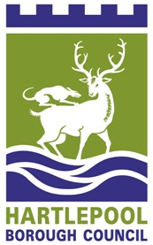
FENS PRIMARY SCHOOL

1. The name of the school is: Fens Primary School

2. The school is a community school.

3. The name of the Governing Body is "The Governing Body of Fens Primary School”

4. The Governing Body shall consist of:

- 2 Parent Governors

- 1 Local Authority Governor

- 1 Staff Governor

- 1 Headteacher

- 6 Co-opted Governors

- Total number of governors (11)

- This instrument of government comes into effect on 15th February 2023

- This instrument was made by order of Hartlepool Local Authority on 28th September 2022

8. A copy of the instrument must be supplied to every member of the governing body (and the headteacher if not a governor).

