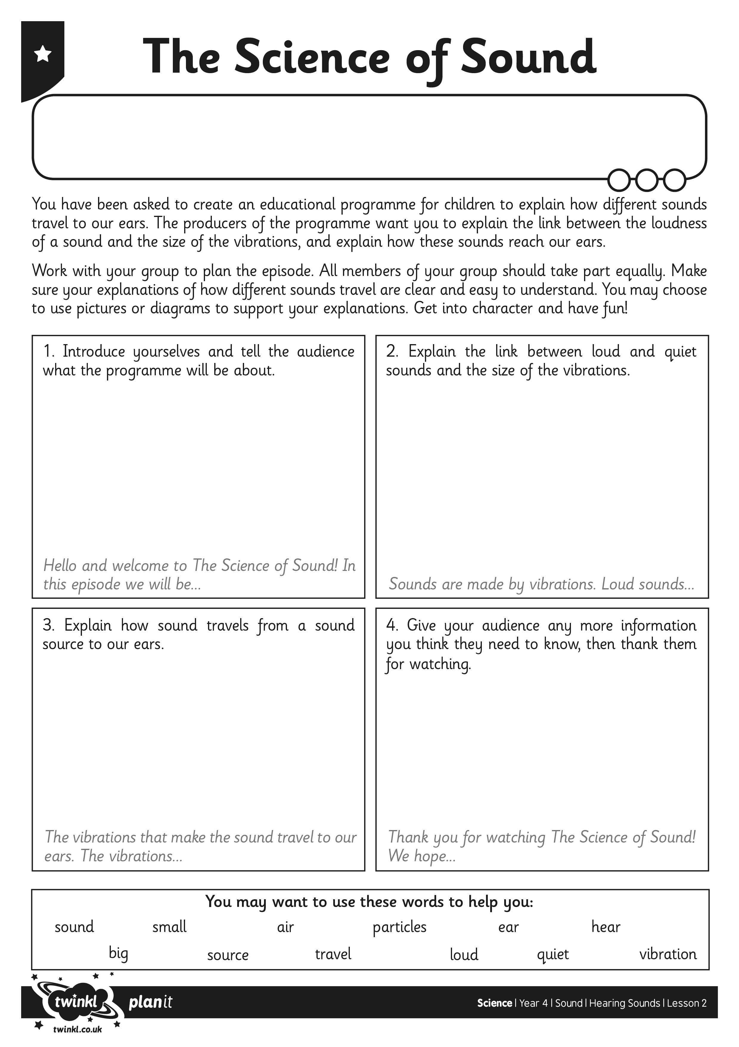
I can explain how loud and quiet sounds travel to our ears.
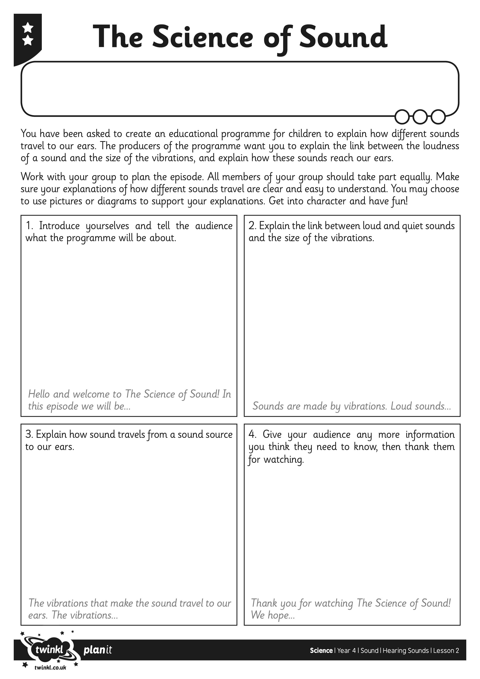
I can explain how loud and quiet sounds travel to our ears.
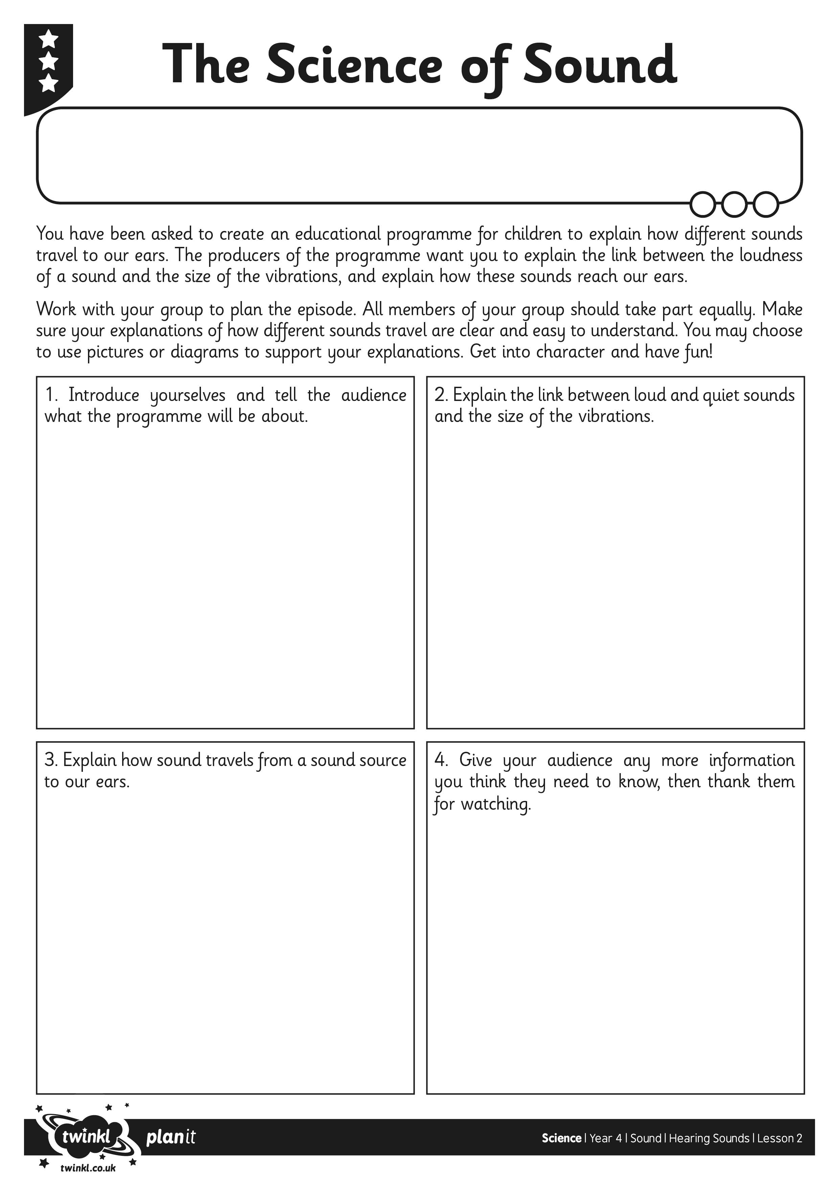
I can explain how loud and quiet sounds travel to our ears.

