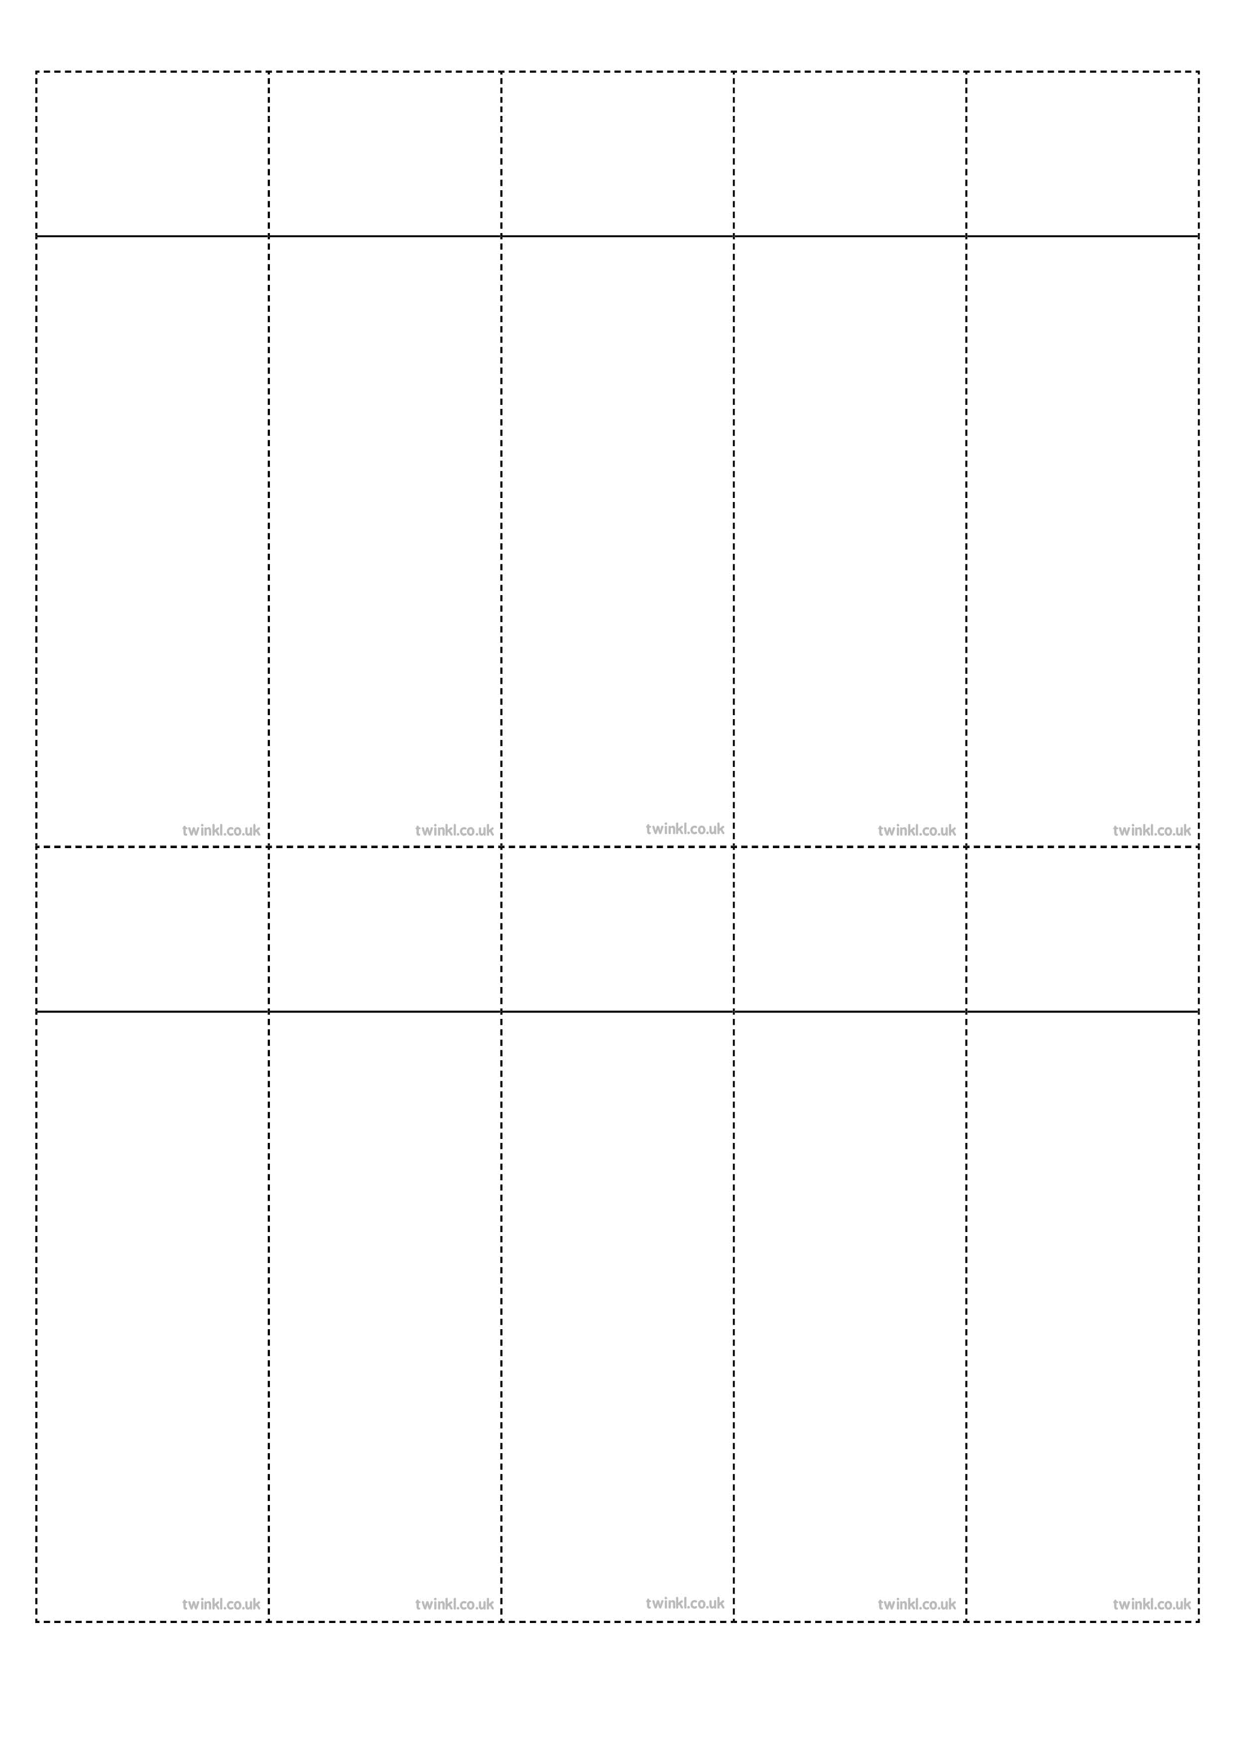
Week 3
Words with a short /u/ sound spelt with ‘ou’
enough
young
touch
double
trouble
country
courage
rough
tough
cousin
Week 3
Words with a short /u/ sound spelt with ‘ou’
enough
young
touch
double
trouble
country
courage
rough
tough
cousin
Week 3
Words with a short /u/ sound spelt with ‘ou’
enough
young
touch
double
trouble
country
courage
rough
tough
cousin
Week 3
Words with a short /u/ sound spelt with ‘ou’
enough
young
touch
double
trouble
country
courage
rough
tough
cousin
Week 3
Words with a short /u/ sound spelt with ‘ou’
enough
young
touch
double
trouble
country
courage
rough
tough
cousin
Week 3
Words with a short /u/ sound spelt with ‘ou’
enough
young
touch
double
trouble
country
courage
rough
tough
cousin
Week 3
Words with a short /u/ sound spelt with ‘ou’
enough
young
touch
double
trouble
country
courage
rough
tough
cousin
Week 3
Words with a short /u/ sound spelt with ‘ou’
enough
young
touch
double
trouble
country
courage
rough
tough
cousin
Week 3
Words with a short /u/ sound spelt with ‘ou’
enough
young
touch
double
trouble
country
courage
rough
tough
cousin
Week 3
Words with a short /u/ sound spelt with ‘ou’
enough
young
touch
double
trouble
country
courage
rough
tough
cousin

