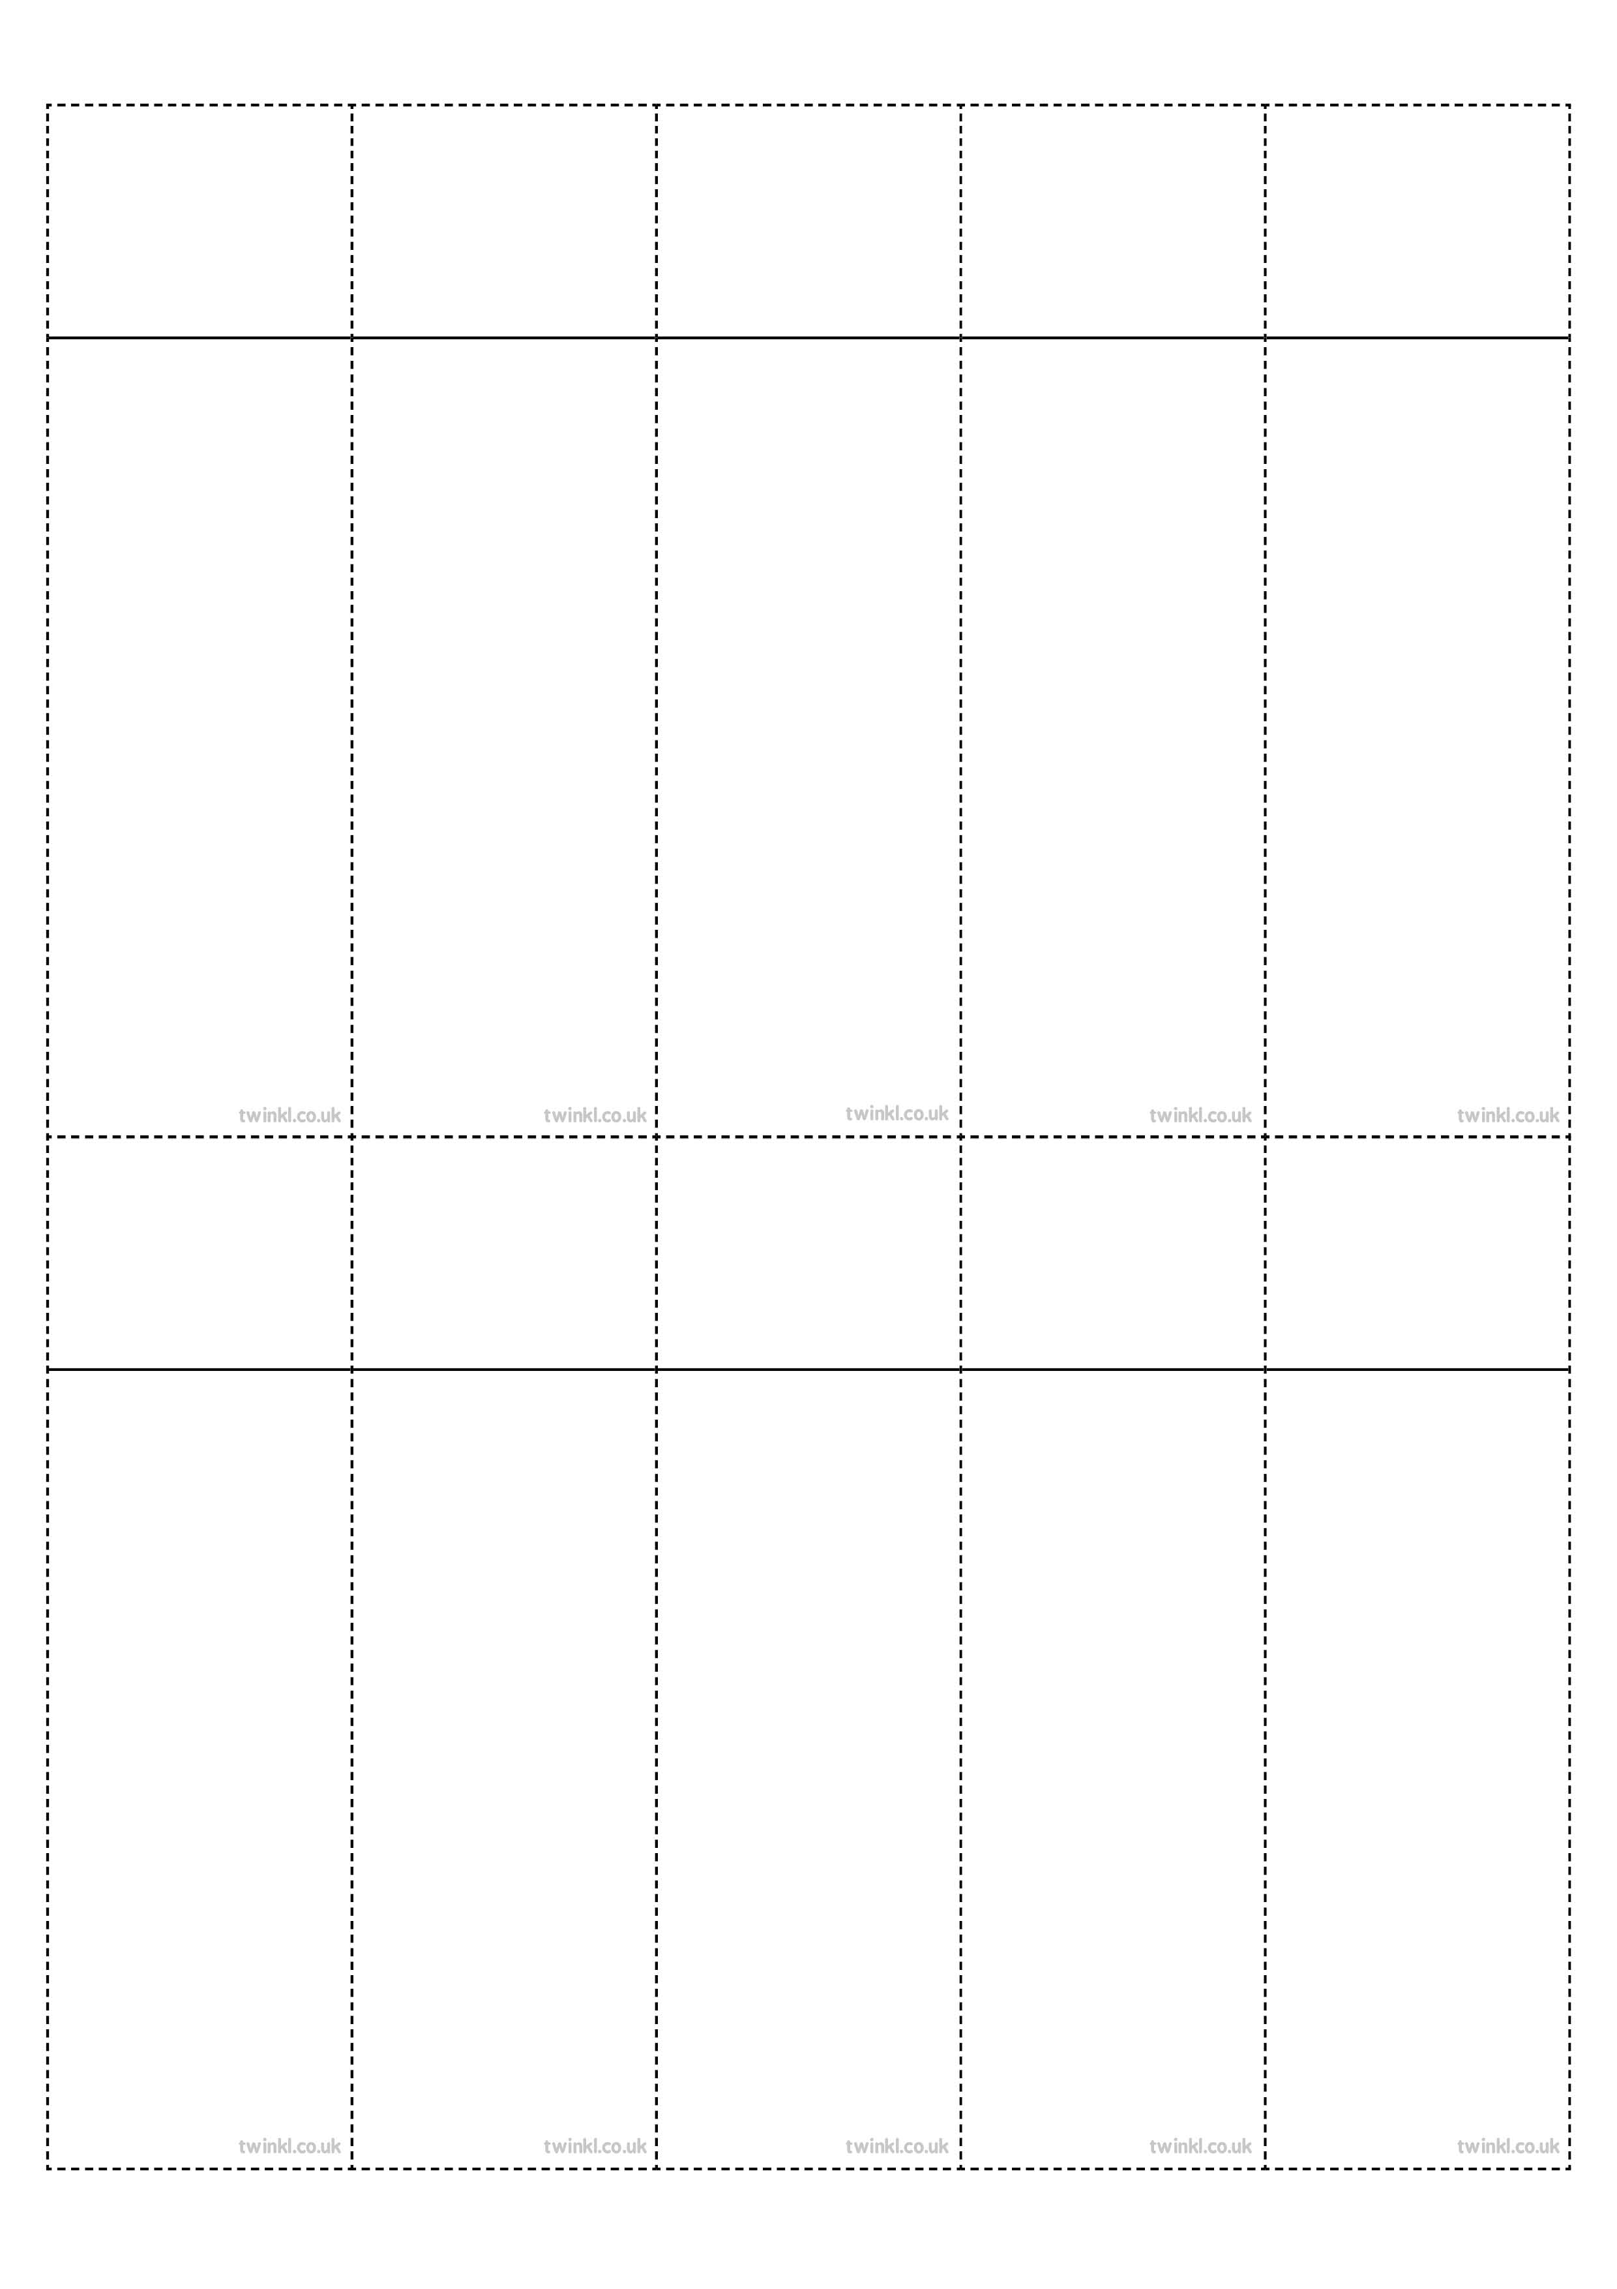
Week 6
Word families based on root words ‘press’ and ‘vent’
press
suppress
express
compress
impress
prevent
invent
venture
adventure
eventful
Week 6
Word families based on root words ‘press’ and ‘vent’

press
suppress
express
compress
impress
prevent
invent
venture
adventure
eventful

Week 6
Word families based on root words ‘press’ and ‘vent’

press
suppress
express
compress
impress
prevent
invent
venture
adventure
eventful

Week 6
Word families based on root words ‘press’ and ‘vent’

press
suppress
express
compress
impress
prevent
invent
venture
adventure
eventful

Week 6
Word families based on root words ‘press’ and ‘vent’

press
suppress
express
compress
impress
prevent
invent
venture
adventure
eventful

Week 6
Word families based on root words ‘press’ and ‘vent’

press
suppress
express
compress
impress
prevent
invent
venture
adventure
eventful

Week 6
Word families based on root words ‘press’ and ‘vent’

press
suppress
express
compress
impress
prevent
invent
venture
adventure
eventful

Week 6
Word families based on root words ‘press’ and ‘vent’

press
suppress
express
compress
impress
prevent
invent
venture
adventure
eventful

Week 6
Word families based on root words ‘press’ and ‘vent’

press
suppress
express
compress
impress
prevent
invent
venture
adventure
eventful

Week 6
Word families based on root words ‘press’ and ‘vent’

press
suppress
express
compress
impress
prevent
invent
venture
adventure
eventful

