- To access 2Email on Purple Mash click on the following:
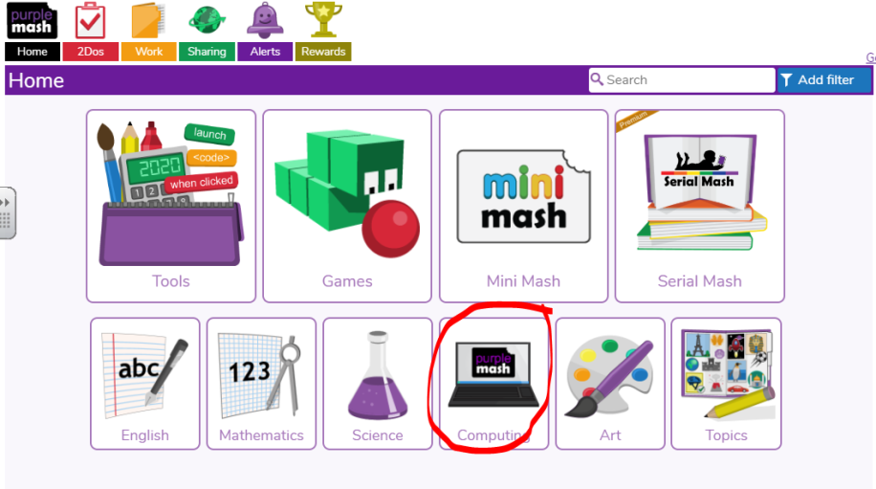

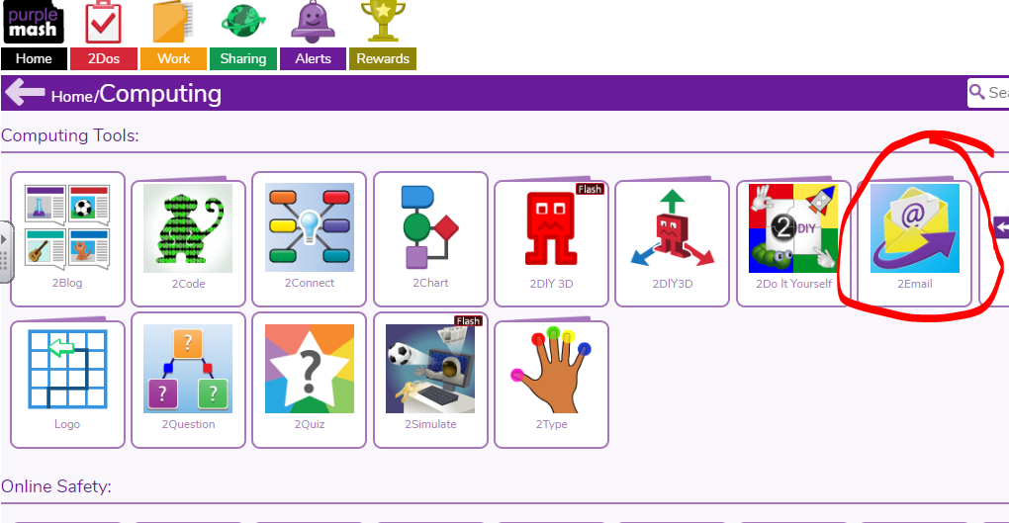

2. 2Email is a safe way of using email in school. You can only send and receive emails from people in our school and your teacher approves the emails you send. While we are using 2Email from home DO NOT send emails to children in other year groups or other teachers without permission from your class teacher.
3. When you open your inbox for the first time it will probably be empty and look like the image below. If you receive a new email you either go to your inbox or it appears as an alert.
Click on the envelope symbol circled to write your first email.

4. Once you are creating your email there are three important steps.

- Start typing the name of the person you want to contact in the To: box and then select their name from the options. If more than one person has the same first name make sure you double check you have chosen the correct person.
- Fill out the Subject box. This tells the person you are emailing what your email will be about e.g. All about me / Catching up
- Now it is time to write your email. Emails are very similar to letters. You start an email to a friend by using Hello/ Hi or use a more formal Dear, to speak to adults or people you don’t know as well. When you are finished, make sure you sign off with your name so people definitely know who the email was from!
Click the blue send button at the bottom when you are happy that your email is complete. Your email will then go to your class teacher to be approved before it is passed on to the person you wrote to.
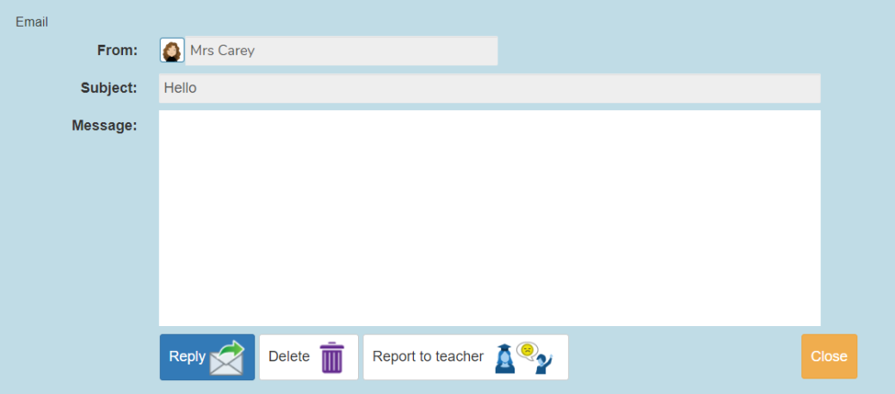
5. When you receive an email you need to click on it to read it.
After reading the email you have different options.
Use the blue reply button to respond to the email you got.
Click the orange close button to go back to your inbox if you do not want to reply but want to keep the email to read again.
If you do not want to keep the email, click on the delete button.
IMPORTANT – The report to teacher button is there in case you find something you are not happy about in the email and you think a teacher needs to check it. Hopefully you will not need this, as all our class emails are checked before you get them. If you press this button, the email will be reported to your teacher. Once you press this button, the email will disappear from your folder.

