Term 3B Week 7 (13th July)
English Maths
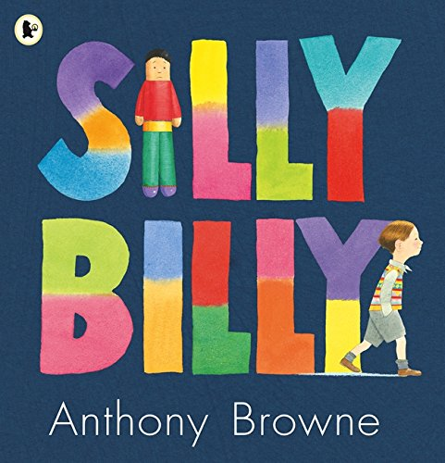  This week our activities focus on the book Silly Billy by Anthony Browne. You can access the story by listening to a read along on YouTube. There are many to pick from.  Task 1:  Before you read: What do you think the story will be about? What might happen?  As you read: Can you use the text and explain what type of things Billy worried about?  Why do you think he worried about rain/clouds/giant birds?  What does his dad mean by ‘it’s just your imagination?  Why do you think Billy was worried about staying at other peoples’ houses?  Can you explain why Billy’s grandma gave him worry dolls?  What does ‘slept like a log mean?’  Why do you think this book is useful?  Can you empathise with Billy? What do you worry about? How do you resole your worries?  Task 2: Follow the instructions below to create your own worry doll. Once you have made your doll you can whisper any worries or concerns you have into your doll. Then put your doll under your pillow.  1. Chn to be given a wooden peg and design their face on the top.  2. Chn to be given a choice of fabric to create a body.  3. Pipe cleaners will be used to create arms.  If you are unable to access the text, alternative work can be found on https://www.thenational.academy/ or https://www.bbc.co.uk/bitesize/tags/z7s22sg/year-2-and-p3-lessons/1  Resources: Spellings, handwriting sheet and word search | White Rose Week 12  Lesson 1 - Telling time to 5 mins  Lesson 2 - Hours and days  Lesson 3 - Find durations of time  Lesson 4 - Compare durations of time  Videos to support completion of each sheet can be found at https://whiterosemaths.com/homelearning/year-2/  If children need to recap telling the time to the nearest hour/ half hour, worksheets are available on the year 1 home learning page.  Extra work linked to each daily lesson available on https://www.bbc.co.uk/bitesize/tags/z7s22sg/year-2-and-p3-lessons/1  PSHE  While this year has definitely not been a normal Year 2 experience, we still have lots of memories we shared together. Reflect on the year and fill out the school year memory sheet to help you think of your favourite moments. Once you have finished that, have a go at the lockdown memories sheet to think about all the learning you have done since working at home.  Resources: School memories sheet, lockdown memories sheet

