[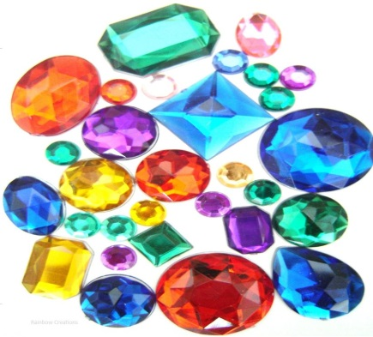](https://www.google.co.uk/url?sa=i&source=images&cd=&cad=rja&uact=8&ved=2ahUKEwi3-vinjKHbAhXHPRQKHVXXB-EQjRx6BAgBEAU&url=https://www.rainbow-creations.co.uk/acrylic-jewels-p-696.html&psig=AOvVaw27cxvaZ33S_B6byVigVDtW&ust=1527345710385579)[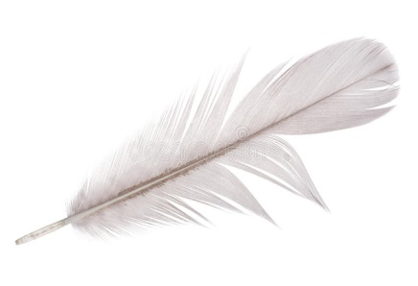](https://www.google.co.uk/url?sa=i&source=images&cd=&cad=rja&uact=8&ved=2ahUKEwi1uKH_i6HbAhXCVRQKHQF3Ce4QjRx6BAgBEAU&url=https://www.dreamstime.com/stock-photography-light-grey-goose-feather-white-isolated-background-image35174482&psig=AOvVaw0YwWq7vyLx1eI7BbWQnAsT&ust=1527345616368922)**A goose feather**

**some jewels**

[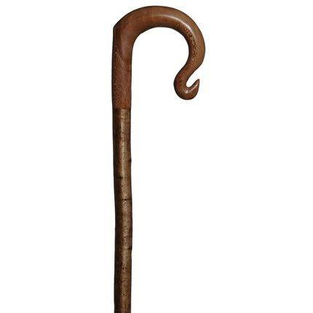](https://www.google.co.uk/url?sa=i&source=images&cd=&cad=rja&uact=8&ved=2ahUKEwjehMjBjKHbAhVBbRQKHfgJCPsQjRx6BAgBEAU&url=https://www.walkingsticksonline.co.uk/new/walking_sticks/hh-shepherds-crook.php&psig=AOvVaw2R0ykCXSW68jHhye-TsXPl&ust=1527345763242474)

[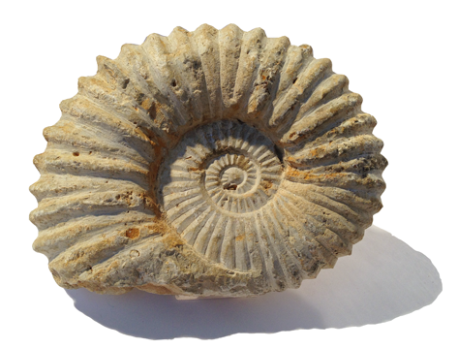](https://www.google.co.uk/url?sa=i&source=images&cd=&cad=rja&uact=8&ved=2ahUKEwi6iZbejKHbAhVHXBQKHQugA2cQjRx6BAgBEAU&url=https://fossilslondon.com/shop/ammonites/agadir-ammonite/&psig=AOvVaw2OIcx_uiz6jYlf0pu6taI_&ust=1527345816767594) **A shepherd`s crook**

**An ammonite**