Habitats
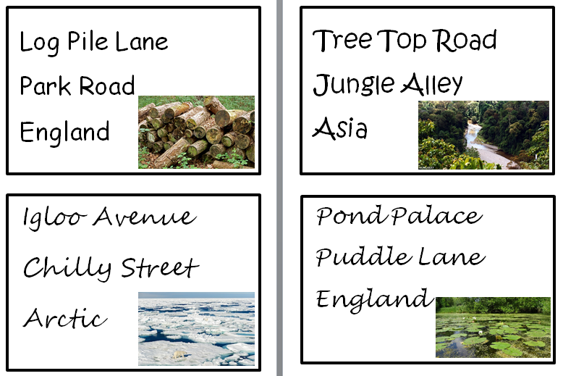
Looking at these addresses what types of animal would you expect to find?

What would it be like to live in these places? Why would a frog live in the pond and not in the artic?

