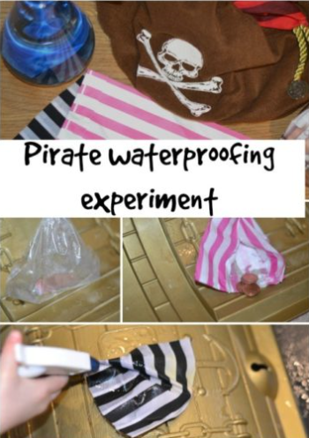

**Instructions**

1. Make 5 bags made from different materials (plastic, paper, tinfoil, tissue etc) (Choose your own materials)
2. Ask the children to feel the bags and see if they know what material each bag is made from. Can they describe each bags properties e,g strong, flexible, thin, hard, soft etc Then ask your child to predict which bag will keep the coins the driest and explain why they made those predictions.
3. Put some coins in each bag (paper, cloth, plastic ) before spraying with water and then examining the coins.
4. Spray the bags one at a time with water. Check the bags after 5 sprays and 10 sprays. What do you notice? What happens if you shake the bag?
5. Can you order the bags from waterproof to least water proof? Take photos if you can.

You will need:

* Coins
* Different types of materials to make bags for example:
* Plastic bag
* Paper bag
* Cloth bag
* Tinfoil bag
* Tissue bag
* Spray bottle
* Water