**Spreading My Wings**

**from Year 1 to Year 2**

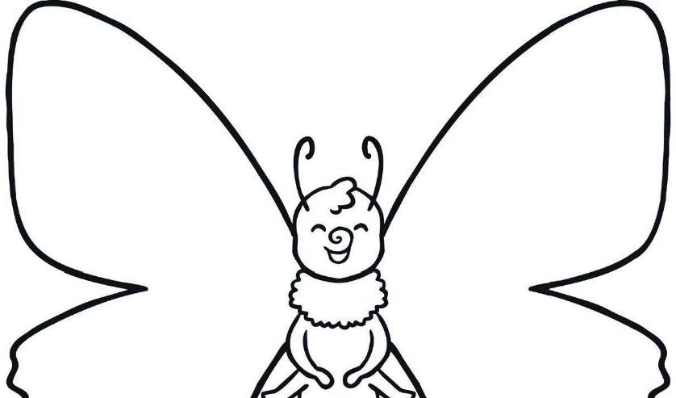

Name:

My favourite thing about school is...

My friends at school are…

Three feelings about moving to Year 2 …

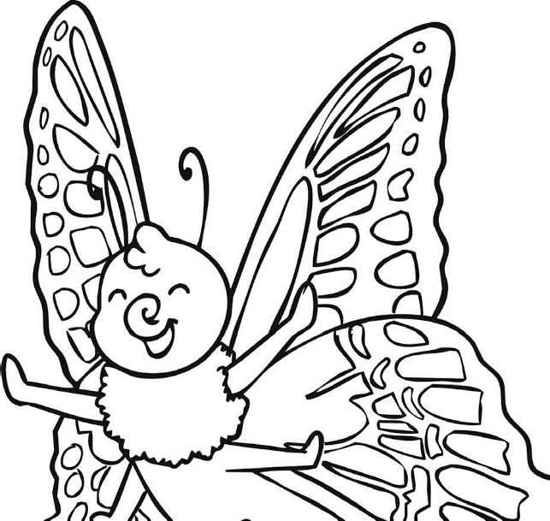

A picture of me with my friends:

My favourite thing to in school is :

I am looking forward to...

I would like to get better at...

I would like to learn...

I am good at...

I enjoy learning about...