I’ll huff and I’ll puff experiment
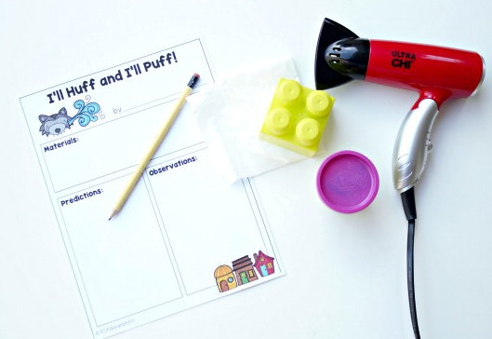
“I’ll huff and I’ll puff, and I’ll BLOW your house down!” is one of our favorite parts to read aloud and enact when reading The Three Little Pigs. This wind science experiment can be performed rather easily by just grabbing a few objects from around your house.
First read The Three Little Pigs, giving attention to the materials chosen and blown down. Then put on your thinking caps and perform this science experiment.
To set up this science investigation, gather 3-5 items of varying weight. For example: a tissue, paper, pencil, a plastic lego block, and a toy etc.
Get a hair dryer. Before you begin blowing with a hair dryer, ask your child to predict which items would be blown away by the wolf’s huffing and puffing. Record these predictions on the prediction and observation sheet. Ask your child to draw a pictures and label their pictures.
Once predictions are made, test the materials. One by one, set each item down on a flat surface and BLOW! Discuss which objects blew away easily and try and give reasons for their answers.

