Fens Primary Home Learning
Year 1 Week beginning 13th July- 17th July 2020
Here are some suggested activities. Pick and Choose the activities you would like to do with your child
English  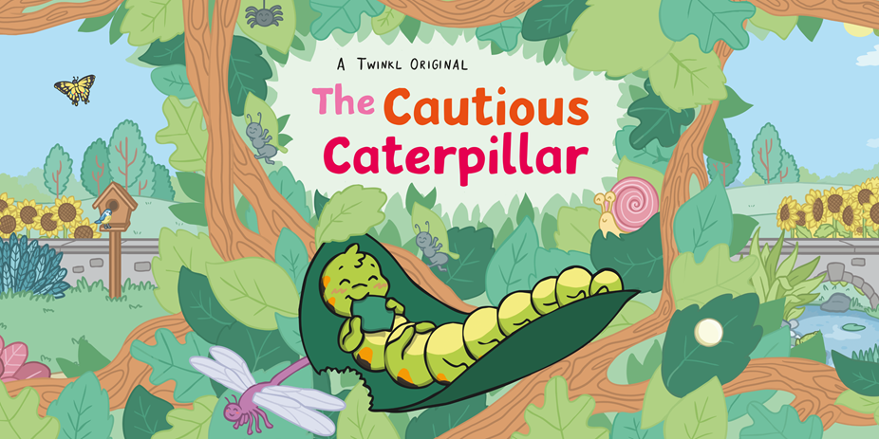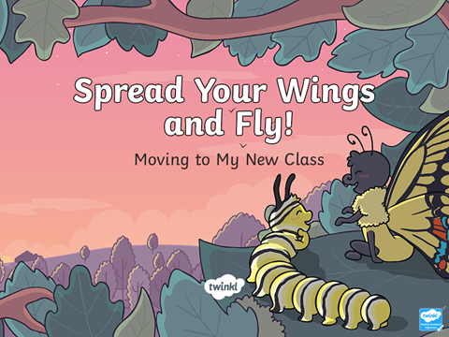  Read Power points The Cautious Caterpillar and Spread your wings and fly! Discuss the key questions and talk about how they are feeling about moving to Year 2. Discuss how change can be good. What good things will happen in Year 2? New teacher, see friends again, new topics, PE, computing etc….  Complete Spreading my wings from Year 1 to Year 2 booklet  https://central.espresso.co.uk/espresso/primary_ uk/subject/module/frontscreen/item1162916 /gradef/index.html  https://central.espresso.co.uk/espresso/primary_uk /subject/news/video/item855957/grade1/index.html? source=search-all-all-all-all&source-keywords=back%20to%20school  Write a letter to your new teacher describing about yourself. See template for ideas. Email your finished letters to our Year 1 email address and we will pass them onto your new teacher.  Learn about contractions (he + will = he’ll) . See powerpoint and worksheet.  Learn about compound words (tea+pot= teapot) See https://www.bbc.co.uk/bitesize/topics/zcgv39q/articles/z38t6fr and powerpoint. Then complete worksheet or make up your own cards and match them together to see if you have made a compound word. | Maths  This week is a recap of topics covered so far during Home Learning  Money: https://central.espresso.co.uk/espresso/primary_ uk/subject/module/frontscreen/item849256/grade1/index.html?source=subject-Maths-KS1-Maths-Resource%20types  Time: https://central.espresso.co.uk/espresso/primary_uk /subject/module/frontscreen/item849349/grade1/index.html?source=subject-Maths-KS1-Maths-Resource%20types  Addition and Subtraction: https://central.espresso.co.uk/espresso/primary_uk/ subject/module/frontscreen/item736870/grade1/index.html?source=subject-Maths-KS1-Maths-Resource%20types  Measures: https://central.espresso.co.uk/espresso/primary_ uk/subject/module/frontscreen/item849225/grade1/index.html?source=subject-Maths-KS1-Maths-Resource%20types  Fractions: https://central.espresso.co.uk/espresso/primary_uk /subject/module/frontscreen/item883167/grade1/index.html?source=subject-Maths-KS1-Maths-Resource%20types  Place Value: https://central.espresso.co.uk/espresso/primary_ uk/subject/module/sub_modules_index/item784742/grade1/index.html?source=subject-Maths-KS1-Maths-Resource%20types  See Key stage 1 Maths section for more topics and activities
Science and Geography  Watch the video clips and complete the online activities  https://central.espresso.co.uk/espresso/primary_uk/subject/module/video index/item376103/grade1/index.html  - Discuss the season Summer  - Complete the worksheet In the Summer I see…  - Be a weather person for a week and record the daily weather, temperature etc. (Use sheet)  - Design an outfit for the summer | History  Ask your child what they think ‘history’ means. What comes to mind when they hear that word. Explain that history is something that has happened in the past. What happened 1000 years ago, 100 years ago, 10 years ago, and even what happened yesterday is all history. Every time we write our ‘News’ – we are writing about past history.  Activity 1: Ask your child to draw a picture of an event they remember from when they were younger. It may be a wedding or other special occasion like birthday or holiday. It might be a representation of when they were babies or toddlers. Encourage your child to write a few sentences about the special event.  Activity 2: Create a timeline of your life and include key events and dates. You might like to add some drawings or photos. We look forward to seeing some of your timelines when we get back to school.  