Fens Primary Home Learning
Year 1 Week beginning 29TH June – 3RD July 2020
Here are some suggested activities. Pick and Choose the activities you would like to do with your child
English  Read or watch the story Rainbow fish https://www.youtube.com/watch?v=ifXlc0QI2kY  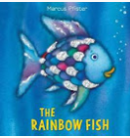  Discuss what you liked/disliked about the story. Find your favourite page/part and discuss what is happening on it. Can you retell the story to an adult? Try and use expression and change your voice for the different characters.  Colour in the sequencing sheet pictures and cut out and sequence in the correct order.  Story Writing- Choose another rainbow animal e.g. a rainbow bird, butterfly or even a unicorn! Draw a storyboard or write a story about them. What might happen to them?  Descriptive writing- Use the writing frames to choose your favourite sea creature and write a few sentences to describe it. E.g. A Jelly fish is wobbly and bright. | Maths  Money songs  https://www.youtube.com/watch?v=jHkUPDjum_E  https://www.youtube.com/watch?v=vs8F_g3MGtM  Please try and complete White Rose lesson each day  Watch the videos online then download the worksheets from our school website  https://whiterosemaths.com/homelearning/year-1  Monday: Ordering numbers  Tuesday: Recognising coins  Wednesday: Recognising notes  Thursday: Counting in coins  Friday: See attached sheet for practical ideas using coins  Extras  Watch Bitesize Maths lessons on theme of coins  https://www.bbc.co.uk/bitesize/topics/zp8dmp3  https://www.bbc.co.uk/bitesize/clips/z8f34wx  Games using coins  https://www.topmarks.co.uk/Search.aspx?q=coins
Geography  Look at a globe or world map and discuss the seas and the oceans. Read through power point Oceans of the world.  Can you learn some?  What is the biggest/smallest?  Can you label the ocean on the map attached? | Science  Watch Animals that live in the sea. Choose your favourite sea creature and write a fact file about them https://www.bbc.co.uk/bitesize/clips/zmxqxnb  How to grow a Rainbow (See attached sheet)  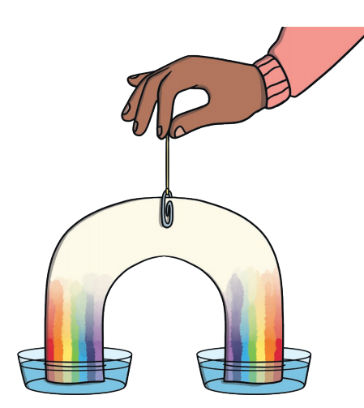
PSHCE  The Rainbow Fish gave away is prize possession, his scales. What is your prized possession? Draw a picture of it and write a sentence to say why it is special to you.  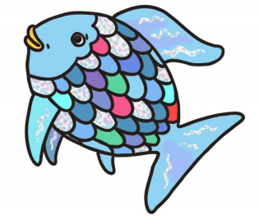  The Rainbow fish learnt how to be a good friend. Tell an adult at home about the different ways to be a good friend or Design a poster to show how to be a good friend. | DT/ Art  Draw/ Create your own Rainbow fish  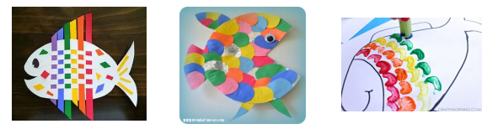  Shoe Box Ocean Scene- Using a shoe box or cereal box; decorate/paint the inside to look like an ocean scene. You can make sea creatures and attach them to the box with string through the roof.  