Fens Primary Home Learning
Year 1 Week beginning 6th July – 10th July 2020
Here are some suggested activities. Pick and Choose the activities you would like to do with your child
English  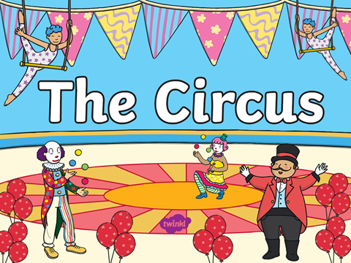 Look at the Circus powerpoint and discuss the pictures. Have you ever been to a circus? What did you see? What was your favourite act?  Write a setting description about the Circus. Use your senses to help you. What can you see, smell, hear, taste and touch?  Watch https://www.bbc.co.uk/iplayer/episode/b0528ngd/lets-play-series-2-21-clown Design your own clown and write a character description using adjectives. My clown has a big, red nose.  An animal has escaped from the zoo. Choose which animal has escaped and write an escaped poster. (See Escaped sheet template)  Who am I? Choose a person/ act from the circus and write down clues for someone to guess who you are describing. For example I have a red coat. I have a big black hat.  Complete Clown School and Day at the Circus Reading comprehensions  Instructions - Get the children to come up with a new act for the circus and have them write instructions on how to perform the act. | Maths  This week we will be focussing on telling the time  Look at Power point Telling the time  Watch the following links  https://www.bbc.co.uk/bitesize/topics/zhk82hv/articles/zcmdwxs  https://www.bbc.co.uk/teach/supermovers/ks1-maths-telling-the-time/zk4t8xs  Activities  - See attached White Rose Maths sheets  - Draw pictures of your daily routine and say what time you do each activity e.g. I get up at 7 o’clock  - https://www.topmarks.co.uk/Search.aspx?q=telling%20time Lots of online games to help learn to tell the time  - Make a clock or a watch  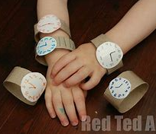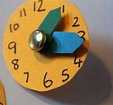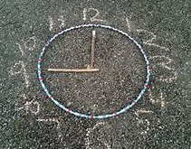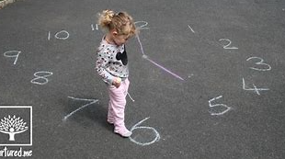
PSHE  Discuss what acts people do in the circus e.g. juggling, riding a unicycle etc… Think and discuss what special talents you have. Are you good at dancing, riding a bike, gymnastics or balancing things on your head?  If you joined the circus what act would you do?  Design your costume.  Design what your mask or face would look like. Would you wear face paint?  Perform your act to your family.  Take photos and email them to us.  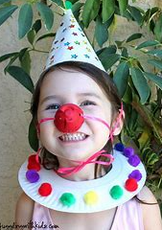 | DT/ Art  - Design and build large circus big tops using boxes and other materials Or make a big top den  - Paint an egg with a clown face or paint each other’s faces as clowns.  - Make a clown Sunday with ice cream and a cone or clown cupcakes  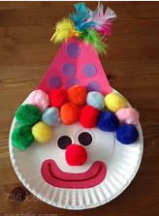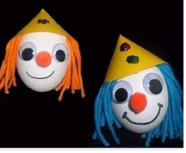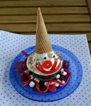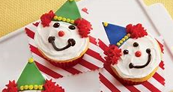
Movie Night  Cuddle up on the sofa with sweets/ popcorn and have a movie night with your family and watch Madagascar 3 Europes Most Wanted.  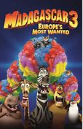 | PE  Learn circus skills  gymnastics  juggling  balancing things on your head  ball skills  Walking along something thin like a tight rope  Make balloon animals

