Fens Primary Home Learning
Year 1 Week beginning 4th May – 8th May 2020
Here are some suggested activities. Pick and Choose the activities you would like to do with your child
English  Activity 1: Watch BBC Bitesize “When to use question marks”  https://www.bbc.co.uk/bitesize/tags/zjpqqp3/year-1-and-p2-lessons/1  Can you write 5 questions using a question mark e.g. What is your pet called? Try and link to minibeasts e.g. How many legs does an ant have?  Activity 2: Can you remember what a noun is? (A noun is a person, place or thing) Go on a noun hunt around your house. See attached worksheet.  Activity 3: Watch Bitesize using Nouns and joining words to write about minibeasts. Choose a Bitesize activity linked to this lesson.  Activity 4: Choose your favourite minibeast and write a few sentences. For example: I am a spider.  I have 8 legs.  I can make webs. | Maths  Watch Jack Hartman on Youtube Counting songs  Please try and complete White Rose lesson each day  https://whiterosemaths.com/homelearning/year-1/  Extras  Watch Bitesize Maths lessons e.g Counting on and back in 1s  https://www.bbc.co.uk/bitesize/tags/zjpqqp3/year-1-and-p2-lessons/1  Games:  - Choose 5 numbers from 1-100 and write them on your whiteboard. Play Bingo with your family.  - Topmarks has lots of interactive maths games to access e.g.  https://www.topmarks.co.uk/learning-to-count/place-value-basketball  - Play Guess my shape with an adult. Describe a shape and see if your partner can guess what it is. e.g My shape has 4 sides. 2 long sides and 2 shirt sides. It has 4 corners.
Phonics  www.phonics play.co.uk  username: march20 password: home  Activity 1: Play Daily Flash cards using phase 3,4 and 5 sounds  Activity 2: Pick a Phase 5 sound each day e.g. oy and play Buried Treasure or Picnic on Pluto.  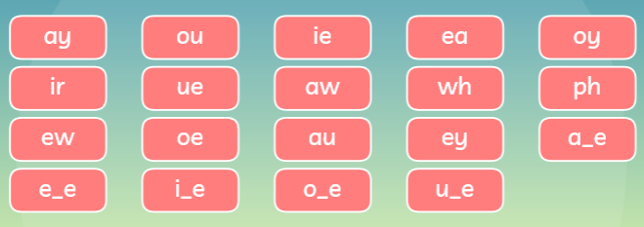  Activity 3: Watch Geraldine the Giraffe or Alpha Blocks on youtube with that sound.  Activity 4: Try and write some words with that sound (boy, toy, royal)  Activity 5: Try and write a sentence using the words e.g The boy had a toy.  Science  This week we our main focus is minibeasts. Here are some suggested activities you could do at home.  Activity 1: Read Minibeast powerpoint then go on a minibeast hunt around your garden or when you are out on your daily walk.  Activity 2: Make a womery or a Minibeast hotel  Activity 3: Complete Reading comprehension on Minibeasts  Activity 4: Make different length worms with playdoh and order them from shortest to longest. You could use a ruler to measure the lengths in cm.  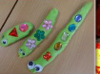  Activity 5: Design your own minibeast. Draw what it would look like, label the main parts of the minibeast and explain where it would live and what it would eat. | Reading  Here are some books you could share at home with your family linked to this week’s theme Minibeasts. If you don’t have the books, have a look on Youtube. Have a look through your books and see if you have any about minibeasts.  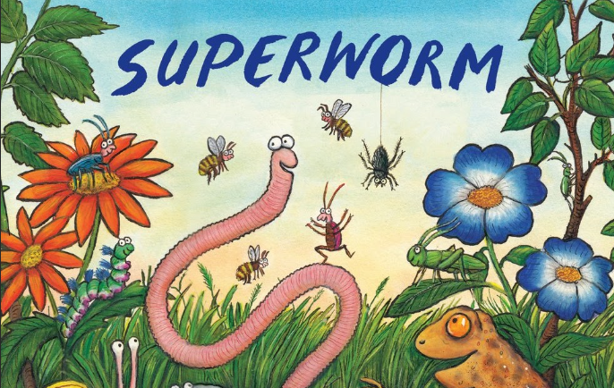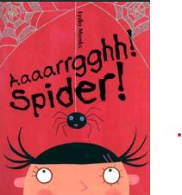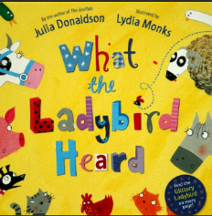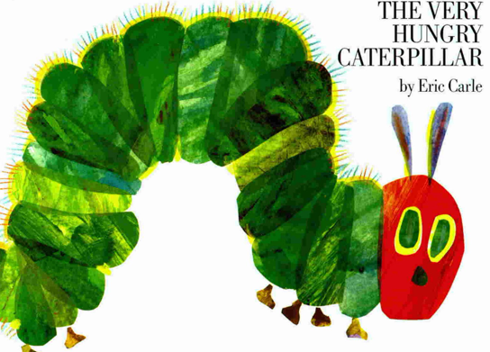  History  On Friday 8th May, we will be celebrating VE Day. See attached Powerpoint and Reading comprehension to find out more.  Maybe you could plan a VE Day party with your family and make bunting and bake a Wartime meal/ cake using the Wartime Recipes. Remember to take photos if you do.  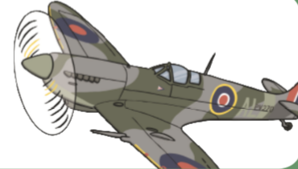
Computing  Learn to touch type using BBC Dance Mat typing  https://toybox.tools.bbc.co.uk/activities/id/activity-dance-mat-typing/exitGameUrl/http%3A%2F%2Fwww.bbc.co.uk%2Fguides%2Fz3c6tfr | Art  There are lots lovely minibeast art activities on the internet your child might like to do. Here are a few ideas:  