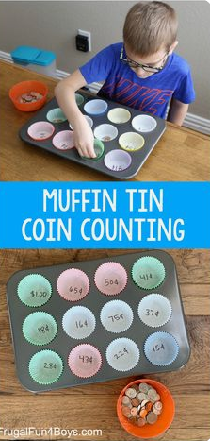
Get a cupcake tray and fill with cupcake cases. Write amounts to make inside e.g. 22p then ask your child to use the correct amount coins to make each amount.
Get a selection of coins and order the coins from smallest value to the largest value and record the value of each coin underneath.
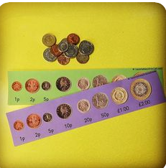
WEBSITE LINKS
https://www.topmarks.co.uk/Search.aspx?q=coins
https://www.bbc.co.uk/bitesize/topics/zp8dmp3
https://www.bbc.co.uk/bitesize/clips/z8f34wx

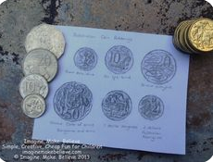
Coin Rubbings
Get a sheet of paper and pencil. Rub over each coin to reveal its value.

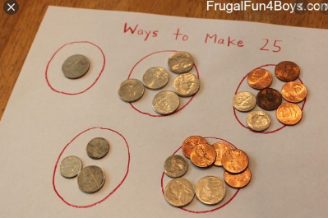
Maths Investigation
How many ways can you find to make 10p? (5p +5p)
How many ways can you find to make 20p? (5p +5p)

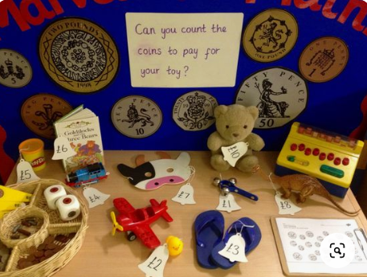
Toy Shop
Create a toyshop and make price tags for each toy. Buy a toy and use the correct amount of coins to buy the item.

