Fens Primary Home Learning
Year 1 Week beginning 27th April 2020
Here are some suggested activities
This week we would like your child to learn about a significant person in History. Meet Florence Nightingale, one of Britain's most famous historical figures. Find out about her remarkable life with the following activities.  Knowledge Organiser  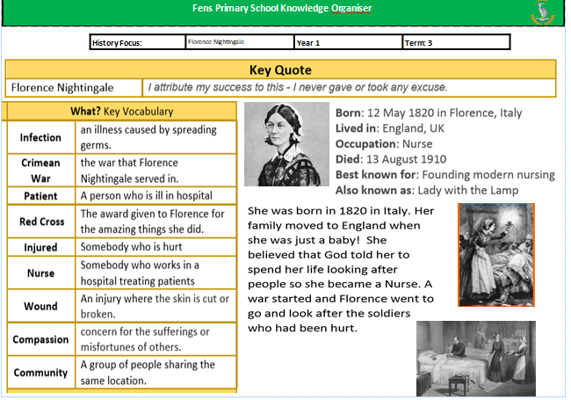 | Watch video about Florence Nightingale  https://www.bbc.co.uk/teach/class-clips-video/history-ks1-ks2-florence-nightingale/z68fcqt  Read the Power Point for more information  Complete Fact file or create your own  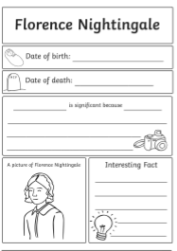
Here are some more activities you could complete.  See attached documents  - Reading comprehension  - Florence Nightingale booklet  - Compare Victorian and Modern hospitals  Useful Websites:  https://learnenglishkids.britishcouncil.org/short-stories/florence-nightingale  https://www.bbc.co.uk/bitesize/topics/zns9nrd/articles/znsct39 | Art  Draw or paint a portrait of Florence Nightingale  Make a paper lantern to show that Florence was the Lady with the lamp.  