Fens Primary Home Learning
Year 1 Week beginning 18th – 22nd May 2020
Here are some suggested activities. Pick and Choose the activities you would like to do with your child
English  Activity 1: Read the book Whatever Next! By Jill Murphy or watch video https://www.bing.com/videos/search?q=whatever+next+story&docid=608052598678687134&mid=B0AFEF2591358613DC3BB0AFEF2591358613DC3B&view=  Actiivty2: Role Play: Find some wellies, a cardboard box or laundry basket, a sieve, a teddy, picnic food etc. and act out the story. Try and use expression and different voices for the different characters.  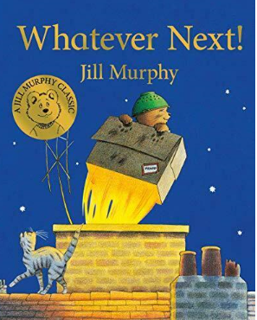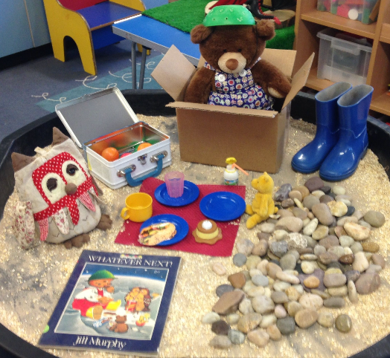  Activity 3: Rewrite the story in your own words. Remember finger spaces, capital letters and full stops.  Activity 4: Write a diary entry from the point of view of Baby Bear. What happened to him? How did he feel about his adventure?  Start your diary with Dear Diary. Include some adjectives to describe the moon, the rocket, space etc… Remember finger spaces, capital letters and full stops.  Activity 5: Ten things to take in your rocket worksheet. Discuss what you would take and why. Explain each item to an adult e.g I would take a camera to take photos of the moon. | Maths  Watch Jack Hartman on Youtube Counting songs  Please try and complete White Rose lesson each day  Watch the videos online then download the worksheets from our school website  https://whiterosemaths.com/homelearning/year-1  Monday: Compare Length and Weight  Tuesday: Measure length 1  Wednesday: Measure length 2  Thursday: Introduce weight and mass  Friday: 3D Shape (no video for this lesson)  Extras  - Watch Bitesize Maths lessons  - These lessons are now linked with the White Rose lessons so they follow the progression of learning and offer some more resources.  - See Space Maths Booklet
Reading  Here are some books you could share at home with your family linked to this week’s theme Space. If you don’t have the books, have a look on Youtube. Have a look through your books and see if you have any books about Space.  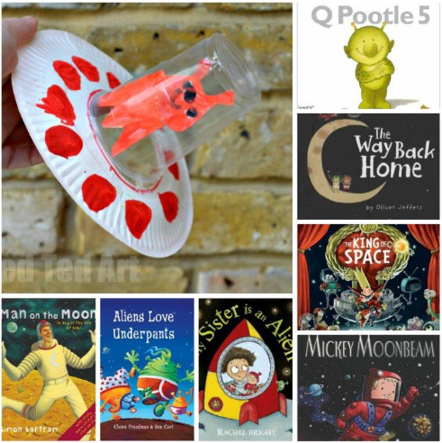 | Baking  During Half term, try and bake some space theme treats for example:  - Star biscuits  - Cheesy moon and planets  - Fruit Rockets  - Star snacks  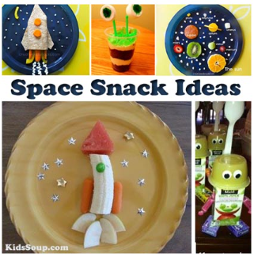
Science  Learn about the solar system and the Planets  Watch https://www.youtube.com/watch?v=BZ-qLUIj_A0  Activity 1: Make a space mobile  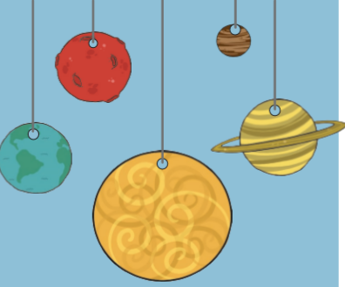  Activity 2: Order the planets (See attached sheet)  Activity 3: How do we get night and day? (See attached sheet)  Activity 4: Choose your favourite planet and try and write a fact file | DT/ART  Try one of these activities or have a look on google and create your own space craft.  Activity 1: Use recycled materials and create a space rocket or space buggy etc  Activity 2: Make handprint or footprint aliens  Activity 3: Make a flying saucer  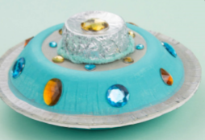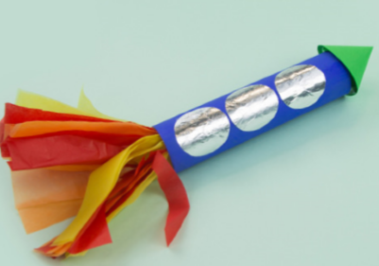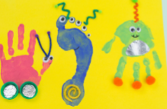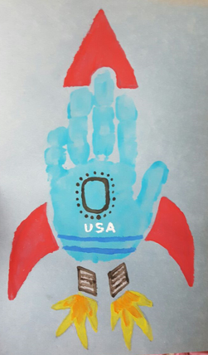
History  Activity 1: Find about Neil Armstrong and the first moon landing.  Look at BBC Bitesize  https://www.bbc.co.uk/bitesize/topics/zjwvb82/articles/zhx4k2p  Activity 2: Read Neil Armstrong Powerpoint and discuss comprehension questions.  Activity 3: Write a fact file about Neil Armstrong | Half term  We hope you all have a lovely half term and that the weather stays nice and warm. Try and make lots of happy memories during this unsettling time.  - Ride your bike  - Learn to tie your shoelaces  - Bake cakes  - Play board games  - Make a card for a family member you haven’t seen in while  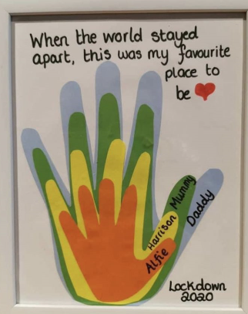

There are lots of ideas and activities on the internet to do with the theme of Space. If your child is enjoying this topic, then please feel free to extend this topic. There are lots of space science experiments they could do, crafts, baking, model making. Pintrest has lots of good ideas too.

