Fens Primary Home Learning
Year 1 Summer Term 3B
Week beginning 1st June – 5th June 2020
Here are some suggested activities. Pick and choose the activities you would like to do with your child.
English  1.Read All about Pirates powerpoint to introduce this week’s theme. Have a discussion about what your child knows about pirates. You might like to research famous pirates or more information about them and make a fact file.  2.Read powerpoint Jake’s first day at school. Retell the story in your own words or draw a story map to show the main parts of the story.  3. Wanted poster Imagine a bad pirate has stolen your treasure! Draw what your bad character would look like then use adjectives to describe the pirate. Remember to give a reward for finding him!  4.Look on the internet for examples of a treasure map. Draw your own treasure map and try make it look old by tea staining it. Then write a set of instructions to help the pirates find the treasure. See attached sheet for information.  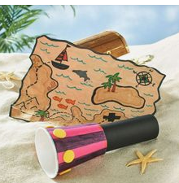  5. Write a message in a bottle about yourself. Here are some things you might want to include:  Name, age, likes and dislikes, pets, family, hobbies, favourite things to do at school etc. | Maths  Watch Numberblocks on Youtube  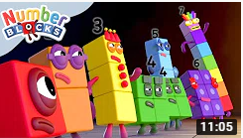  Please try and complete White Rose lessons each day  www.whiterose.com/homelearning/year-1  Watch the videos online then download the worksheets from our school website and complete by filling in the worksheets or answer the questions verbally or on whiteboards.  Monday: Measure Mass  Tuesday: Compare Mass  Wednesday: Introduce capacity and volume  Thursday: Measure capacity  Friday: See attached sheets on Position and Direction (no videos for these lessons)  Extras:  Watch daily BBC Bitesize Math’s lessons linked to the above lessons  See Pirate Maths theme booklet
DT/ART There are lots of craft ideas on Pintrest  - Draw a portrait of a pirate  - Read the instructions and make a paper pirate hat  - Make a treasure chest using egg cartons  - Design and decorate your own pirate flag  - Pirate Handprints  - Create a pirate ship using junk modelling  - Paper boat origami  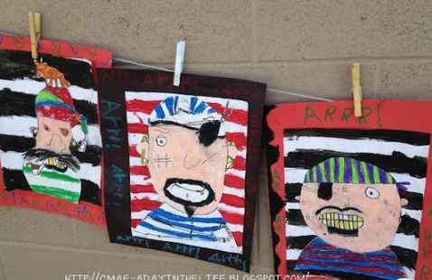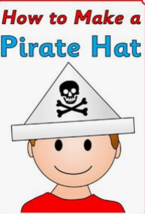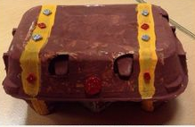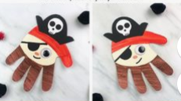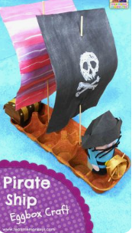 | Science  Floating and sinking – You will need a large bowl of water or bath etc. Choose objects from around the house. Predict which object will sink or float. Test out each object to see if your predictions are correct. Take a photo to show your experiment.  Pirate Waterproofing experiment (See attached sheet)  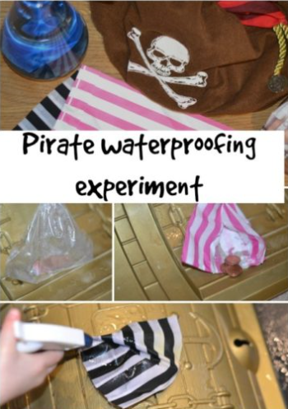
Phonics  Please keep trying to learn to read and spell the Year 1 Common exception words.  Please see attached phonics booklets to help practice with spellings  Pirate Phonics phase 3 and Phase 4 booklets.  Please see attached Feel Safe, Feel Happy activities for some things to do with the family during this uncertain time. | Reading  There are lots of books with the pirate theme. Have a look through your books and see if you that you can read at bedtime.  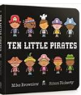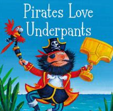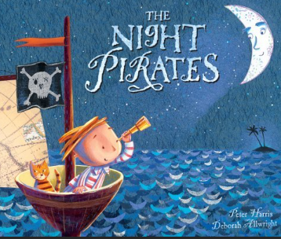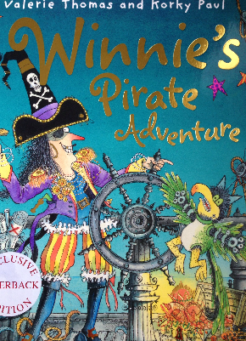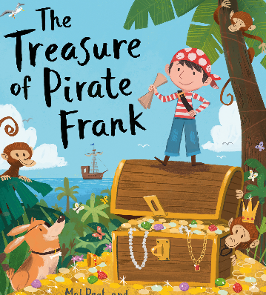
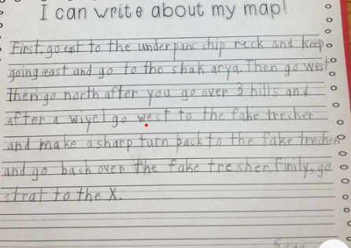
Treasure Map writing activity
When you are writing your instructions try and include:
- First, Next, Then, After that and Finally
- Capital letters, finger spaces and full stops
- Adjectives e.g. the smelly, black swamp or long, wavy grass
- Try and include a compass
- Don’t forget to include X to mark the spot

