Fens Primary Home Learning Year 1 Summer Term 3B Week beginning 22nd – 26th June 2020
Here are some suggested activities. Pick and choose the activities you would like to do with your child.
English  - With an adult, try learning your address and practice writing it down on an envelope. Remember place names have capital letters.  - Watch the story of the Three Little Pigs https://www.youtube.com/watch?v=SKxWJP_LH7A  - Make stick puppets and act out the story  - Write a letter to say sorry to the 3 little pigs for blowing their houses down  - Can you change the story of the 3 Little pigs?  - You could change the pigs to a different animal e.g. The 3 Little Lambs or 3 Little Pugs  - You could change the houses to kennels or baskets etc.  - You could change the Big Bad Wolf to the Big Bad Cat  - Once you have decided what you are going to change, then draw a story board of your new story and tell your story to a family member. (You do not need to write the whole story out just retell it verbally using expression)  Here is an example my little boy made up  Once upon a time there were 3 Little Pugs. They lived with their Grandpa in a small kennel. One day Grandpa told them to leave and make a new kennel. Pug no.1 made his kennel out of straw, Pug no. 2 made his kennel of sticks and Pug no. 3 made his kennel out of bricks. One sunny day, a naughty little kitten came along and said “Little Pug, Little Pug let me come in!”  “Not by the whiskers on my chinny chin chin!” shouted Pug no. 1  The naughty little got very cross and shouted “Ill scratch and Ill scratch until I scratch your house down!” | Maths  Watch Numberblocks Three Little pigs on Youtube  https://www.bbc.co.uk/iplayer/episode/b08cqtk0/numberblocks-series-1-three-little-pigs  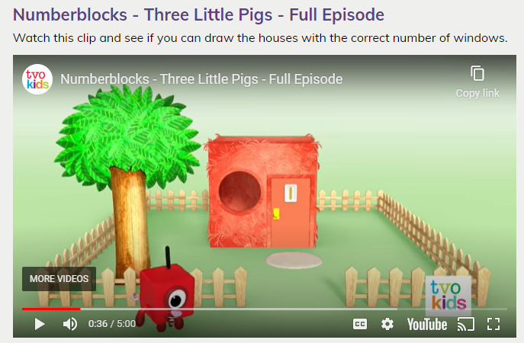  Please try and complete White Rose lessons each day  www.whiterose.com/homelearning/year-1  Watch the videos online then download the worksheets from our school website and complete by filling in the worksheets or answer the questions verbally or on whiteboards.  Monday: Count to 100  Tuesday: Partition numbers  Wednesday: Compare numbers 1  Thursday: Compare numbers 2  Friday: Practice writing your numbers 1 -20 or to 100. You could do this on paper or your whiteboard from your pack.  Make sure they are not reversed. Play Number Bingo with your family
Geography  Look at Types of Houses power point  Discuss what kind of house you live in. Go on a local walk and look at the different kinds of houses. (See local walk sheet)  Can you find out about three houses from around the world?  Read power point Homes around the world  Choose up to three homes from different parts of the world and make a little booklet with photo or drawing of each house and write down 3 facts for each. Can you locate the countries the houses you have chosen are from? (See booklet)  Can you compare these houses with yours? What are the similarities and differences? Which house is your favourite and why? | Science  Activity 1: I’ll huff and I’ll puff experiment (See attached sheet for instructions)  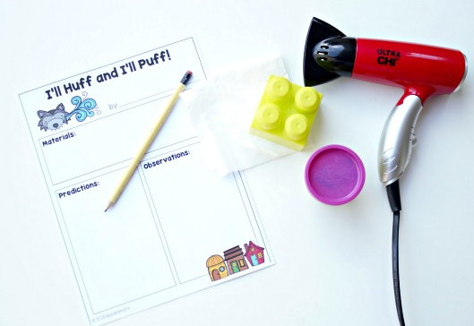  Or  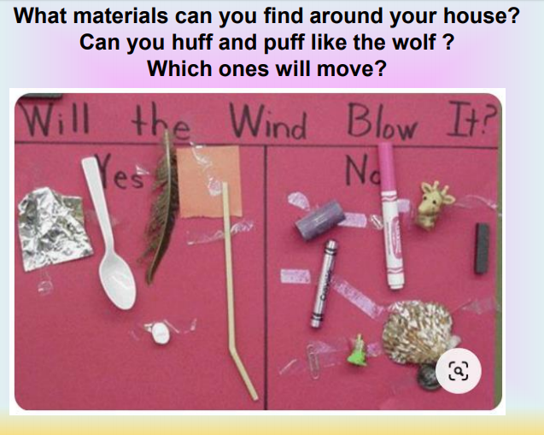
Baking  - Pig Cupcakes  - Marshmallow pig biscuits  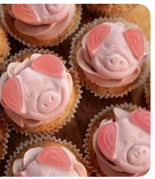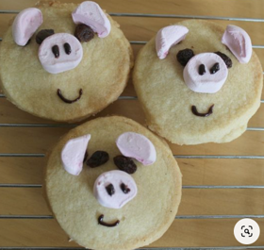 | Purple Mash  www.purplemash.com/fens  then type in your user name and password.  See below for instructions on how to access the work set  If you have not been given your login details over the phone by Miss Pearson or Mrs Atkinson then please email us at Year1@fensprimary.co.uk
DT/ART There are lots of craft ideas on Pintrest
- Have a go at observational drawing from outside your house. Sit outside on the front of your house and sketch and draw it. Remember to draw your garden and drive if you have one. You could finish your drawing by painting it or colouring it in.
- Build your ideal house. What would it look like? Would it be a lego house or house made from sand? Can you make a 3D model? You could use cereal boxes, lego, sand, wooden bricks, matchsticks, sugar cubes …
- You could go on Minecraft to build a house
- Use toilet rolls to make the Three Little Pigs
- Finger puppets
- Peg piglets

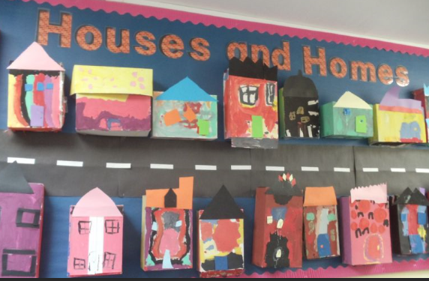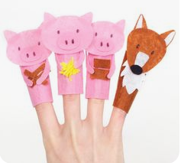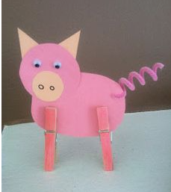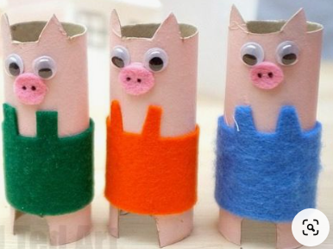

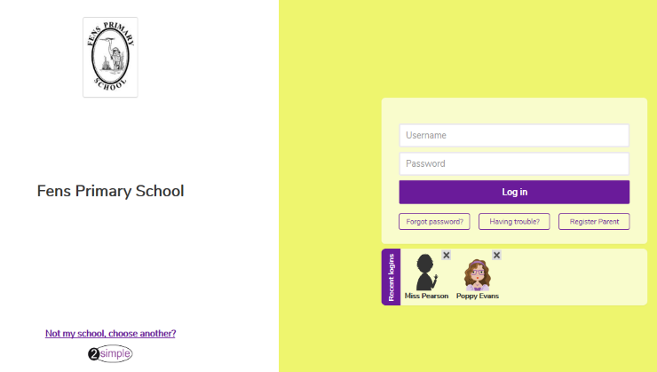
Step 1: Log in to www.purplemash.com/fens
Step 2: Type your username and password in

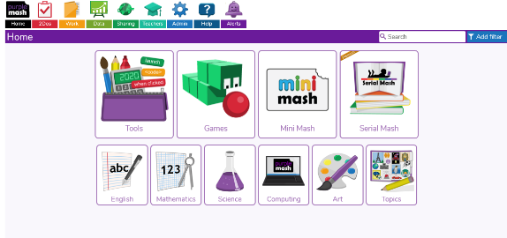
Step 3: Click on red 2 DO button next to Home.
Step 4: Have a look through the 2 Do list and choose which activities you would like to complete.

