Fens Primary Home Learning
Year 1 Week beginning 11^{h} May – 15th May 2020
Here are some suggested activities. Pick and Choose the activities you would like to do with your child
English  Activity 1: Read the story The Enormous Turnip (Powerpoint) and have a discussion with your child about the text using the Reading comprehension question prompts.  Activity 2: Watch Youtube version of the story https://www.youtube.com/watch?v=z9W8Tyz3AOY  Activity 3: Draw a story map of what happened in the story. Try and include speech bubbles.  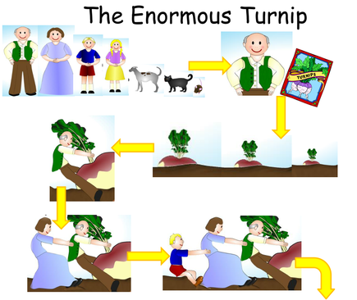  Activity 4: Act out the story using actions, props from home or story characters cut outs. Encourage your child to retell the story in their own words using the repeated refrains (They pulled and they pulled and enormous turnip would not budge)  Activity 5: Complete the Book review worksheet. This can be completed verbally or fill the sheet in.  Activity 6: Write an alternative version.  - Choose a different vegetable or fruit to plant.  - Choose different farm animals and characters.  - Draw your new story out first in a story map.  - Then start your story with Once upon a time … and end with they all lived happily ever after. | Maths  Watch Jack Hartman on Youtube Counting songs  Please try and complete White Rose lesson each day  https://whiterosemaths.com/homelearning/year-1/  Watch the daily videos and complete attached worksheets from school website  Activities linked to the Enormous Turnip  Activity 1: Provide some weighing or balance scales and encourage the children to weigh a selection of vegetables and order them from lightest to heaviest.  Activity 2: Classify objects into different categories (tiny, small, big, large, enormous). Look around your house and find 3 things that are tiny, small etc.  Activity 3: Create a family Pictogram of your favourite vegetable. Ask each family member or facetime other family members which are their 3 favourite vegetables and record on pictogram. Which is the most popular vegetable? Which the least popular?

Phonics  www.phonics play.co.uk  username: march20 password: home  Activity 1: Play Daily Flash cards using phase 3,4 and 5 sounds  Activity 2: Pick a Phase 5 sound each day e.g. oy and play Buried Treasure or Picnic on Pluto.  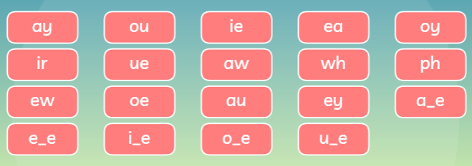  Activity 3: Watch Geraldine the Giraffe or Alpha Blocks on Youtube with that sound.  Activity 4: Look at Phonics Phase 5 Home Learning challenges worksheet.  Activity 5: Read the phoneme spotters comprehension sheets. Encourage your child to try and read the passage and then complete the activities. | Reading  Here are some traditional stories you could share at home with your family. If you don’t have the books, have a look on Youtube. Have a look through your books and see if you have any other traditional stories. Which one is your favourite and why?  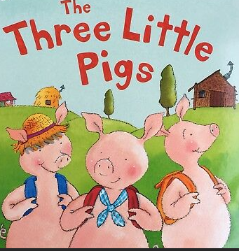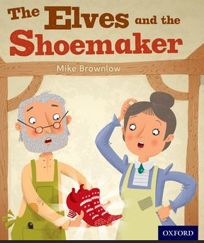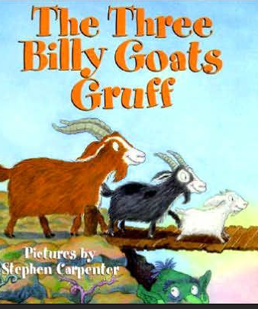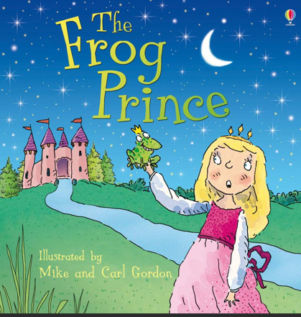
Computing
Learn to touch type using BBC Dance Mat typing
https://toybox.tools.bbc.co.uk/activities/id/activity-dance-mat-typing/exitGameUrl/http%3A%2F%2Fwww.bbc.co.uk%2Fguides%2Fz3c6tfr

E Safety
https://www.childnet.com/ufiles/DigiDuck-eBook.pdf
Read DigiDuck’s big decision with your child. Discuss how to stay safe on the internet. Can your child some rules to stay when working online?
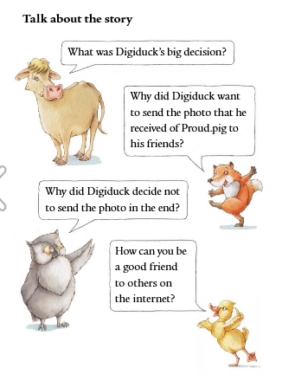

Science
Linked with this week’s story The Enormous Turnip we would like your child to learn about Forces.

What does push and pull mean?
Push and pull are forces that change the way an object moves. It might make them go faster, go slower or stop them.
You can also use push and pull to change the shape of an object or the direction the object is moving in.

Activity 1: Read the Push and Pull Powerpoint
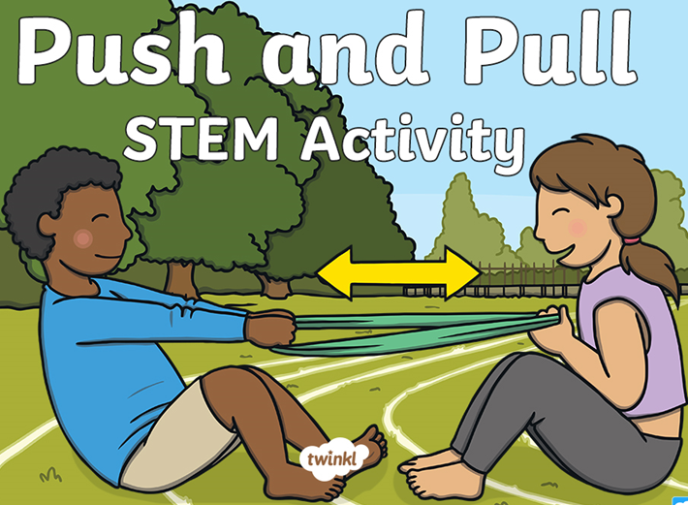

Activity 2: Watch BBC Bitesize https://www.bbc.co.uk/bitesize/clips/z9nkqty

Activity 3: Go for a walk around your house and garden. Can you find 5 things that you can push, 5 things you can pull and 5 things that you can twist?

Activity 4: Your task is to create a new toy that uses the push and/or pull force. Think about whether your toy will use the push or pull force, how it will work and what materials you will need. Design and plan your toy before building.

Activity 5: Research Sir Isaac Newton
Read the Powerpoints and have a discussion using the attached worksheets

