Fens Primary Home Learning Year 1 Summer Term 3B Week beginning 15th June – 19th June 2020
Here are some suggested activities. Pick and choose the activities you would like to do with your child.
English  Walking with Dinosaurs  https://www.youtube.com/watch?v=YN2_rkpyC3g&list=PLMVBruCm4-yP-Tdbw7vYrZ8GNQq4D4Zrm  Watch this amazing BBC video.  Read E Book Dinosaurs and look at the key features of a non fiction book  (contents page, page numbers, headings, photos, labels  Make a Non Fiction book about dinosaurs (See mini booklet)  Or turn the sound down and write a diary as if you were there.  Dino Fact File  Choose your favourite dinosaur and research them using websites and non-fiction books.  - What did they eat?  - How big were they?  - Where did they live?  Could you pretend to be a paleontologist using props etc and create a video explaining all your new facts?  Dinosaur Dictionary  Write a list of 6 dinosaur names in alphabetical order.  See attached worksheet  Pet dinosaur  Create your own dinosaur and label the key body parts. Write a few sentences describing it for example My dinosaur has sharp claws. It has three horns. It is 10m tall. It eats bugs and leaves.  Write instructions on how to look after your pet dinosaur. Try to think of at least 5 instructions. | Maths  Please have a look at this website for some fun maths games  www.topmarks.co.uk  Please try and complete White Rose lessons each day  www.whiterose.com/homelearning/year-1  Watch the videos online then download the worksheets from our school website and complete by filling in the worksheets or answer the questions verbally or on whiteboards.  Monday: Arrays  Tuesday: Doubles  Wednesday: Sharing  Thursday: Grouping  Friday: One more One less worksheet  Extras:  Compare objects within 50  Compare numbers within 50  Order numbers within 50
History  Mary Anning  Watch the following links on Mary Anning- the fossil collector. Start and stop the video and write down 10 facts about her.  https://www.youtube.com/watch?v=qNOh-85_Dmc  https://www.youtube.com/watch?v=Of5sK8p2rZY | Science  Venn Diagram  Read power point Dinosaurs carnivore, herbivore or omnivore  Look at Venn Diagram and sort out the dinosaurs into carnivores, herbivores or omnivores.  If you have dinosaurs at home, see if you can sort them out practically and take a photo.  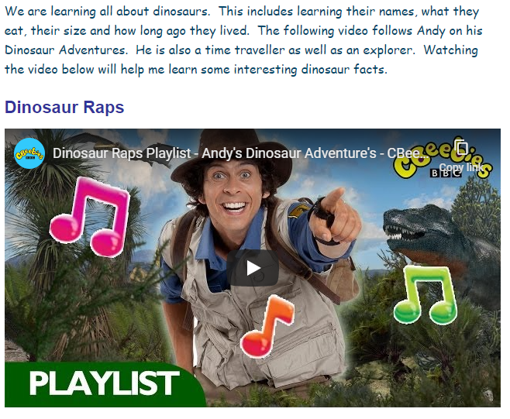
CBeebies have lots of Dinosaur themed games, video clips and stories
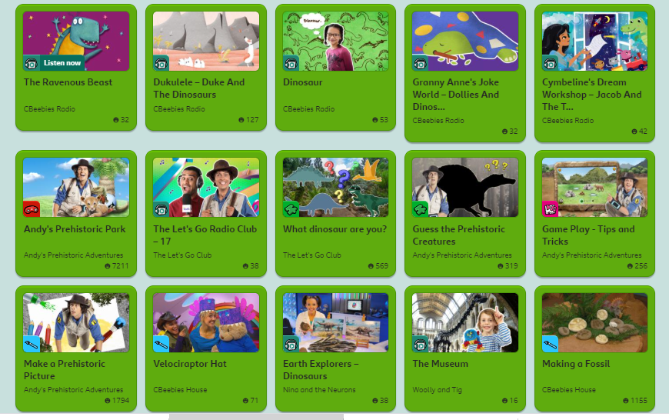

DT/ART There are lots of craft ideas on Pintrest  - Salt dough fossils  - Prehistoric pasta  - Dinosaur silhouettes  - Use playdough to create your dinosaur and use cotton buds etc to add detail.  See Dinosaur topic sheet for more ideas and links. | Reading  There are lots of books with the Dinosaurs theme. Have a look through your books and see if you that you can read at bedtime.  