Fens Primary Home Learning Year 1 Summer Term 3B Week beginning 8th June – 12th June 2020
Here are some suggested activities. Pick and choose the activities you would like to do with your child.
English  Read the story Owl Babies or watch animation version on Youtube.  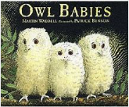  Choose your favourite part of the story Owl Babies OR write the full story in your own words. (See story booklet resources)  Try and include:  - Capital letters  - Full stops  - Finger Spaces  - Exclamation Mark  - Question mark  - Adjectives  You can email your lovely writing to admin@fensprimary.co.uk for Miss Pearson or Mrs Atkinson to see.  Read the story A tale of two feathers to tour child and use the comprehension questions to discuss the text verbally.  Research facts about Owls. Make a booklet or draw an owl and write your facts inside.  Owls have …  Owls can…  Owls are …  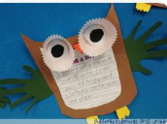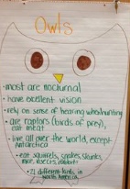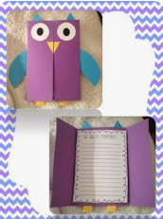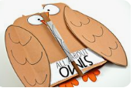 | Maths  Watch counting in 2s,5s and 10s songs on Youtube  Please try and complete White Rose lessons each day  www.whiterose.com/homelearning/year-1  Watch the videos online then download the worksheets from our school website and complete by filling in the worksheets or answer the questions verbally or on whiteboards.  Monday: Count in 2s  Tuesday: Count in 5s  Wednesday: Count in 10s  Thursday: Add equal groups  Friday: Numbers to 50 and Tens and ones worksheets (no videos)  Extras:  If you fancy a challenge then complete the Mystery Maths Game booklet “The Mystery Daytime Feather”.
DT/ART  - Make paper birds  - Make a bird feeder  - Make binoculars  - Use natural materials like twigs and leaves to make an owl  - Handprint robins  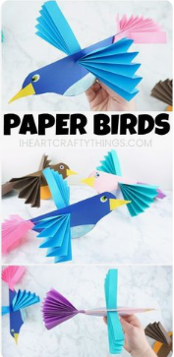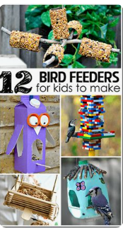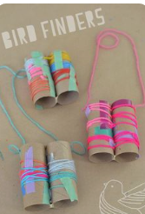  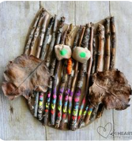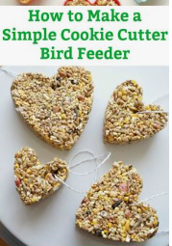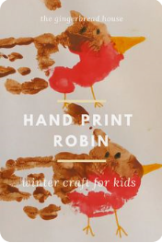  See Pintrest for more ideas on bird or nocturnal animals | Science  Read power point British Birds information and use the following BBC Bitesize clips to find out about birds.  https://www.bbc.co.uk/bitesize/topics/z6882hv/articles/zyd6hyc  https://www.bbc.co.uk/bitesize/clips/zrynvcw  https://www.bbc.co.uk/bitesize/clips/zk9g9j6  https://www.bbc.co.uk/bitesize/clips/zx4rkqt  Go in your garden or go on a walk to your local park or Summer Hill and see how many birds you can spot. Take photos or complete Garden Birds Bar chart or Bird Sighting sheet.  Choose your favourite garden bird and write a fact file  Read Nocturnal and Diurnal animals Powerpoint. Complete worksheet on Diurnal and Nocturnal animals (See Fill in the blacks sheet)  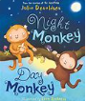
Phonics/Grammar  - Discuss what an adjective is and complete adjective alphabet worksheet  - Complete SPAG worksheets to support spelling, grammar and punctuation (See below)  - www.phonicsplay.co.uk  - Alphablocks  - Geraldine the Giraffe (YouTube) | Reading  There are lots of books with the bird theme. Have a look through your books and see if you that you can read at bedtime.  