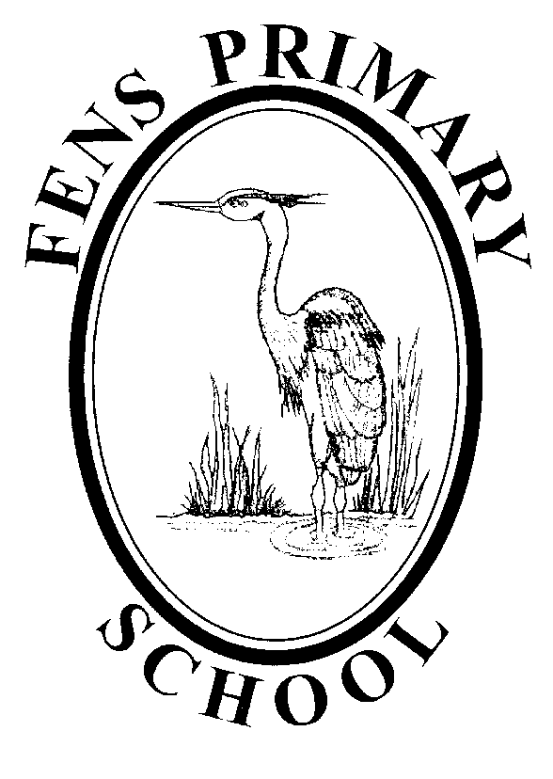

Covid 19 – Outbreak Management Plan – September 2021

Introduction

The Government has made it a National priority that education and childcare settings should continue to operate as normally as possible during the COVID-19 pandemic. The DfE’s published COVID Contingency Framework states that schools should have an “outbreak management plan”, outlining how they would operate if any of the measures described in the guidance were recommended for their setting or area.
Measures affecting education and childcare may be necessary in some circumstances, for example:
- to help manage a COVID-19 outbreak within a setting
- as part of a package of measures responding to a Variant of Concern (VoC) or to extremely high prevalence of COVID-19 in the community
- to prevent unsustainable pressure on the NHS

In these cases, the Guidance also states that councils, directors of public health and Public Health England health protection teams can recommend certain measures for individual schools or clusters of settings.
If there is a need to address more widespread issues across an area, “ministers will take decisions on an area-by-area basis”.
This plan should be read alongside the latest guidance for education settings operating during COVID (this is not an exhaustive list and these documents change frequently so the reader should check they have the most up to date guidance) as well as the Fens Primary School COVID 19 Risk Assessment.
- actions for early years and childcare providers during the COVID-19 outbreak https://www.gov.uk/government/publications/coronavirus-covid-19-early-years-and-childcareclosures
- actions for schools during the COVID-19 outbreak https://www.gov.uk/government/publications/actions-for-schools-during-the-coronavirusoutbreak
- protective measures for holiday and after-school clubs, and other out-of-school settings during the COVID-19 pandemic https://www.gov.uk/government/publications/protective-measures-forholiday-or-after-school-clubs-and-other-out-of-school-settings-for-children-during-the-coronaviruscovid-19-outbreak
- guidance for special schools and other specialist settings: COVID-19 https://www.gov.uk/government/publications/guidance-for-full-opening-special-schools-andother-specialist-settings
- contingency framework: education and childcare settings
- https://www.gov.uk/government/publications/coronavirus-covid-19-local-restrictions-ineducation-and-childcare-settings/contingency-framework-education-and-childcare-settings
The Operational Guidance sets out the measures that all education settings should have in place to manage transmission of COVID-19 day to day. For most settings it will make sense to think about taking extra action if the number of positive cases substantially increases. This is because it could indicate transmission is happening in the setting. The thresholds, detailed below, can be used by settings as an indication for when to seek public health advice if they are concerned.
Scenario 1 – Single Confirmed COVID Case
If there is one case identified in school, the following steps will be taken in line with the latest guidance:
- School will liaise with Public Health passing on the relevant information
- Schools will follow their Local Authority reporting guidance
- Control Measures set out in Fens Primary Covid Risk Assessment to be followed
- Remote learning plan to be implemented for those isolating
- School Covid Risk Assessment to be evaluated in light of any learning from new case
Scenario 2 – Outbreak Within Setting
For most education and childcare settings, whichever of these thresholds is reached first:
• 5 children, pupils, students or staff, who are likely to have mixed closely, test positive for COVID-19 within a 10-day period; or
• 10% of children, pupils, students or staff who are likely to have mixed closely test positive for COVID-19 within a 10-day period
When the above thresholds are reached, school will review and reinforce the testing, hygiene and ventilation measures we already have in place. School will seek additional public health advice, either by phoning the LA or DfE helpline (0800 046 8687, option 1).
The best way to avoid an outbreak in a setting is to ensure preventative measures are in place. Within all settings the following will be in place:
- A risk assessment for each setting that reflects the current Government Guidance
- Appropriate PPE will be provided and worn in line with Guidance
- Hand sanitiser will be freely available
- LFT testing will be available for staff

Should an outbreak be identified, guidance from LA and PHE will be acted upon, as well as:
- Remote Learning will be implemented where necessary
- External visits to school will be reviewed on a case-by-case basis
- Daily school activities for whole school - or groups within school - to be closely monitored and amended in line with advice from LA and PHE.
- Fens Primary School COVID Risk Assessment will be evaluated in light of any learning from new cases.

Scenario 3 – School is affected by a package of local or national measures
The COVID situation is ever changing as are the directed responses. School will work with the LA, PHE and DfE to ensure that they implement any Local or National restrictions and guidance. Schools will work in collaboration with professionals and stakeholders to limit the impact on educational delivery. This will include working with the following:
- Parents/carers
- Pupils
- Public Health
- Local Authority
- Social Care
- DfE
The following plans are in place to support the continued delivery of education under local or National measures:
Testing:
- Staff will receive LFTs to complete twice a week
- School will ensure we are well stocked with LFT tests in case there is a requirement to increase home testing
Face Coverings:
- Should face coverings be recommended, school will amend our RA in line with further guidance
Shielding:
- Should shielding be reintroduced, those on the shielded patient list will be supported to follow guidance. If this is a pupil, then the remote learning plan would be implemented. Shielding staff will be supported to work from home and measures put in place to support their wellbeing.
Fens Primary School COVID Risk Assessment:
- This is a regularly updated document which sets out the expectations of risk management for the school.

Attendance restrictions:

Places will be prioritised for pupils in line with current local and national guidance

High-quality remote learning in schools, further education and higher education settings should be provided for all pupils and students if:

• they have tested positive for COVID-19 but are well enough to learn from home; or
• attendance at their setting has been temporarily restricted

On-site provision should in all cases be retained for vulnerable children and young people and the children of critical workers. If settings have to temporarily stop onsite provision on public health advice, they should discuss alternative arrangements for vulnerable children and young people with the local authority. Full detail on remote education expectations and the support available to schools and FE providers is available at Get help with remote education

Contingency Framework: Education and Childcare Settings (DFE, 25 June 2021) • Where pupils have EHCPs and cannot attend school a risk assessment will be undertaken to assess if they are safer at home or in school.

Safeguarding:

- School will ensure a DSL is on site. If this is not possible, a senior leader will take on the responsibility for coordinating safeguarding and remote support sought by the LA.
- School safeguarding team and SLT will review child protection and safeguarding policies so that they reflect the local restrictions and remains effective.
- Wellbeing calls will be made regularly (in line with individual pupil risk assessments) to ensure that pupils are safe and well at home.

Meals:

- Meals will continue to be provided for those on site. Those in receipt of free school meals who are not on site will either be provided with vouchers or food for the time the pupil is isolating, or the school is restricting attendance.

IT Access:
- As part of the school remote learning plan, details will be held of who requires a device to be provided. These will be available to be collected from school or, if there is prior warning, they will be distributed prior to class/school closures.
- Part of the wellbeing calls will be to monitor this provision and pupil access to the remote learning so that support can be given as required.

