Supporting your child with maths at home
Year 2

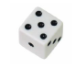
Pasta Subtraction
For this game you will need a dice and some dried pasta or buttons.
- Start with a pile of pasta in the middle. Count how many pieces you have.
- Throw a dice. The number shown tells you how many pieces of pasta you must subtract. Call out the answer as quickly as you can.
- Take the number of pieces away and count how many are left to check if you were correct.
- Keep playing. The winner is the person who takes away the last piece of pasta.
How Heavy?
For this game you will need some kitchen scales.
- Challenge your child to find something that weighs close to 1 kilogram.
- Can he/ she find something that weighs exactly 1 kilogram?
- Then find something which weighs half a kilogram. Repeat with different measurements. Discuss how we know whether an object is heavier or lighter than other objects.
Out and About
Over the course of a week look for ‘thirties’ numbers. How many different places can you spot them? Can you see them on number plates, house doors, bus stops etc? What is the biggest ‘thirties’ number that you spot?
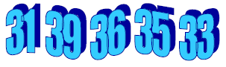
The following week look for ‘fifties’ numbers or ‘sixties’ numbers etc.
Counting
Practise counting from different numbers. Start at 5 and count up to 11. Start at 9 and count back t 0. Choose a different starting number each time. In year 2 children will be expected to count up to 120.

Number Facts
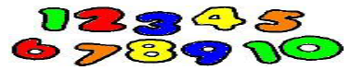
For this game you will need a 1-6 dice.
- Take turns rolling the dice. Look at the number and race to shout the number which would be added to the number to make 10. E.g. If the dice lands on 4, you would shout 6.
- The player who calls the correct answer first, wins a point.
- The first to get to 10 points wins the game.
You can extend this game by making the two numbers add up to make 20. You could tell the child that each dot on the dice represents 10 and they need to call the number which adds to give 100. E.g. You roll 3 this represents 30 so you call out 70.
Speedy Pairs to 10
Work with your child to make a set of 12 cars showing the numbers 0 to 10 plus an extra 5 card.
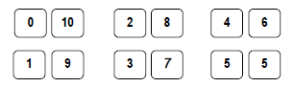
- Shuffle the cards and give them to your child.
- Use a timer to record how long it takes to pair the cards up so that each pair equals 10.
- Repeat the game and challenge your child to beat their previous time.
The game can be extended by making pairs to 20, 50 or 100.
Straight Lines
Choose 4 different toys and place them in order of length on a table. Use a ruler to measure each toy to the nearest centimetre.

Guess My Shape
Think of a 2D shape (triangle, circle, rectangle, square, pentagon or hexagon). Ask your child to ask you questions which will help them to try to guess the shape which you are thinking about. The main rule in the game is you can only answer with yes or no. For example, your child could ask: Does it have 3 sides? Are its sides straight? Does it have 4 vertices?
Challenge your child to try to guess your shape in fewer than five questions.
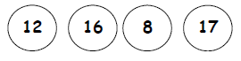
Circle Trios
Each player draws four circles on a piece of paper. They then write four numbers between 3 and 18, one in each circle. Take turns to roll a dice three times and add the three numbers. If the total of the numbers is one of the numbers in the circle, you can cross it out. The winner is the first player to cross out all four of their circles.
Shopping Maths
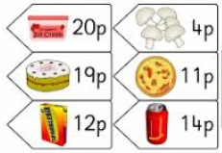
After you have been shopping, choose 6 different items each costing less than £1. Make a price label for each item. Shuffle the labels and ask your child to do one or more of the following challenges.
- Place the items in order starting with the lowest item.
- Say which price is an odd number and which is an even number.
- Add 10p to each price in their head.
- Take 20p away from each price in their head.
- Say which coins you could use to pay for the item.
- Choose two of the items and find the total cost for these two items.
- Work out how much change you would need from £1 when buying one of the items.

Useful website

Topmarks- Hit the Button
Allow your child time to play x2, x5, x10 and number bonds games.

https://www.topmarks.co.uk/maths-games/hit-the-button

