Calculations in Year Six
Addition:  In Year Six, we use column addition. Children always start adding from the units/ ones place. Note that carried numbers are recorded to the left and on the line.  127 + 498 = 625  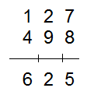 | Subtraction:  We use column subtraction with the children subtracting from the units. If digit being subtracted is larger than the number above, children are required to exchange from the next column.  1137 – 129 = 1108  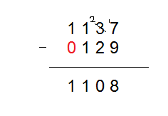
Multiplication:  In Year Six, we use long multiplication. The children place the larger number above and are required to add a zero (shown in red) in the second line of working out to indicate multiplying a number in the tens column.  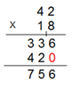  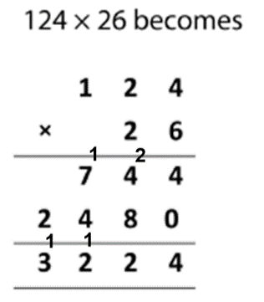 | Division:  We use the methods outlined below for division. Children use multiples of the divisor when working out. If they are working with larger numbers they may be required to note down the multiples as shown in the second example.  