Calculations in Year Five
Addition:  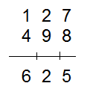  In Year Five, we use column addition. Children always start adding from the units/ ones place. Note that carried numbers are recorded to the left and on the line.  127 + 498 = 625 | Subtraction:  We use column subtraction with the  1137 – 129 = 1108  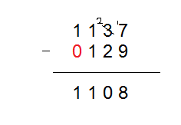
Multiplication:  In Year Five, we use both short multiplication and long division. Both methods are detailed below.  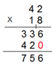 | 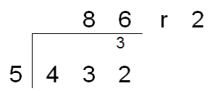  Division:

