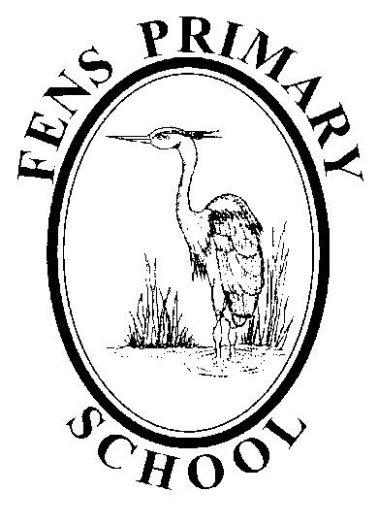

Science Policy
Reviewed: September 2021
Next Review: September 2022

Fens Primary School

Science Policy

Science Vision & Curriculum Intent

To provide each and every one of our naturally curious learners with purposeful, inspiring and enjoyable practical experiences in Science, that fully engage them in building securely and precisely upon their knowledge, skills and understanding.
Developed by children, staff and governors of Fens Primary School
(Reviewed September 2021)

Our Science Curriculum Intent

In Fens School, pupils are given appropriate learning opportunities so that they develop the skills needed to be active citizens within an increasingly scientific world. Science is a powerful and useful tool through which children’s understanding of the world around them is carefully developed. It is our intent to create a challenging environment that raises standards of achievement in Science through high quality teaching and learning. Pupils build up their scientific skills and knowledge, developing the necessary ability to investigate, question and understand scientific concepts (See Appendix 1 Science Learning Journey).

Our intent is to:
- Strive to be an ‘Evidence Informed’ school, taking into account the important role different forms of evidence can play in improving our school Science curriculum through informing decision making and implementation practices that continually work to improve the outcomes of teaching and learning.
In order to achieve this goal, we will:
  - Engage with a wide range of research, related to both science and wider teaching and learning
  - Explore areas of school practice that can be improved and clearly define them for all school stakeholders
  - Prepare clear school development plans that outline how implementation activities and resources will be deployed to meet the intended outcomes
  - Deliver and Adapt implementation strategies, monitoring their effectiveness through developed school systems and a flexible and collaborative peer-to-peer approach to school improvement
  - Sustain and scale successful implementation practices to ensure they are embedded.
- Develop children’s awareness of their ability to self-regulate and think about their learning by sustaining and promoting the school’s metacognition agenda, in order to develop metacognitive strategies in conjunction with building a progressive understanding of scientific concepts.
- Offer a wide range of opportunities for pupils to work scientifically, developing their disciplinary knowledge, through:
  - observing ‘real life’ phenomena, including a range that are relevant to them
  - asking and answering their own questions about the world around them
  - designing of different types of scientific enquiry (becoming increasingly controlled as children progress through the school)
  - drawing of meaningful conclusions through critical reasoning and the evaluation of evidence, leading to – where appropriate – further questions and evidence gathering.
- Give pupils a knowledge and understanding of scientific processes through purposeful ‘hands on’ experiences.
- Develop a progressive understanding of scientific ideas, facts and data deepened by the role of questioning in Science.
- Offer children accurate, timely feedback – both verbally and written – that promotes deeper learning for each individual.
- Prepare pupils for living in an increasingly scientific and technological world.
- Foster concern for our environment.
- Develop each pupil’s self-confidence and social skills so that they can work both independently and co-operatively.
- Establish an understanding of Science skills in real contexts by the reading and construction of graphs, diagrams, charts and tables using accurate measurements and observations.
- Encourage imaginative and original thinking and reasoning.
- Provide opportunities for each pupil to develop their skills in order to reach their potential.
- Have high expectations of the vocabulary children are using to explain their science reasoning.
- Offer a growing range of Science experiences beyond the classroom.
- Maintain a ‘growth mindset’ that ensures Science at Fens never stands still – we always look for ways to improve the outcomes for everyone in our school.

The importance of science in the curriculum

Science stimulates and excites pupils’ curiosity about phenomena and events that are happening in the world around them. It links direct practical knowledge with ideas and can engage learners at many levels. Through science, pupils gain a range of transferable critical thinking skills and come to understand how major scientific ideas contribute to technological change, and how this can have an impact on industry, business and medicine.

Equal Opportunities

All teaching and non-teaching staff at Fens Primary School are responsible for ensuring that all pupils irrespective of gender, ability, ethnicity and social circumstance, have access to the curriculum and make the greatest possible progress and achievement.

How we implement our Science Curriculum

Science Progression of Learning by strand:

There is a long term plan for science delivery from Y1 to Y6.

Key content and understanding taught throughout the school:
- Working Scientifically (To be embedded within each unit of study from Year 1 to Year 6)
- Biology: Living Things and their Habitats (Year 2, Year 4, Year 5 and Year 6)
- Biology: Plants (Year 1, Year 2, Year 3 and revision in Year 5)
- Biology: Animals including Humans (Year 1 to Year 6)
- Biology: Evolution and Inheritance (Year 6)
- Chemistry: Everyday Materials (Year 1)
- Chemistry: Uses of Everyday Materials (Year 2)
- Chemistry: States of Matter (Year 4)
- Chemistry: Properties and Changes of Materials (Year 5)
- Chemistry: Rocks (Year 3)
- Physics: Seasonal Changes (Year 1)
- Physics: Light (Year 3 and Year 6)
- Physics: Forces and Magnets (Year 3 and Year 5)
- Physics: Sound (Year 4)
- Physics: Electricity (Year 4 and Year 6)
- Physics: Earth and Space (Year 5)

Early Years Foundation Stage:

Science in Early Years Foundation Stage (EYFS) is encompassed in the Understanding of the World area of learning. In EYFS our children gain science knowledge and skills that they will build upon throughout their time at Fens Primary School, such as developing their skills of observation, prediction, critical thinking and discussion. Science activities in the Foundation Stage help the way children's ideas are formed.

Key Stage 1:

Pupils observe, explore and ask questions about living things, materials and physical phenomena. They develop their understanding of scientific ideas by using different types of scientific enquiry to answer their own questions, including observing changes over a period of time, noticing patterns, grouping and classifying things, carrying out simple comparative tests, and finding things out using secondary sources of information. They are taught to use simple scientific language to talk about what they have found out and communicate their ideas to a range of audiences in a variety of ways. Teachers predominantly use first-hand practical experiences to build up a body of key foundational knowledge and concepts however this is complimented with the use of appropriate secondary sources, such as books, photographs and videos.
‘Working scientifically’ is taught through, and clearly, related to the teaching of substantive science content in the programme of study. The notes and guidance outlined in the National Curriculum are used as guidance by staff, to link scientific methods and skills to specific elements of the content.
Pupils read and spell scientific vocabulary at a level consistent with their increasing word-reading and spelling knowledge at key stage 1.

Lower Key Stage 2 (Year 3 and Year 4):

Pupils broaden their understanding of a wider range of living things, materials and physical phenomena. They apply their knowledge and understanding of scientific ideas to their investigation of the world around them, everyday things and their personal health. They carry out more systematic investigations, working both in groups and independently to ask their own questions about what they observe. They are encouraged to make some decisions about which types of scientific enquiry are likely to be the best ways of answering these questions, including observing changes over time, noticing patterns, grouping and classifying things, carrying out simple comparative and fair tests and finding things out using secondary sources of information. Initially, they talk about their work and its significance using a wider range of scientific language, building up through the key stage to communicate through scientific writing, conventional diagrams, graphs, tables and a range of ICT.
‘Working scientifically’ is taught through and clearly related to the teaching of substantive science content in the programme of study. The notes and guidance outlined in the National Curriculum are used as guidance by staff, to link scientific methods and skills to specific elements of the content.
Pupils read and spell scientific vocabulary correctly and with confidence, using their growing word-reading and spelling knowledge.

Upper Key Stage 2 (Year 5 and Year 6):

Pupils deepen their understanding of a wider range of scientific concepts, encountering more abstract ideas and begin to recognise how these ideas help them to understand and predict how the world operates. They apply their knowledge and understanding through exploring and talking about their ideas; asking their own questions about scientific phenomena; and analysing functions, relationships and interactions, including scientific ideas that change and develop over time. They carry out regular systematic investigations, working both in groups and independently to ask their own questions about what they observe. They are regularly encouraged to select the most appropriate ways to answer science questions using different types of scientific enquiry, including observing changes over different periods of time, noticing patterns, grouping and classifying things, carrying out comparative and fair tests and finding things out using a wide range of secondary sources of information. With increased confidence and scientific detail, pupils verbally, and in increasingly sophisticated writing, draw conclusions based on their own data and observations, using evidence to justify their ideas and scientific knowledge and understanding to explain their findings. They are able to evidence their ideas with a range of conventional diagrams, graphs, tables and a range of ICT.
‘Working scientifically’ is taught through and clearly related to the teaching of substantive science content in the programme of study. The notes and guidance outlined in the National Curriculum are used as guidance by staff, to link scientific methods and skills to specific elements of the content.
Pupils read and spell scientific vocabulary correctly and with confidence, using their growing word-reading and spelling knowledge.

Science is taught in units which follow the National Curriculum guidelines. The material within each unit is adapted to meet the needs of the pupils.

Pupils read, spell and pronounce scientific vocabulary correctly.

Planning:

- Long Term Planning is based on the National Curriculum at a whole school level- See appendix 2
- Medium Term Planning is set for each year group, with each unit having clear objectives which are then included in the short term planning. See appendix 3 for example
- Short Term Planning is on a weekly basis at parallel class level on the agreed planning format. These take into account the needs of the particular abilities within the class and work is differentiated to meet those needs. Short term planning clearly shows the learning objectives for that lesson, the main input of the lesson, including key questions, and the organisation of differentiated activities in order for learning to take place for all pupils. The planned assessments show the focus for the learning outcomes of the lesson.
- Planning takes into account the high emphasis which the school places on the pupils’ skills of working scientifically.
- Assessment opportunities are built in to each lesson, with an assessment outcomes grid for completion after each lesson. Planning sheets are annotated with information regarding pupils’ progress, and difficulties or misconceptions are noted which will be addressed in future lessons.
- Teaching assistants make an important contribution to class, group and individual work and their contributions are planned into the lessons accordingly.
- Planning/ assessment grids are together in one document and saved on the staff shared folder on the school network at the end of each half term.

Resources:

- Practical resources are located on shelves in the upper school cloakroom. Each box is labeled to show its equipment. Batteries are stored in the Subject Leader’s room. Materials such as vinegar, bicarbonate of soda and salt are stored in the cupboard in the cloakroom. A key is available from the office.
- Rising Stars Assessment books are available from Y1 to Y6.
- A kitchen is available to be used by small, supervised groups.
- Both Key Stage 1 and Key Stage 2 school libraries have large sections relating to science.
- DVDs and Videos and on science units are located in the storeroom in the staff room.
- There is also a large section of science books and leaflets for staff located on shelves in the staff-room storeroom.
- Each year group has a list of science programs and Internet sites which are related to their units.
- Every classroom is equipped with an interactive whiteboard for use with relevant software.
- The wildlife garden and pond are available to be used as an outside classroom under close supervision.
- Any resource issues/ needs are to be shared with the Subject Leader in a timely manner.

Cross Curricular Links:

The role of Digital Literacy in enhancing pupils’ learning in Science:

Digital Literacy is developed and used to support teaching and learning in a number of ways:
- Explore, describe and explain scientific processes.
- Practice and consolidate understanding.
- Explore the natural world through information programs, DVDs, video clips and Internet.
- Investigating the results of changing data in graphs, tables and experiments.
- Use of computer-linked microscopes, data-loggers, sensors and web cams.
- Developing scientific vocabulary, logical thinking and investigative skills.
- Revision of information from class units.
- Measure, record and interpret data from sensors.
- Presenting evidence and results of investigations.
- Individual revision in preparation for end of year tests in Y6.
- Digital camera images and motion clips to record investigations and fieldwork.
- Use of Interactive Whiteboards.
- A set of classroom laptops for individual work.

Examples of cross-curricular integration of science:

English:
- Through stories and poems.
- Styles of writing e.g. ingredients in recipes.
- Report writing on animals and environments.

Mathematics:
- Through the use of scales.
- Exploring patterns in data.
- Estimating and accurate measuring.
- Reading of graphs and tables.

The Foundation curriculum has been planned to be skills based and this enables scientific activities to be linked into other areas of the curriculum, thereby giving a cross-subject approach, integrating subject-specific learning goals within a broader framework.

Art and DT:
- Growing plants
- Observational drawing
- Printing with fruits and vegetables
- Food technology where equipment is used practically and the reading of scales is necessary
- Using electricity, wind, water and light to power models
- Representations of animals

History, Geography and RE:
  - How animals are adapted to their environment
  - Conditions needed for plants and animals to survive
  - Seasons and climates
  - The water cycle
  - Life cycles of animals, plants and ourselves
  - Presentation of organic and non-organic substances
  - Space, sun, moon and planets
  - Collection and interpretation of statistical data

P.E.:
- Pulse rates before and after exercise
- Movements to show growth
- The skeleton for movement, support and protection
- Exercises to improve health

Music:
- Vibrations
- Investigations into sound insulation and conduction
- Changes in pitch and level of sound.

Personal, Social and Health Education:
- Keeping healthy - eating the right foods.
- The dangers of smoking
- Drug awareness
- Looking after our teeth
- Safety in the environment

British Values & Citizenship:
- Social skills learned through working together as a team
- Developing an understanding of their environment
- Respect for other people’s beliefs and values
- Taking responsibility for their own actions
- Making choices about their health and well-being
- Understanding the harmful aspects of some household products and medicines

Role of the subject leader:

- To provide leadership and direction in Science.
- To promote high standards of teaching and learning.
- To be a positive role model for the teaching of Science.
- To produce long term and medium term planning to match the national curriculum requirements.
- To bring new developments and ideas to the attention of the staff.
- To have a pivotal role in motivating, supporting and guiding staff in the planning and delivery of Science.
- To review, monitor and evaluate planning and to scrutinise standards of pupils’ work.
- To evaluate standards achieved in Science.
- To monitor and evaluate pupil achievement in relation to targets across the school.
- To provide internal CPD for staff to ensure continuing professional development.
- To attend Science network meetings.
- To ensure relevant resources are available and used effectively.
- To write, review and evaluate the Science Development Plan which contributes to the School Development Plan.

Homework:

This follows government guidelines and is set to build on the knowledge and vocabulary taught in the class lesson and is frequently of a practical nature. This builds pupils’ development in acquiring scientific skills and concepts.

How we measure the impact of our Science Curriculum

Assessment and Monitoring (Including Assessment for Learning through verbal and written feedback)

- Assessment follows the guidelines in the Assessment Policy and is part of the school’s self evaluation process. It is based on the appropriate levels of attainment and is linked to learning objectives and learning outcomes. It is carried out to monitor pupils’ progress and achievements and ensure that individual pupil needs are being met.
- At the beginning of each science unit, year group teams look at the key skills and vocabulary of the medium term planning objectives which needs to be incorporated into planning, adapting activities for their own cohort, taking into account all potentially vulnerable groups. Rising Star assessment tests are carried out in Year 1 to Year 6 in order to add to the teachers’ understanding of prior knowledge and to give the children an opportunity to develop their written responses to science questions.
- Ongoing assessments inform weekly planning and individual lesson delivery. Teachers regularly offer children timely feedback both verbally and through written marking.
  - Teacher Questioning and pupil-teacher classroom dialogue is used as an integral element of assessment. Teaching staff will adapt their curriculum to the needs of all children based on the ongoing feedback this process provides.
  - Marking is to be against clearly set lesson objectives that the children’s title will relate to.
  - Assessment for learning stickers can be used to offer children feedback in their workbooks.
  - The stickers should relate to individual/ group objectives and make appropriate use of differentiation when asking the children to respond.
  - Children of all ability groups should be challenged through marking with an emphasis on promoting progress in their scientific understanding.
  - Teachers should ensure children respond to their feedback when asked to do so.
- End of unit assessments assess pupils’ learning against expectations on the school’s agreed format.
- At the end of each Science unit teachers make an assessment judgment as to whether pupils are working towards the expected standard, working at the expected standard or working at greater depth within the expected standard (more information is given in APPENDIX 4 of this policy). This information is inputted into the school’s SIMs based assessment tracker.
- Year group/ phase teams should moderate their judgements to ensure consistency.
- Information from assessments is used to establish progress and identify where reinforcement of concepts is needed. This information is recorded on ‘Information for future teaching’ (See Appendix 5) sheet below the ‘End of Unit Assessment’ on the agreed format. The Science Leader monitors this whole school data and supports teachers in identifying vulnerable groups that may require additional attention and appropriate support (See Appendix 6 for example Target Children Assessment Feedback).

The Science Subject Leader monitors the planning and assessments. School needs for staff development, resources and assessment monitoring are linked in to the School Self-Evaluation timetable as part of the whole School Development Plan.

Class teachers report on pupils’ progress and attainment at parental consultations each term, as well as in their annual report to parents.

Evidence of pupils’ work is kept in the Science workbooks. Examples of workbooks of higher ability, middle ability, lower ability and SEND pupils are kept each year.

Targets

Individual targets are set throughout each unit of work through teachers’ use of verbal and written feedback. These should be clearly evidence in children’s workbooks. Through assessment and monitoring of pupils’ progress, teachers acquire information which they use to inform future planning.

Adapting our Science Curriculum for ALL learners

Special Educational Needs and Disability, Pupil Premium and More-Able

At Fens School all pupils have equal access to all areas of the Science curriculum. A broad and balanced Science curriculum is the entitlement of all our pupils regardless of background, ethnic origin, gender, class, attitude or disability. Our aim is to support the less able and challenge the more-able pupils so that they may all reach their potential.

Differentiation is planned into lessons to develop pupils’ ability whatever their level. This may be in the form of additional differentiated resources, support from the class teacher or a teaching assistant, targeted questioning as well as the pupils working individually or in groups.
Those pupils who are on the SEN register and have IEP’s are supported and taught according to their individual needs.

Extra Activities, educational visits and visitors:

Visits and workshops are arranged at venues around the region, such as Salthome Nature Reserve and visiting Science theatre groups enhance and consolidate work in school. There are frequent visits by specialists from a range of disciplines, which help foster an awareness of healthy living and caring for the environment, as well as developing community links (please see Appendix 1 Science Learning Journey for more information).

Health and Safety:

The Code of Practice for Health and Safety in Primary Science is encompassed in the booklet “Be Safe!” The Science Subject Leader keeps copies of this booklet and there is one available on the science shelves. All staff are expected to be familiar with the contents and follow its guidance during planning each teaching unit. Relevant safety measures are identified in short term planning.

Staff ensure that pupils are made aware of the importance of safety rules during scientific investigations.

Under COSHH regulations (Control of Substances Hazardous to Health) no chemicals should be used until a Risk Assessment has been made. This means checking the “Be Safe!” documentation.

CLEAPSS booklets are available for staff to check on health and safety concerns within set activities. Through being a member of this scheme there is also expert scientific advice available if needed.

All mains-powered electrical equipment in school undergoes regular safety checks.

SMSCD & PSHE :
Staff ensure they help their pupils develop into self-assured, confident, happy, positive young people. Pupils learn to articulate their feelings and justify them in both informal and formal settings and are given responsibility and trust to develop their confidence. Staff encourage pupils to have the confidence to undertake difficult tasks and have a wide range of experiences. Scientific achievements are celebrated through regular merit star assemblies, annual Science Weeks and through the school’s website. It is important for adults and older pupils in the school to act as role models for younger pupils.

Monitoring and Reviewing the Science Policy

The policy will be reviewed annually by the Science Subject Leader in consultation with the Staff, Headteacher and the Governors to ensure it meets the needs of every child at Fens Primary School.
It will be updated, modified or amended as necessary.

Signed: ……………………………………………………….. Date: …………………..
(Science Subject Leader)

……………………………………………………….. Date: …………………..
(Headteacher)

……………………………………………………….. Date: …………………..
(Science Link Governor)

APPENDIX 1 Our Science Learning Journey

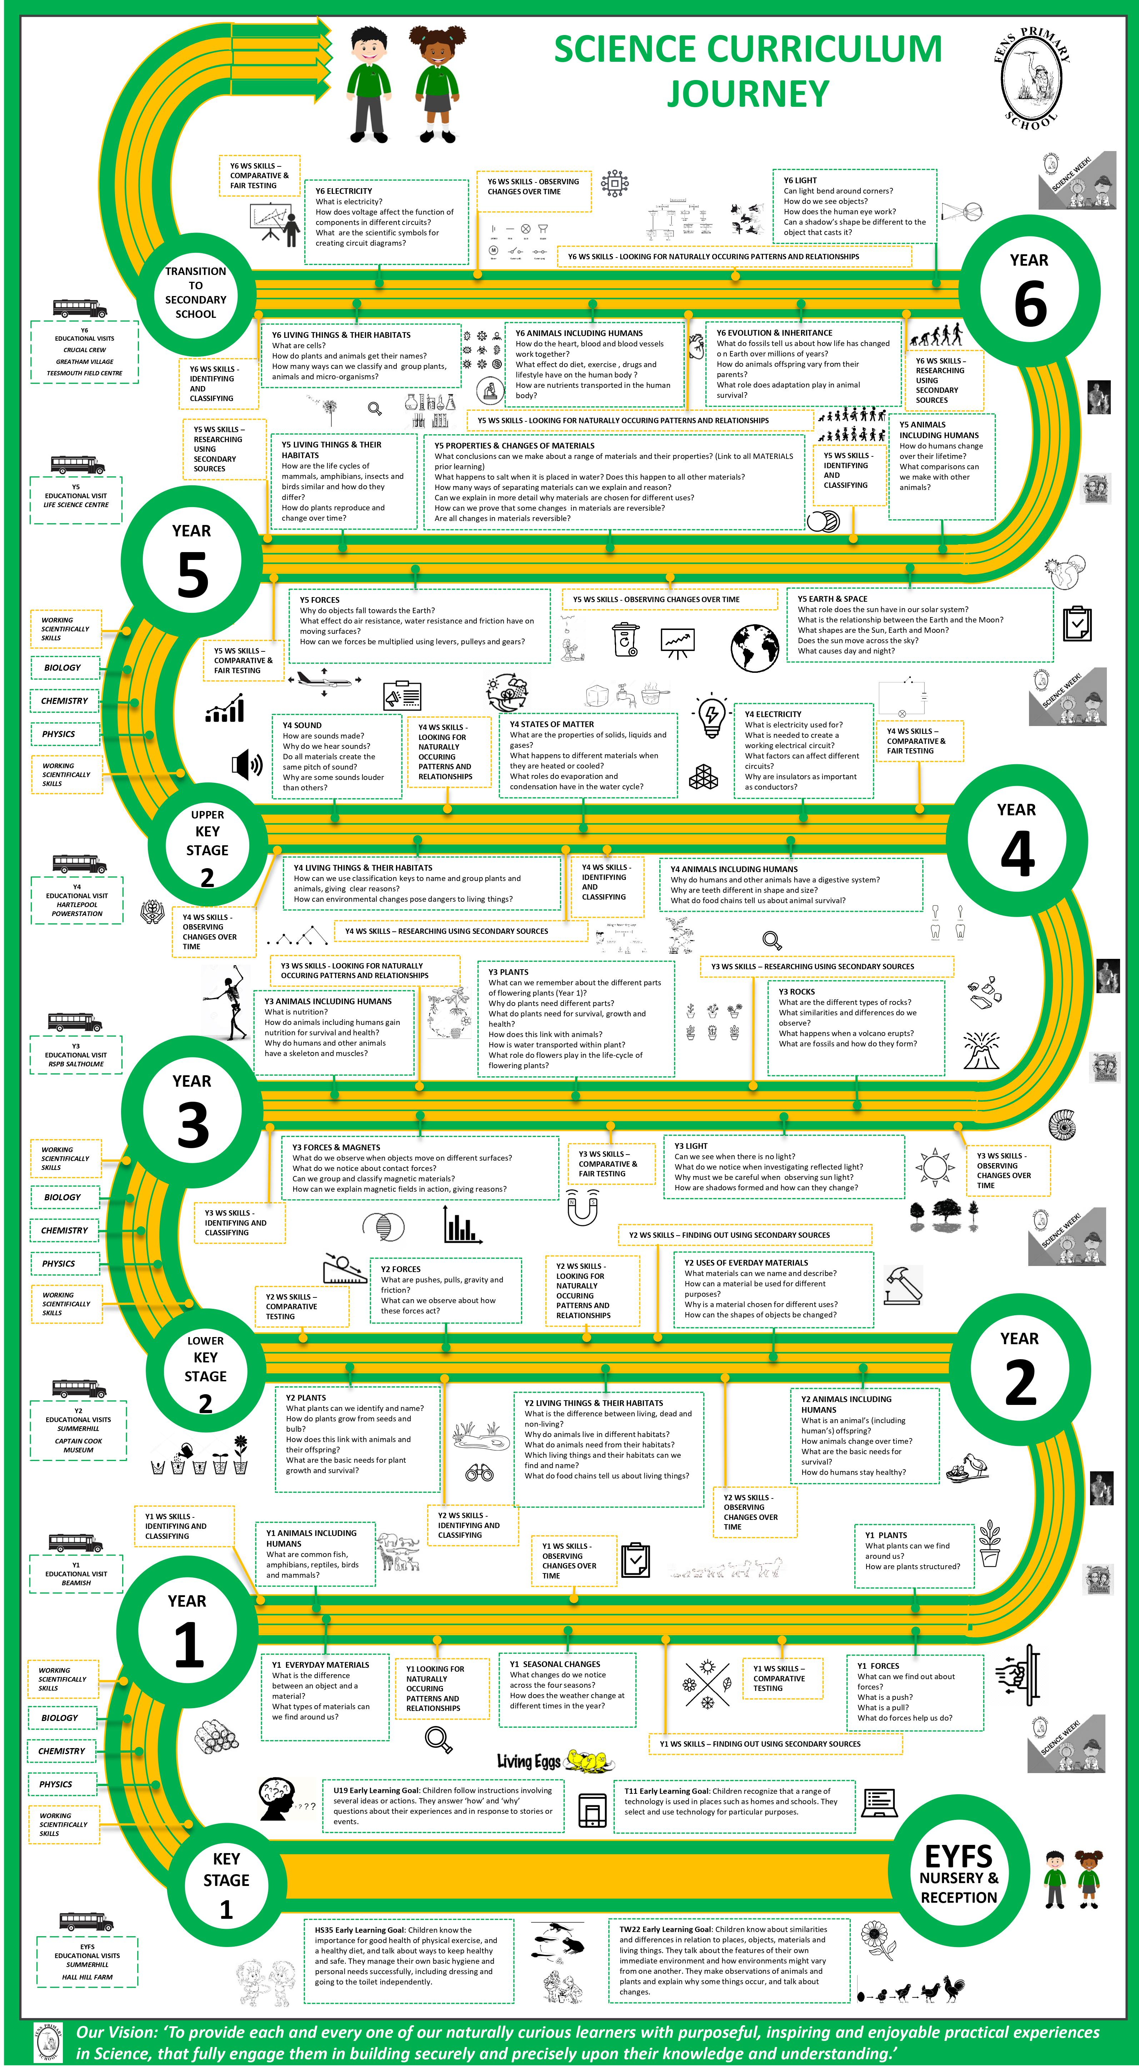

APPENDIX 2 Long Term Plan

Fens Primary School, Hartlepool | 2021-2022

Long Term Plan 2021/2022
PROGRAMME OF STUDY: SCIENCE

 | Term | YEAR 1 | YEAR 2 | YEAR 3 | YEAR 4 | YEAR 5 | YEAR 6
 | T1A | Animals, including humans | Animals, including humans | Forces and magnets | Living things and their habitats | Living things and their habitats  Revision : Green plants | Living things and their habitats
 | T1B | Light & Sound | Uses of everyday materials | Light | Animals, including humans  (Teeth) | Animals, including humans | Animals, including humans
 | T2A | Everyday materials | Forces/ Electricity | Rocks | States of matter | Properties and changes of materials | Evolution and inheritance
 | T2B | Forces | Living things and their habitats | Animals, including humans  (Skeletons) | Electricity | Earth and space | Light
 | T3A | Plants | Plants | Plants | Sound | Forces | Electricity
 | T3B | Revision/ Revisiting of key concepts for target groups.  Science Project  (Linked to key learning from the year)  Seasonal changes Taught Throughout | Revision/ Revisiting of key concepts for target groups.  Science Project  (Linked to key learning from the year) | Revision/ Revisiting of key concepts for target groups.  Shadows  Science Project  (Linked to key learning from the year) | Revision/ Revisiting of key concepts for target groups.  Sound Science Project  (Linked to key learning from the year) | Revision/ Revisiting of key concepts for target groups.  Science Project  (Linked to key learning from the year) | Revision/ Revisiting of key concepts for target groups.  Science Project  (Linked to key learning from the year)

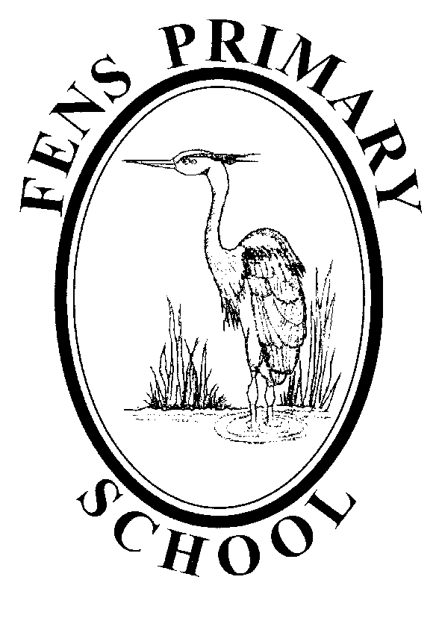
PLANNING FILE –Science– MEDIUM TERM PLAN Term 1
Year 6 2021/2022
Living things and their habitats
NNC Statutory Requirements | Fens Primary School Science Learning Objectives | Y5 and Y6 - Working Scientifically (NNC Statutory)
Pupils should be taught to:  - describe how living things are classified into broad groups according to common observable characteristics and based on similarities and differences, including micro-organisms, plants and animals  - give reasons for classifying plants and animals based on specific characteristics. | Session 1:  To learn about a significant Scientist in the field of classification.  Session 2:  To describe how living things can be classified into kingdoms, phylum and classes.  To develop our use of keys to organise data.  Session 3:  To accurately use taxonomy and explain how organisms are related to each other  Session 4  To revise and refine our knowledge when grouping and classifying vertebrates.  Session 5  To develop our use of scientific diagrams.  To deepen and develop reasoning when comparing and contrasting vertebrates.  Session 6  To use and apply our enhanced knowledge to developing our use of scientific keys.  Session 7  To develop our use of bar-line charts when analysing a data set  To use the PEE(L) structure to refine our conclusion writing.  Session 8  To know that micro-organisms are living organisms that are often too small to be seen, and that they can be beneficial or harmful to humans  LO: To Know that micro-organisms exist, they can be easily spread and that some are harmful.  Session 9  To recognise the difference between a Scientific question that can be investigated and one that cannot.  To develop our questioning skills so that we can plan an investigation.  To develop our data recording and conclusion skills.  Vocabulary: taxonomy, classification, binomial, Eukaryote, Domain, Kingdom, Phylum, Class, Order, Family, Genus, Species, vertebrate, invertebrate, habitat, organism, mammal, bird, fish, reptile, amphibian, lungs, gills, microorganism | During years 5 and 6, pupils should be taught to use the following practical scientific methods, processes and skills through the teaching of the programme of study content:  - planning different types of scientific enquiries to answer questions, including recognising and controlling variables where necessary  - taking measurements, using a range of scientific equipment, with increasing accuracy and precision, taking repeat readings when appropriate  - recording data and results of increasing complexity using scientific diagrams and labels, classification keys, tables, scatter graphs, bar and line graphs  - using test results to make predictions to set up further comparative and fair tests  - reporting and presenting findings from enquiries, including conclusions, causal relationships and explanations of and degree of trust in results, in oral and written forms such as displays and other presentations  - identifying scientific evidence that has been used to support or refute ideas or arguments.
Cross Curricular Opportunities
Maths: data handling (venn, Carroll, binary key)
Literacy: non-chronological reports, speaking and listening (guest speaker Ian Bond), note-taking, reciprocal reading
Geography: biomes
Bousfield Learning Suite Opportunities: seed dispersal activities, non-chronological team teaching
NNC Notes and Guidance
Pupils should build on their learning about grouping living things in year 4 by looking at the classification system in more detail. They should be introduced to the idea that broad groupings, such as micro-organisms, plants and animals can be subdivided. Through direct observations where possible, they should classify animals into commonly found invertebrates (such as insects, spiders, snails, worms) and vertebrates (fish, amphibians, reptiles, birds and mammals). They should discuss reasons why living things are placed in one group and not another.
Pupils might find out about the significance of the work of scientists such as Carl Linnaeus, a pioneer of classification.
Pupils might work scientifically by: using classification systems and keys to identify some animals and plants in the immediate environment. They could research unfamiliar animals and plants from a broad range of other habitats and decide where they belong in the classification system.
APPENDIX 3 Example Medium Term Plan
APPENDIX 4 End of Unit Assessment of Learning

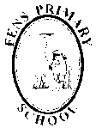
ASSESSMENT FILE –Science– Assessment of Learning Term 1a
Year 2 2021/2022
Animals including humans
Y1 Statutory requirements:
- identify and name a variety of common animals including fish, amphibians, reptiles, birds and mammals
- identify and name a variety of common animals that are carnivores, herbivores and omnivores
- describe and compare the structure of a variety of common animals (fish, amphibians, reptiles, birds and mammals, including pets) identify, name, draw and label the basic parts of the human body and say which part of the body is associated with each sense.
Working towards Y2 NNC Requirements:  - notice that animals, including humans, have offspring which grow into adults?  - find out about and describe the basic needs of animals, including humans, for survival (water, food and air)?  - describe the importance for humans of exercise, eating the right amounts of different types of food, and hygiene? | Working at the expected standard, having learned to:  - notice that animals, including humans, have offspring which grow into adults?  - find out about and describe the basic needs of animals, including humans, for survival (water, food and air)?  - describe the importance for humans of exercise, eating the right amounts of different types of food, and hygiene? | Working at greater depth within the expected standard.  Y3 NNC requirements for information:  - identify that animals, including humans, need the right types and amount of nutrition, and that they cannot make their own food; they get nutrition from what they eat  - identify that humans and some other animals have skeletons and muscles for support, protection and movement.
Staff to consider which learners are ‘Working Towards’ the expectations for this unit of Science.  Working Scientifically skills should be taken into account to make this judgement.  Careful consideration should be given as to why learners have not met the expectations of the unit. Which key concepts do they need revisit? How can this be achieved?  If the learner has not met the expectations because of their ‘Working Scientifically’ skills, then what opportunities need to be planned for future teaching?  Year group teams should moderate their judgements to ensure consistency.  Notes for future teaching for this group should be recorded on ‘Information for future teaching grid’. | Staff to consider which learners are ‘Working at’ the expected standard.  Working Scientifically skills should be taken into account to make this judgement.  A range of evidence should be taken into account, including observation of the learner at work, verbal and written responses by the learner, Rising Star or other appropriate test materials among any other evidence that the teacher deems appropriate, knowing the children in their class.  Year group teams should moderate their judgements to ensure consistency. | Staff to consider which learners are ‘Working at greater depth ’ within the expected standard.  Working Scientifically skills should be taken into account to make this judgement.  A range of evidence should be taken into account, including observation of the learner at work, verbal and written responses by the learner, Rising Star or other appropriate test materials among any other evidence that the teacher deems appropriate, knowing the children in their class.  Year group teams should moderate their judgements to ensure consistency.  Notes for future teaching for this group should be recorded on ‘Information for future teaching grid’.
Notes for Coordinator (Resource needs/ issues arising etc…)

APPENDIX 5 Information for Future Teaching grid


ASSESSMENT FILE –Science– Assessment of Learning Term 1a Year 2 2021/2022
INFORMATION FOR FUTURE TEACHING
Animals including humans
 | GAT | HA | MA | LA | SEN
Objective 1  To know why we need food, water and air; and that food can be put into different groups. |  |  | Names of/Assessment notes on individuals/ groups to be noted with particular reference to vulnerable groups.
Objective 2  To understand what eating healthily means. |  |  |  | Names of/Assessment notes on individuals/ groups to be noted with particular reference to vulnerable groups.
Objective 3
To collect data about our favourite food.
Objective 4  To know we need to exercise to be healthy. |  |  |  |  | Names of/Assessment notes on individuals/ groups to be noted with particular reference to vulnerable groups.
Objective 5  To know that animals (including humans) produce young which grow into adults. |  | Names of/Assessment notes on individuals/ groups to be noted with particular reference to vulnerable groups.
Objective 6
To observe closely using simple equipment.
To gather and record data to help answer a question.

Appendix 6 – Target Children Feedback to Staff
ASSESSMENT FILE –Science– Children requiring monitoring and appropriate support and challenge. Informed by End of Topic Assessments.
Science Data for Year 4 - 2020/2021
INFORMATION FOR FUTURE TEACHING 2021/2022
‘Working Scientifically’ assessed as an integral part of each unit covered.
Term 1a – Living Things and their Habitats  - recognise that living things can be grouped in a variety of ways  - explore and use classification keys to help group, identify and name a variety of living things in their local and wider environment  - recognise that environments can change and that this can sometimes pose dangers to living things. | Term 1b – Animals, including Humans (Teeth)  - describe the simple functions of the basic parts of the digestive system in humans  - identify the different types of teeth in humans and their simple functions  - construct and interpret a variety of food chains, identifying producers, predators and prey. | Term 2a – States of Matter  - compare and group materials together, according to whether they are solids, liquids or gases  - observe that some materials change state when they are heated or cooled, and measure or research the temperature at which this happens in degrees Celsius (°C)  - identify the part played by evaporation and condensation in the water cycle and associate the rate of evaporation with temperature. | Term 2b – Electricity  - identify common appliances that run on electricity  - construct a simple series electrical circuit, identifying and naming its basic parts, including cells, wires, bulbs, switches and buzzers  - identify whether or not a lamp will light in a simple series circuit, based on whether or not the lamp is part of a complete loop with a battery  - recognise that a switch opens and closes a circuit and associate this with whether or not a lamp lights in a simple series circuit  - recognise some common conductors and insulators, and associate metals with being good conductors. | Term 3a –Sound  - identify how sounds are made, associating some of them with something vibrating  - recognise that vibrations from sounds travel through a medium to the ear  - find patterns between the pitch of a sound and features of the object that produced it  - find patterns between the volume of a sound and the strength of the vibrations that produced it  - recognise that sounds get fainter as the distance from the sound source increases. | Y4  Working  Scientifically | Y4  SCIENCE  OVERALL
Working Towards Expectations
Child’s name | Child’s name | Child’s name | Child’s name | Child’s name | Child’s name | Child’s name
Child’s name | Child’s name | Child’s name | Child’s name | Child’s name | Child’s name | Child’s name
Working Above Expectations
Child’s name | Child’s name | Child’s name | Child’s name | Child’s name | Child’s name | Child’s name
Child’s name | Child’s name | Child’s name | Child’s name | Child’s name | Child’s name | Child’s name

