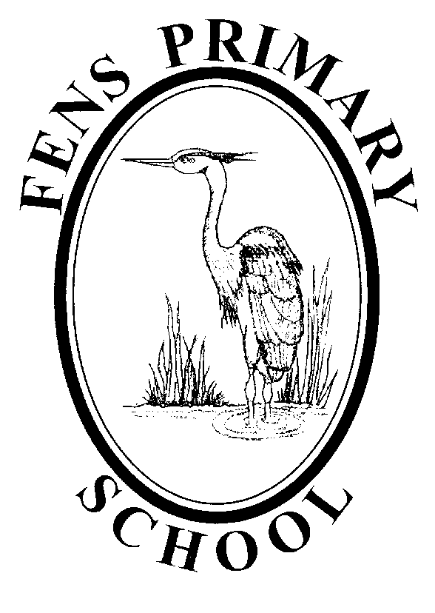

HISTORY POLICY

Policy review: October 2017
Next Review: October 2020

The History Curriculum at Fens
At Fens Primary School we have an exciting History curriculum that engages the children’s curiosity in learning about the lives of people who lived in the past. We believe that the study of historical persons, places, periods and change over time, not only helps children develop a sense of their own identity, but also allows them to explore their own and other people’s cultures with respect. In considering the actions of historical persons and people, the pupils of Fens Primary School are better equipped to develop their own moral code which impacts on their own life decisions.

Quality teaching stimulates the children’s interest and understanding of how past events have influenced our lives today and inspires them to find out more. Children are taught to investigate and raise perceptive questions about events, developing the essential skills of enquiry, analysis, interpretation and problem solving.

Aims for the teaching of History
We aim:

- To promote an interest in the past.
- To develop an understanding of events over time.
- To develop a sense of chronology.
- To understand and use a variety of historical terms.
- To understand a variety of historical concepts.
- To learn about the roles that individuals and events have played in shaping modern society.
- To develop an ability to investigate and interpret different versions of past events.
- To learn to study historical evidence and to ask and answer questions about the past.
- To develop the ability to communicate historical knowledge and understanding using a variety of techniques.
- To encourage children to understand other people, their beliefs, thoughts, values and experiences.
- To develop an awareness of the world around them.
- To develop an understanding of society and their place within it, so that they acquire a sense of their cultural heritage.
- To develop a knowledge and understanding of historical development in the wider world.

Key Skills
We encourage children to develop the following skills:

- Empathy
- Interpretation of secondary and primary sources
- Historical enquiry and questioning
- Communicating history dramatically, verbally and narratively
- Research

Delivering the Curriculum
History teaching at Fens Primary School aims to facilitate all children in engaging with the curriculum. Learning opportunities are differentiated in order to accommodate the needs of the children and appropriate support is provided where necessary.
Teachers plan units of work with a view to using:
- Historical artefacts and primary sources.
- Secondary sources.
- Support from local historical organisations.
- Visits to local sites of historical significance.
- Visitors with specific knowledge or experiences to share.
- Questioning and interpretation.
- Stories and storytelling.
- Hot – seating.
- Links to other areas of the curriculum.
- The use of the ‘Bousfield Suite’.

Teachers differentiate their lessons through:
- Matching the challenge of the task to the ability of the child and grouping the children accordingly.
- Having mixed ability groups where learners can support each other.
- Questioning at different levels.
- Additional support for some learners.
- The use of appropriate vocabulary at varying levels of difficulty during lessons.
- Modified text passages as expected in other curriculum areas.
- Additional or different resources.
- Using different methods of recording work.
- Elements of lessons catering for all learners, audio, visual, kinaesthetic.
- Incorporating targets and strategies from SEND children’s IEPs into lesson planning.
- Planning some open ended activities with a variety of outcomes and possibilities.
- Allowing for children to extend their own learning through research, homework or extracurricular activities.

For gifted and talented pupils we will:
- Provide teaching and learning experiences that encourage pupils to think creatively, explore and develop ideas, and try different approaches. Pupils should be encouraged to set their own questions, offer ideas, suggest solutions or explanations, and reflect on what they have heard, seen or done in order to clarify their thoughts.
- Encourage greater independence in working, e.g. a pupil to be able to carry out their own simple historical enquiry.
- Provide real-life research and presentation opportunities, for example carrying out interviews with local people and collating the results.

The importance of questioning in History

In order to begin to understand the past we must encourage children to be curious. They must want to ask questions and partake in the process of enquiry, examining sources about the past, querying and debating their meaning and implications.

Examples of questioning:

Closed and open questions

Closed questions test recall and understanding and help children to revise what they know. In this way children can support other learners by reminding them of previous learning.
Open questions in History encourage children to give their own views and stimulate discussion. They focus the children’s attention, interest and curiosity and serve as a platform for investigation. Open questions promote higher order thinking and so help children to develop their thinking skills.

Key questions
Key questions are useful in giving the children a focus on which to base their learning throughout the unit of work. They inspire investigation into a topic and can provide a framework on which to base future learning.

Asking questions
At Fens we provide opportunities for children to ask their own questions and History gives the pupils occasion to regularly practise this valuable skill. All children are encouraged to record, research and investigate a particular topic with their questions in mind. Where a question cannot be answered we then discuss why it was not possible.

Links to other areas of the curriculum

Fens Primary School History Curriculum

Early Years Foundation Stage
History in the Foundation Stage is taught through ‘Knowledge and Understanding’. It encompasses humanities subjects and science. Historical concepts and terminology are therefore closely linked and interchangeable with other curriculum areas. The children are supported in developing the knowledge, skills and understanding that helps them to make sense of the world. The pupils are encouraged to talk about their families and past and present events in their lives. They are beginning to gain knowledge and understanding of the world through:
- Photographs
- Listening to stories and memories of older people
- Role play activities
- Discussing events in the past and their own personal lives
- Sequencing events to gain a sense of time
- Celebration and commemoration of significant historical events
- Assemblies and class worship
- School trips and visits
- Books and television programmes
- Access to explore artefacts

Key Stage 1

The National Curriculum Programme of Study at Key Stage 1 focuses on developing children’s awareness of the past, using common words and phrases relating to the passing of time. They should know where the people and events they study fit within a chronological framework and identify similarities and differences between ways of life in different periods. Children should use a wide vocabulary of everyday historical terms. They should ask and answer questions, choosing and using parts of stories and other sources to show that they know and understand key features of events. They should understand some of the ways in which we find out about the past and identify different ways in which it is represented.
In planning to ensure the progression described above through teaching about the people, events and changes outlined below, teachers are often introducing pupils to historical periods that they will study more fully at Key Stage 2.
Pupils should be taught about:
- Changes within living memory
- Events beyond living memory that are significant nationally or globally
- The lives of significant individuals in the past who have contributed to national and international achievements
- Significant historical events, people and places in their own locality

Key Stage 2
The National Curriculum Programme of Study at Key Stage 2 should continue to allow children to develop a chronologically secure knowledge and understanding of British, local and world history, establishing clear narratives within and across the periods they study. They should note connections, contrasts and trends over time and develop the appropriate use of historical terms. They should regularly address and sometimes devise historically valid questions about change, cause, similarity and difference, and significance. Children should construct informed responses that involve thoughtful selection and organisation of relevant historical information. They should understand how our knowledge of the past is constructed from a range of sources.
Pupils should be taught about:
- Changes in Britain from the Stone Age to the Iron Age
- The Roman Empire and its impact on Britain
- Britain’s settlement by Anglo-Saxons and Scots
- The Viking and Anglo-Saxon struggle for the Kingdom of England to the time of Edward the Confessor
- A local history study
- A study of an aspect or theme in British history that extends pupils’ chronological knowledge beyond 1066
- The achievements of the earliest civilizations – an overview of where and when the first civilizations appeared and a depth study of one of the following: Ancient Sumer; The Indus Valley; Ancient Egypt; The Shang Dynasty of Ancient China
- Ancient Greece – a study of Greek life and achievements and their influence on the western world
- A non-European society that provides contrasts with British history – one study chosen from: early Islamic civilization, including a study of Baghdad c. AD 900; Mayan civilization c. AD 900; Benin (West Africa) c. AD 900-1300

Assessment
Children’s progress should be assessed through observation and completion of differentiated tasks. Assessment outcome sheets should accompany planning documents and be used as a basis for ‘next steps’ and further learning opportunities. End of unit assessment sheets are completed at the end of a topic.

Marking
The marking of work in History should be in line with the whole school marking policy and feedback should refer to the historical objective. Comments regarding to other areas of the curriculum should not be used to form an assessment on the child’s historical skills. Pupils are encouraged to improve their own learning performance through the school marking policy.

Resources
The History resources are centrally stored, largely in historically themed boxes. All staff have access to the resources.
Resources include original artefacts, replica artefacts as well as published materials, photographs, costumes, video and audio tapes and computer software. If further material is required in order to teach a particular topic, we can liaise with the local museum services to borrow their resource boxes on short term loan.

Monitoring and Reviewing
The policy will be reviewed annually by the History Leader in consultation with the Headteacher, the Governors and the Chair of Governors.
It will be updated, modified or amended as necessary.
Signed:……………………………………………………….. Date:…………………
(History Lead)
Signed:……………………………………………………….. Date:…………………..
(Headteacher)
Signed:……………………………………………………….. Date:…………………..
(Chair of Governors)

