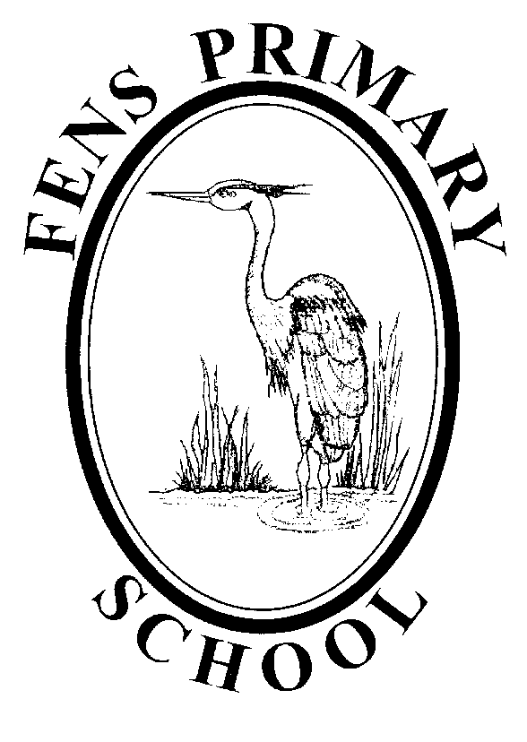

EARLY YEARS FOUNDATION STAGE POLICY

Policy review: October 2017
Next Review: October 2018

Within this document, the term Early Years Foundation Stage is used to describe children who are in our Nursery and Reception classes.

Aim
At Fens we aim to provide the highest quality care and education for all our children thereby giving them a strong foundation for their future learning. We create a safe and happy environment with motivating and enjoyable learning experiences that enable children to become confident and independent. We value the individual child and work alongside parents and others to meet their needs and help every child to reach their full potential.
As outlined in the EYFS Statutory Framework, ‘Every child deserves the best possible start in life and the support that enables them to fulfil their potential. Children develop quickly in the early years and a child's experiences between birth and age five have a major impact on their future life chances.’

We adhere to the Statutory Framework of the EYFS and the four guiding principles that shape practice within Early Years settings.
- Every child is a unique child, who is constantly learning and can be resilient, capable, confident and self-assured
- Children learn to be strong and independent through positive relationships
- Children learn and develop well in enabling environments, in which their experiences respond to their individual needs and there is a strong partnership between practitioners and parents and/or carers
- Children develop and learn in different ways and at different rates

Principles into practice
As part of our practice we:
- Work in partnership with parents and other agencies
- Have a key person approach to develop close relationships with individual children
- Provide a secure and safe learning environment indoors and out
- Provide a broad and balanced curriculum across the seven areas of learning
- Promote equality of opportunity and anti-discriminatory practice. We provide early intervention for those children who require additional support
- Plan challenging learning experiences, based on the individual child, informed by observation and assessment
- Provide opportunities for children to engage in activities that are adult-initiated and child-initiated, supported by the adult

Foundation Stage Curriculum
We plan an exciting and challenging curriculum based on our observation of children’s needs, interests, and stages of development across the seven areas of learning to enable the children to achieve and exceed the early learning goals by the end of the reception year.
All the seven areas of learning and development are important and inter-connected.
Three areas are particularly crucial for igniting children's curiosity and enthusiasm for learning, and for building their capacity to learn, form relationships and thrive.

These three areas are the prime areas:
Communication and Language
Physical Development
Personal, Social and Emotional Development

Children are also supported through the four specific areas, through which the three prime areas are strengthened and applied.

The specific areas are:
Literacy
Mathematics
Understanding the World
Expressive Arts and Design

Children are provided with a range of rich, meaningful first-hand experiences in which children explore, think creatively and are active. We aim to develop and foster positive attitudes towards learning, confidence, communication and physical development.
Practitioners working with the youngest children in Nursery will focus strongly on the three prime areas, which are the basis for successful learning in the other four specific areas. The three prime areas reflect the key skills and capacities all children need to develop and learn effectively, and become ready for school. The balance will shift towards a more equal focus on all areas of learning as the children move through the Early Years at Fens and grow in confidence and ability within the three prime areas.

Children have whole group and small group times which increase as they progress through the EYFS with times for a daily phonics session using ‘Letters and Sounds’, and teaching aspects of Mathematics and Literacy, including shared reading and writing.
The curriculum is delivered using a play-based approach as outlined by the EYFS Guidance.
‘Each area of learning and development must be implemented through planned, purposeful play and through a mix of adult-led and child-initiated activities’
Planning
We plan a balance between children having time and space to engage in their own child-initiated activities and those that are planned by the adults. During children’s play, early years practitioners interact to stretch and challenge children further.
In planning and guiding children's activities, we reflect as practitioners on the different ways that children learn and reflect these in our practice. Planning is thematic and is based on popular books, first-hand experience, children’s interests and fascinations, and current events.
We create a stimulating environment for children to learn indoors and outdoors. Teaching outdoors reflects the indoor learning. Practitioners are developing the use of ‘Forest Schools’ for outdoor learning.

Observation and Assessment
As part of our daily practice, we observe and assess children’s development and learning to inform our future plans. We record our observations in a variety of ways. Everyone is encouraged to contribute and discussions take place. Children’s progress is closely monitored through the use of on entry assessment, termly pupil trackers, and the EYFS profile. Staff moderate assessments internally and externally with other schools within the local authority to validate the judgements and ensure consistency and transparency. Significant observations of children’s achievements are collated in their own personal learning journey, which are shared with parents. Parents are invited to attend a parents evening each term, and reports are written at the end of the school year.
Within the final term of Reception, we provide the parents with a report based on their child's development against each of the Early Learning Goals and the characteristics of their learning. The parents are then given the opportunity to discuss these judgements with the Reception teacher in preparation for Year 1.

Safety
Children’s safety and welfare is paramount. We create a safe and secure environment and provide a curriculum which teaches children how to be safe, and make good choices. We have stringent policies, procedures and documents in place to ensure children’s safety.
We promote the good health of the children in our care in numerous ways, including the provision of daily fruit, following set procedures when children become ill or have an accident.
Please see our separate policies and procedures on Health and Safety, Child Protection, Safeguarding, Educational Visits, Intimate Care, and Administration of Medication.

Inclusion
We value all our children as individuals at Fens, irrespective of their ethnicity, culture, religion, home language, background, gender or ability. We plan a curriculum that meets the needs of the individual child and supports them at their own pace so that most of our children achieve and even exceed the Early Learning Goals. We strongly believe that early identification of children with additional needs is crucial in enabling us to give the child the support that they need and in doing so, work closely with parents and outside agencies.

Parents as Partners
We strive to create and maintain an excellent partnership with parents and carers as we recognise that together, we can have a significant impact on a child’s learning. We welcome and actively encourage parents to participate confidently in their child’s education and care in numerous ways. We operate an open door policy, supported by our school parent support officer.
Working with other services and organisations is integral to our practice in order to meet the needs of our children. At times we may need to share information with other professionals to provide the best support possible.
We draw on our links with the community to enrich children’s experiences by taking them on outings and inviting members of the community into our setting.

Transitions
Transitions are carefully planned for and time is given to ensure continuity of learning. At any transition, we acknowledge the child’s needs and establish effective partnerships with those involved with the child. Children attend introductory sessions to Nursery/Reception to develop familiarity with the setting and practitioners. They receive a small booklet containing photos and parents complete an ‘All about me’ sheet, providing practitioners with information to best care for the child during their early days in the setting. Parents are also invited to a meeting with the teachers, and head teacher, in the summer term before the transition to Reception. Parents are also invited to bring their child to sample a school meal.
In the final term in Reception, the Year 1 teacher will meet with the Early Years staff and discuss each child's development against the Early Learning Goals in order to support a smooth transition to Year 1. This discussion helps the Year 1 teacher to plan an effective, responsive and appropriate curriculum that will meet the needs of all children.

Monitoring and Reviewing
The policy will be reviewed annually by the EYFS Leader in consultation with the Headteacher, the Governors and the Chair of Governors.
It will be updated, modified or amended as necessary.
Signed:……………………………………………………….. Date:…………………
(EFS Lead)
Signed:……………………………………………………….. Date:…………………..
(Headteacher)
Signed:……………………………………………………….. Date:…………………..
(Chair of Governors)

