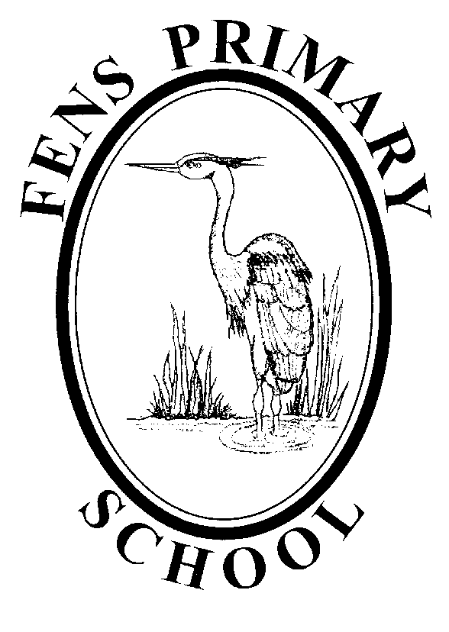

ARTS POLICY

Policy review: 2017
Next Review: 2020

Fens Primary School
The Arts Policy

Vision
To ensure that every child in Fens Primary School has access to quality teaching and learning and that staff maintain their commitment to raising standards.
Ethos
Fens Primary school is dedicated to the pursuit of high standards in all aspects of school life, academic, creative, inter-personal skills and citizenship. We encourage our pupils to be caring, self-motivated and independent. They are secure in the knowledge that they will be treated fairly as equals with compassion and respect. We hope that this atmosphere will develop pupils with high self-esteem who are able to achieve their full potential.
Equal Opportunities
The staff and governors recognise that all children will be given the same opportunities to develop their full potential, regardless of race, gender or ability.
Aims
At Fens School we aim to provide children with arts experiences which are creative, enjoyable and develop confidence, based on the central activities of creating, performing, appraising and appreciating.
The aims of the Arts curriculum at Fens Primary School are to enable pupils to:
- Be taught within the requirements of the National Curriculum and beyond.
- Realise their full potential in an individual, creative and imaginative way and to value their own capacity for producing a range of different art forms.
- Understand and communicate ideas and feelings through the languages of art, music, drama and dance.
- Develop aesthetic awareness and the ability to make informed critical judgements.
- Understand the cultural diversity and appreciate different values and traditions.
- Gain enjoyment from participation in and appreciation of the different art forms

Schemes of work
Pupils will be taught art, music, drama and dance throughout the curriculum. These will be linked to other curriculum areas, as and where appropriate.
The teaching of the Arts will be in line with the National Curriculum and will extend beyond this. All staff should implement the school’s remodelled programmes of study for art, music, drama and dance.
The Arts subjects should also be used wherever possible to enhance the whole curriculum and promote and develop creativity.
Resources
All resource cupboards are well organised and clearly labelled to ensure that staff can access all materials quickly and efficiently.
All art materials and resources are located in the central store in the Upper School hall.
Musical instruments are kept in the music store opposite the Garden Room or in the Resource Room.
There are two pianos and two Yamaha Clavinovas, available for performances and use in classrooms. All additional resources can be obtained from the music coordinator.
The halls are available for class performance rehearsals at various times during the week. The most relevant timetable can be found on the staffroom notice board.
The library contains a range of books on the Arts, which are for use by children and staff.
Any additional requests for resources must be handed in to the Arts coordinator.
Role of the subject coordinators
Both the art and music coordinators will endeavour to:
- provide advice, guidance, support and training to staff
- set a good example
- monitor and evaluate the planning and teaching of the Arts
- ensure that resources are readily available
- attend appropriate courses and disseminate appropriate information
- review, evaluate and produce a development plan for the Arts in line with the school development plan
- lead curriculum improvement in the Arts.
- liaise with other staff to offer a range of extra-curricular arts activities which will be accessible to all children. These will mainly take place over lunchtimes and after school.
- organise a range of Arts enrichment activities and projects in line with local Arts agencies.
- promote the arts in school within the wider community
- liaise with Literacy, P.E, multicultural and extended schools co-ordinators in order to achieve all of the above.
- To plan and evaluate an annual Arts Week which may be based around internationalism or multicultural awareness.

Assessment and Monitoring
Assessments are recorded on an end of unit assessment sheet and are then used to inform future planning.
Planning and Organisation
All staff should follow agreed topics as detailed in LTPs. Each year group are allocated two units of work in Art and 3 units of work in Music. The order of these units and timetabling is up to the individual class teacher.
Teaching time for the Arts varies according to the topics being taught however this should be approximately 2 hours per week. Dance is incorporated in to the PE and takes place over a term block each year. As a guide teachers should deliver 6 hours of art and 6 hours of music every term.
Short term planning should include learning objectives, main teaching activities, learning outcomes, differentiation and any cross curricular links. These detailed plans should be kept in short term planning files.
Teaching assistants will assist the teacher where necessary and their role will be planned for in the short term planning. Assessment and feedback will be given after the lesson. Teachers should record feedback on an assessment outcomes sheet.
Arts Week
The objective for the annual event is to enhance the Arts curriculum by providing opportunities for all children, in both key stages, to access a range of cross-curricular activities.
Foundation Stage
The creative development of all children at the Foundation stage should be planned for in accordance with the Early Learning Goals and assessed in line with the Foundation Stage Profile. Creative work should be encouraged as part of the theme as decided by the Early Years Practitioners.

Homework
Parents are encouraged to take an active role in supporting children’s development in the arts. This includes supporting their learning of instruments, songs and parts for productions. Homework may be given to support activities within the classroom and will be set in accordance with the school’s homework policy.
Special Educational Needs
Pupils are taught in mixed class groups and we consider it vital that all pupils irrespective of gender, ability, ethnic origin and social class are given access to the full Arts curriculum. Teachers’ should set high expectations and provide opportunities for all pupils to achieve and progress. Where appropriate individual needs should be catered for so that all pupils can take part in lessons fully, effectively and to the best of their ability.
Health and Safety
It is the responsibility of each teacher to make themselves aware of Health and Safety guidelines as detailed in the National Curriculum.
Children will be taught the safe handling of tools and materials and will be encouraged to develop a sense of safety for themselves and others.
Displays
Displays should be used to create a rich, challenging and lively environment for pupils to learn. Children’s work should be well displayed and displays should be titled and labelled with a context of work. Displays should also pose questions and stimulate enquiry as well as arouse the children’s interest and curiosity. They should be changed regularly and used to celebrate and value children’s achievements. Work across all ages and abilities should be included and reflect the curriculum on offer.
Display boards within communal areas, throughout the school, are allocated to each member of staff and should be changed on a regular basis.
The display in the entrance hall is a school council/merit winner board to be updated by Art Coordinator.
M.Carson/ J.Sibly
September 2017

Monitoring and Reviewing
The policy will be reviewed annually by the SLT Designated Safeguarding Leader in consultation with the Headteacher, the Governors and the Chair of Governors.
It will be updated, modified or amended as necessary.
Signed:……………………………………………………….. Date:…………………
(Designated Safeguarding Lead)
Signed:……………………………………………………….. Date:…………………..
(Headteacher)
Signed:……………………………………………………….. Date:…………………..
(Chair of Governors)

