Dear Parents and Carers,
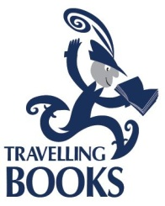
We are having a visit from Travelling Books ‘Book Fair’ on Friday 1st March until Wednesday 6th March. Every Book Fair is packed with hundreds of the best children’s books for all ages – from award-winners and the newest titles to pocket-money pick-ups and treasured classics.
The range includes picture books, early readers, chapter books, books for reluctant readers, older fiction, non-fiction, home learning and lots more. The main hall will be open from 3.20-4.15pm each afternoon. We ask that you accompany your child to the book fair. Books can only be purchased during this time; money for books cannot be sent to classes. This year we will be able to accept cards payments.
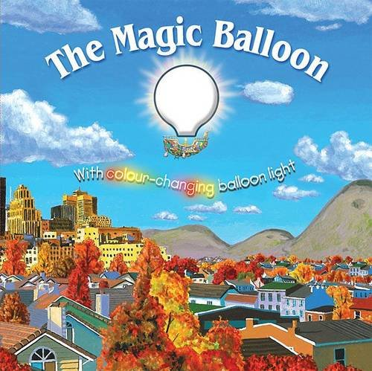
We are celebrating the love of books and writing this year during the week of the 04.03.19. This year we are basing our writing on the story of The Magic Balloon. We will showcase our writing on Friday 8th March from 3.30-4.30pm. We hope to see you all there.

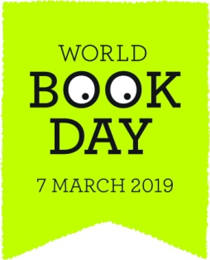
We will be celebrating ‘World Book Day 2019’ in school on Friday 8th March. We will celebrate the joy and value of books and reading by choosing from the following ideas:
- Come to school dressed in a costume as a character from a favourite book.
- Wear, or bring, an item which will be a clue for us to guess a book character (e.g scarf for Harry Potter, red shoes for Dorothy from the Wizard of Oz).
- We will have a book swap on Thursday 7th March. Entry to the book swap is a book your happy for your child to swap. There isn’t any pressure to be involved with this. Children can bring books from Monday 4th March in preparation for the Thursday.
- ‘Share a story with me’ –see separate letter.
In addition, each child will receive a £1 book token which can be used to buy one of the specially produced books, or towards any book worth £2.99 or more at any book store.
Many thanks for your continued support
Mrs Keen

