Supporting your child with maths at home
Year 4
Dicey Tens
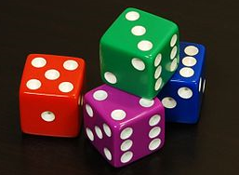
For this game you will need a 1-100 square (a snakes and ladders board could work for this game), 20 counters or coins and a dice.
- Player one chooses a two-digit number on the board e.g. 24.
- They then roll the dice.
- If they roll a 6, they must miss a turn.
- Multiply the number shown on the dice by 10. E.g. if you roll a 4, it becomes 40.
- Either add or subtract this number to or from your two digit number. E.g. 24 + 40 = 64. If you are correct, put a counter/ coin on that number.
- Player two repeats the above steps.
- The first player to get 10 coins on the board is the winner.
Sum It Up
Each player needs to roll a dice at the same time. Add all of the numbers showing on the dice (this should include the top number plus the four numbers around the sides). The player with the highest total scores a point. The first player to 10 points is the winner.
Mugs
For this activity you will need a 1 litre measuring jug and a selection of different mugs, cups or beakers.
- Ask your child to fill a mug with water. Pour the water carefully into the jug and read the measurement to the nearest 10 mililetres.
- Record this on a piece of paper.
- Repeat this with different mugs. Throughout the activity question your child- which mug will hold the most liquid? Is this more or less than the last mug? How much do mug A and B hold in total?
Extension: Ask your child to first estimate how much liquid is in each mug/ beaker and then measure it. How accurate were they?
Measuring
Using a tape measure that shows centimetres, measure different objects e.g. the length of the sofa, the width of the door, the height of the table etc. Order the measurements from the smallest to the largest.

Pairs To 100
This is a game for two players.
- Each player should draw 10 circles and write a different two-digit number in each one. This number cannot be a ‘tens’ number (10, 20, 30, 40).
- Player 1 then chooses one of player 2s numbers and player 2 must say what to add to that number to make 100 e.g. player 1 chooses 64 so player 2 should say 36.
- If player 2 is correct, they cross out the chosen number.
- Player 2 will then choose one of player 1s numbers.
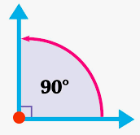
- The first player to cross out 6 numbers is the winner.
Looking Around
Choose a room at home. Challenge your child to spot 20 right angles around the room.

Dicey Division
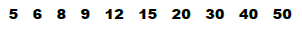
Each player should choose five numbers from the list below and should write them on a piece of paper.

- Take turns to roll a dice. If one of your numbers can divide eactly into the number rolled, cross it out. E.g. You roll a 4 and one of your numbers is an 8. 8 can divide exactly by 4 and so you can cross it out.
- If you roll a 1, miss a go.
- The first to cross out all five of their numbers wins the game.
Tables
By the end of Year Four, the expectation is that children will know all of their times tables up to 12 x 12. Practise times tables with your child as often as possible. This could be when walking home from school, in the car, coming down the stairs etc. Even just five minutes of practise eah day can make a huge difference. Say them forwards and backwards and ask your child quick fire questions such as what are three fives? What is 15 divided by 3? How many threes are in 12? What is seven times four?
Number Game 1
For this game you will need about 20 counters or coins and two dice.
Take turns to roll two dice to make a two-digit number. E.g. If you roll a 4 and a 1, this could be 14 or 41. Add the two numbers in your head. If you are correct, you win a counter. Tell your partner how you worked it out. The winner is the first to get 10 counters/ coins. You could also play this game using subtraction.
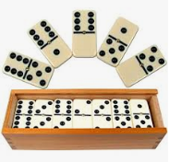
Number Game 2
- Put some dominoes face down on a table or playing space.
- Shuffle them and allow each player to choose a domino.
- Multiply the two numbers on your domino. Whoever has the biggest answer keeps the two dominos.
- The winner is the person with the most dominoes when they are all gone.
Number Game 3
- Using three dice, make a three digit number. E.g. If you roll a three, a two and a five, you could have 325 or 352 etc. Ask your child to round the three digit number to the nearest multiple of 10. Then round to the nearest multiple of 100. Repeat with different 3 digit numbers.

