Supporting your child with maths at home
Year 3

Make 20
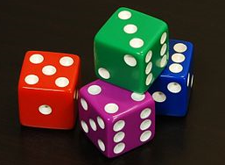
For this game you will need to write out the numbers 0-20 on a piece of paper. Make them big enough to put counters or coins on.
- Take turns to roll two dice and put a coin on the number which you would need to add to make 20. E.g. If you throw a 4, you would put a coin on the number 16 because 16 + 4 = 20.
- If someone else already has a counter on this number you can replace it.
- The first to have counters on 6 different numbers wins the game.
Fractions
Use 12 buttons or paper clips or other small objects. Ask your child to find half of the 12 things. Next find one quarter of the 12 objects and then one third etc. Repeat with different fractions and stress the importance of sharing equally into groups.
Order, Order!
Each player must draw 6 circles. Take it in turns to roll two dice and use the numbers shown on the dice to make a two digit number. Write the two digit number in one of your circles but think carefully about where to place it as the aim is to get all of your numbers in order. Once you write the number in a circle, you cannot change it or move it. If you roll a number which will not fit into your order then forget the number and let the other player take their turn. The first player to successfully place 6 numbers in their circles is the winner.
Number Games
Roll two dice. Make a two-digit number e.g. if you roll 4 and 6, you could make 46 or 64. Ask your child to do one of the following tasks:
- Count on or back from each number in tens.
- Add 19 to each number mentally (a quick way to do this is to add 20 and then take 1 away).
- Subtract 9 from each number mentally (Take away 10 and then add one back on).
- Double each number.

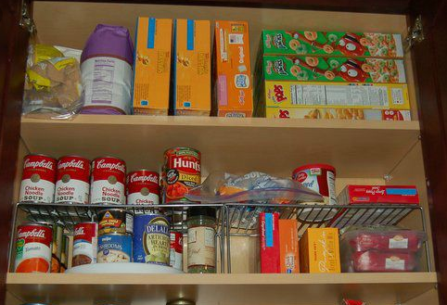
Cupboard Maths
Ask your child to help you sort out your food cupboard. Try putting heavier items on the lower shelf and lighter items on the upper shelf. Encourage your child to pay close attention to the labels and discuss the weight of each item.
Secret Calculations
Ask your child to say a number e.g. 43. Secretly do a caluclation in your head, such as add 30. Tell your child the answer and they must work out what you have done to the number.
Digit Divide
Make digit cards 0-9. Cut out and place them face down on a surface. Choose 3 and make a 3 digit number. Ask your child to read the number aloudand then partition it.
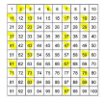
e.g. If your child chooses the 4, 5 and 6 digit cards, they could make the number 456. The child would then read the number as four hundred and fifty-six and partition it as four hundreds, five tens and six ones.
Board Games
For these games you will need to sketch a simple 1-100 square.
Game 1- Start on one and toss a coin. If it lands on heads, move 1 place up the number square. If it lands on tails, add 10 to your number and move to that space. The first player to reach the bottom row is the winner.
Game 2- Start anywhere on the board. Roll a dice. If you land on an even number, you move forwards this many spaces. If you and on an odd number, you move backwards this many spaces.
The first player to land on either 1 or 100 is the winner.
Bingo!
For this game you will need 1-12 number cards. One player has the 2 times tables and the other has the 5 times tables. Write six numbers in that table on your piece of paper. E.g. If you have the 2 times tables, you could write 2, 4, 8, 12, 20, 6 and 16. One player chooses a number card. Multiply that number by your times table (either the 2 or 5s) and check if you have the answer on your piece of paper and cross it out. The first player to get all 6 of their numbers is the winner.
Pasta Race
Take turns to roll two dice. Multiply the two numbers and call the answer out. The first player to shout the answer wins a piece of pasta. The first player to win ten pieces of pasta is the winner of the game.

