Supporting your child with maths at home
Year 1

Adding Circles
For this game, you will need a dice, a pencil and a piece of paper.
Each player should draw four circles on their piece of paper. Write a different number between 2 and 12 in each circle. Roll the dice twice and add the two numbers together. If the total is one of your four numbers, then you can cross it out. The first player to cross out all 4 numbers is the winner.
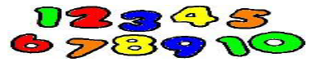
Track Games
Make a number track from 1 to 20. Throw a dice and move along this number of spaces. The first to land on 20 is the winner.
Shape activity
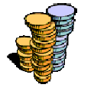
At home or when you are out, look for different shapes. Ask your child questions such as what shape is this plate? You could even choose a shape for the week and try to spot as many different objects which are this shape as possible.
Dicey Coins
For this game, you will need a dice and about twenty 10p coins.
Take turns to roll the dice and take that number of 10p coins. Guess how much money you have and then count aloud in tens to check the answer.

Secret Numbers
Write the number 0-20 on a sheet of paper. Ask your child to secretly choose a number on the paper and then ask him or her questions to try to guess the number. E.g. Is it less that 10? Is it between 10 and 20? Does it have a 5 in it?
Cupboard Maths
Choose two tins or packets from your food cupboard. Ask your child to hold one in each hand and tell you which is lighter.
Housey, Housey
When out walking, look at the house numbers. These will probably be following a pattern of odd or even numbers. Can your child predict what number will be next? Discuss the patterns with your child.
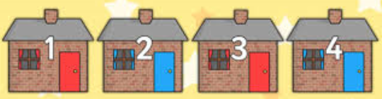
How Old?
Start with you child’s age and ask your child several questions:
How old will you be next year? How old were you last year?
How old will you be in 5/ 10 years time?
Takings
For this game you will need a dice and a collection of small things such as lego bricks, shapes or dried pasta. Take it in turns to roll the dice and take that number of objects. Write down the number.
Roll the dice again and add this number of objects. Before taking the objects call out your new total. The first player to have 20 objects wins the game.

