Calculations in Year Two
Addition:  In Year Two, we use partitioning. Children can label the digits tens (T) and units (U). Children add the tens first and move onto the units.  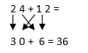  If the units are bigger than ten, partition again. | Subtraction:  We use an empty number line to solve subtraction questions. You place the smallest number at the start of the number line and the largest number at the end. You make jump of ten until you have a single digit left. Finally, add your jump amount  E.g.  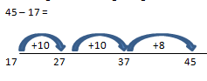  10+10+8= 28
Multiplication:  In Year Two, we count in 2’s, 5’s and 10’s to complete multiplication calculations.  We read this number sentence as 6 groups of 2.  E.g.  6 x 2 =  This many times Count in twos.  9 x 10 =  This many times Count in tens. | Division:  We use groups and sharing when we divide. Children will read the number sentence:  12 ÷ 2 =  How many to share. In this amount of groups  Children will share 12 between 2 groups.  How many is in one group?

