Calculations in Year Four
Addition:  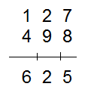  In Year Four, we use column addition. Children always start adding from the units/ ones place. Note that carried numbers are recorded to the left and on the line.  127 + 498 = 625 | Subtraction:  We use column subtraction with the  1137 – 129 = 1108  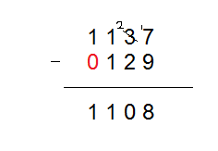
Multiplication:  In Year Four, we recap the grid method and move onto using the short multiplication method. Both methods are detailed below.  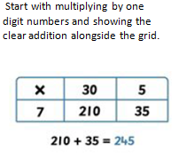  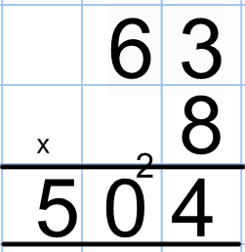  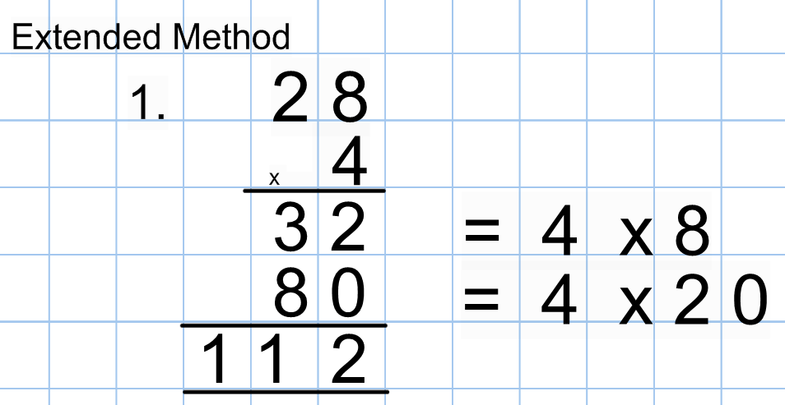 | 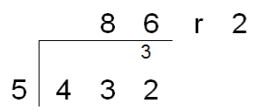  Division:

